1. INTRODUCTION
From November 15th to December 22nd, 2004, deep seismic reflection data was acquired, as part of the Venezuelan Continental Reflection Project – VENCORP 2004. The study was done in the framework of the inter-institutional project “Proyecto SE-Caribe: Estudio sobre la Interacción Corteza-Manto en la Zona de Colisión Caribe-Suramérica – Estudios sísmicos adicionales con fuentes en tierra”, by means of PDVSA-INTEVEP – FUNVISIS financial support contract Nº 04-141 of April 2nd, 2004. During the acquisition campaign, 67 borehole shots of approximately 100 kg of explosives each one were fired and recorded along 3 seismic profiles. This study corresponds to the second part of the mentioned contract, due to the previous execution of deep seismic refraction measurements over the same profiles in April/May 2004, in the framework of the BOLIVAR project (Levander et al., 2002; Levander et al., 2004; Schmitz et al., 2004a; Schmitz et al., 2004b). Figure 1 presents seismic refraction sections from land shots and the seismic lines at sea. The study was executed by FUNVISIS, in cooperation with PDVSA-INTEVEP and with the support of the following universities: Universidad Central de Venezuela (UCV), Universidad Simón Bolívar (USB), Universidad de Los Andes (ULA), and Universidad de Oriente (UDO). The project was carried out with the support of the IRIS-PASSCAL Instrument Centre Inc. which provided 768 seismic recorders and technical support. All acquisition parameters and a brief description of the activities carried out in this second phase of the project are presented in this report.
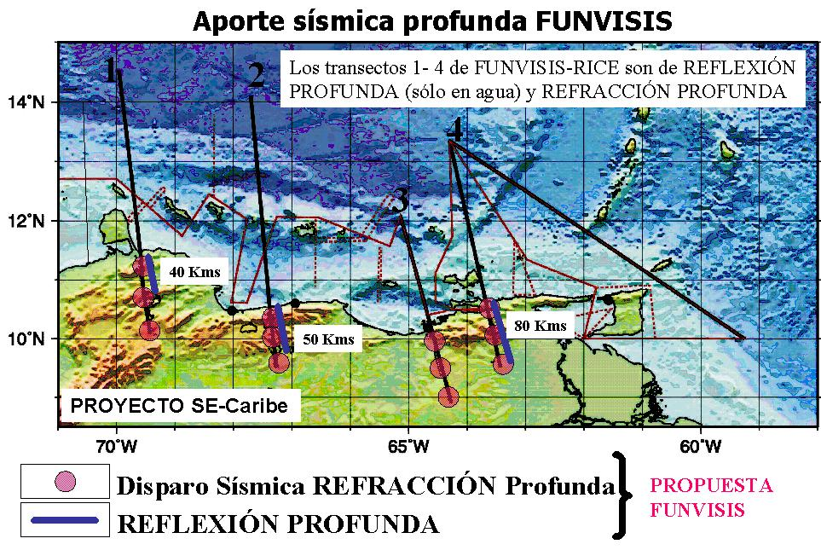
Figure 1. Location of seismic refraction shots and seismic reflection lines done as SE-Caribe Project land adicional studies.

1.1 Participants
The following list contains the names and institutions of all field work participants:
USB: Melissa Hernández, Willy Goncalves, Verónica Cordero, María F. Quijada, Ligia Martínez, Donata Liuzzi, Maximiliano Bezada, Erwins Castillo, Jessica Pardo, Sergio Enrique Pedraza, Juán José Nobile, Ernesto Vieira, Andrés Landa, Jesús Ávila.
ULA: Fernando Mazuera.
UCV: Jozsef Hecht, Giovanni José Prada, Francisco Moreno, Carlos Alfredo Hönig, Roberto Álvarez, Kenny García, Sidonio Yépez, Marianne Yánez, Luís Moros, Nelson Oriach, Jesús Humberto Delgado, Cecilio Morales, José Francisco Suniaga.
PASSCAL: Pnina Miller, Greg Chavez, Galen Kaip (UTEP).
FUNVISIS: Ricardo De Marco, Javier Sánchez, Gabriel Gil, Michael Schmitz, Víctor Cano, Víctor Rocabado.

1.2 Location of the study area
The study was concentrated in northern Venezuela, specifically in the Lara-Falcón, Aragua-Guárico and Sucre-Monagas states (Figure 2). These three profiles are located in such a way that they will provide information about Caribbean and South American plates interaction 50 Ma ago (70ºW), 30 Ma ago (67ºW) and 15 Ma ago (64ºW), crossing the Oca-Ancón, La Victoria, and El Pilar fault systems. The profiles will provide crustal and upper mantle information in the the zone of change in subduction polarity, and therefore they will increase the knowledge of the evolution of this plate interaction zone. The three profiles in this study are identified as: Western profile 70ºW, located in the Falcón and Lara states; Central profile 67ºW, located in the Aragua and Guárico states; and Eastern profile 64ºW, located in the Sucre and Monagas states (Figures 3, 4, and 5).

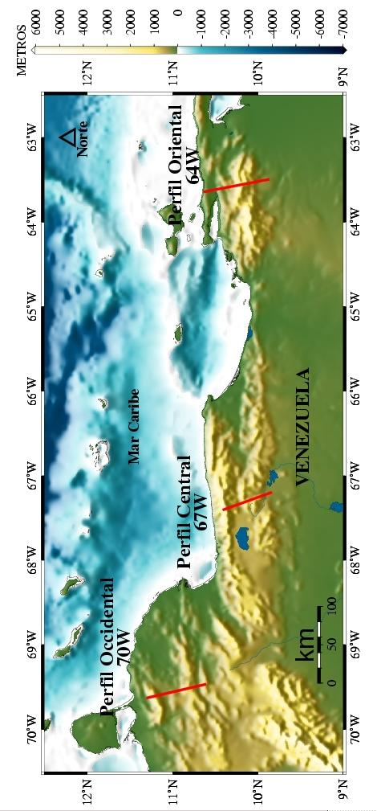
Figure 2. Location of seismic reflection lines.

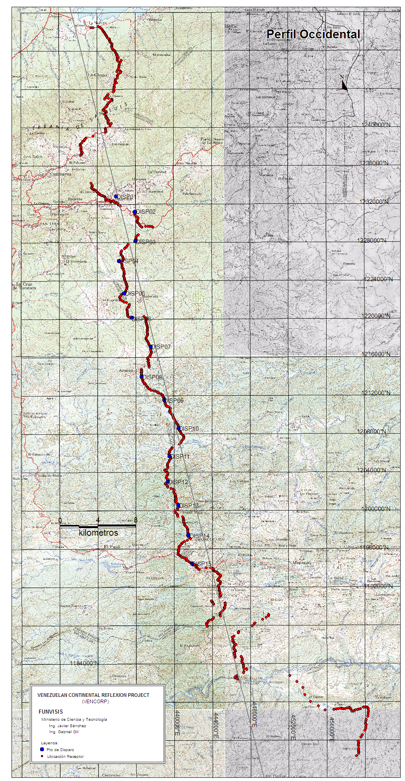
Figure 3. Location of the western seismic profile (70ºW). Red squares are recording points, blue circles are shot points.
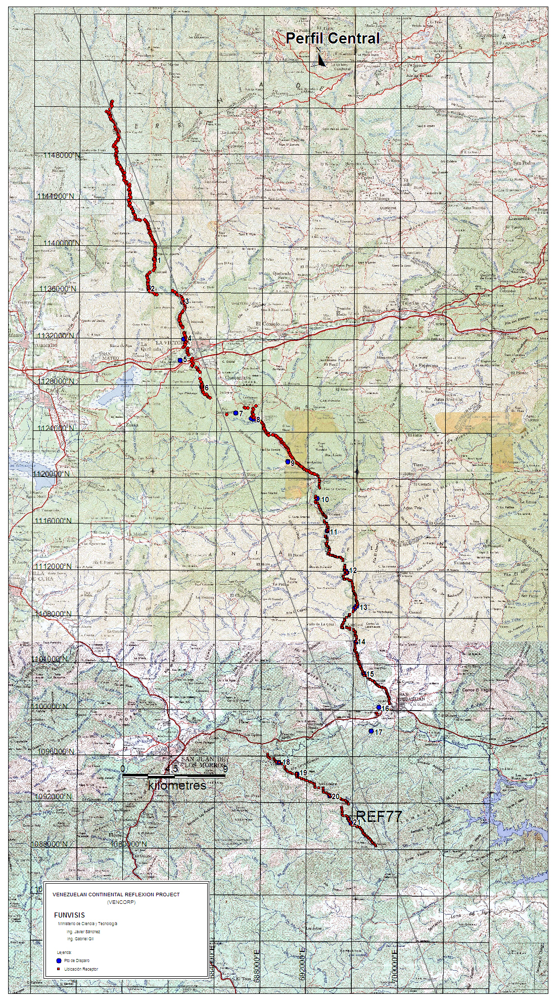
Figure 4. Location of the central seismic profile (67ºW). Red squares are recording points, blue circles are shot points.
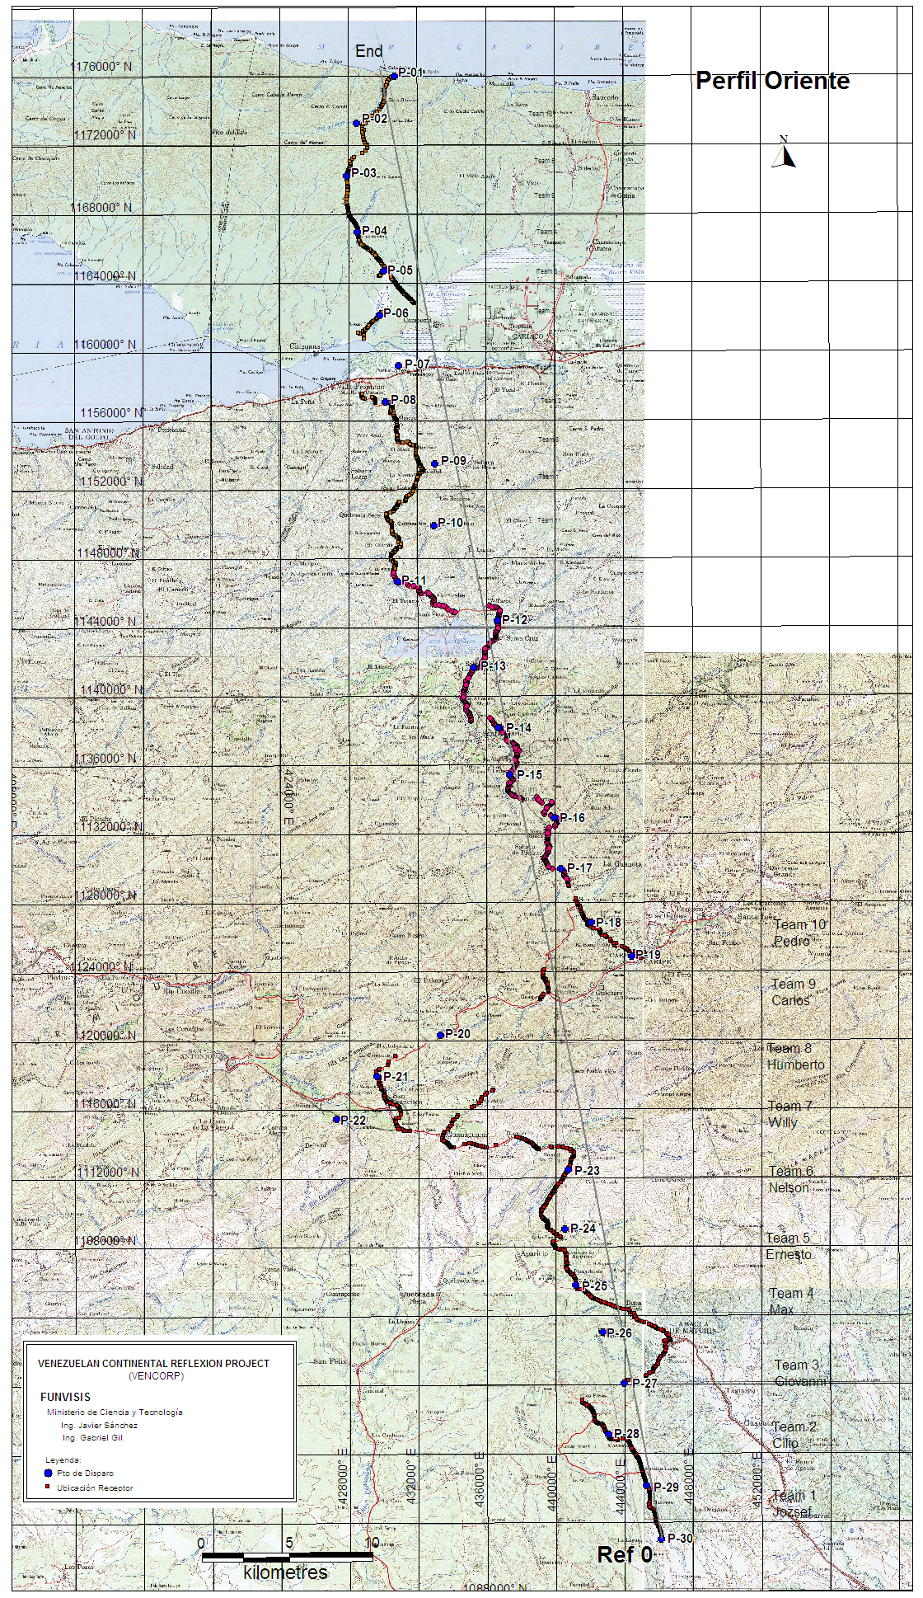
Figure 5. Location of the eastern seismic profile (64ºW). Red squares are recording points, blue circles are shot points.
1.3 Instruments used
768 single component (vertical component), 24 bit REF TEK 125 potable seismic recorders (TEXANS) were used as seismic recorders (Figure 6; see Attachment A for technical specifications) lent by IRIS/PASSCAL Instrument Centre Inc. They were equiped with 32 and 64 Mb memory. TEXAN recording is based in the selection of time windows of 100 seconds in length, with a sampling frequency of 250 Hz, and GPS synchronization with accurate internal clocks.

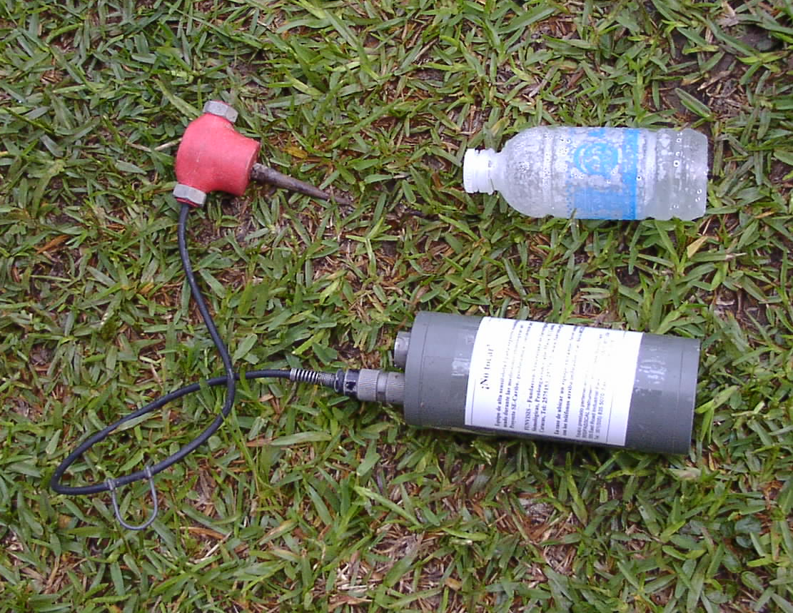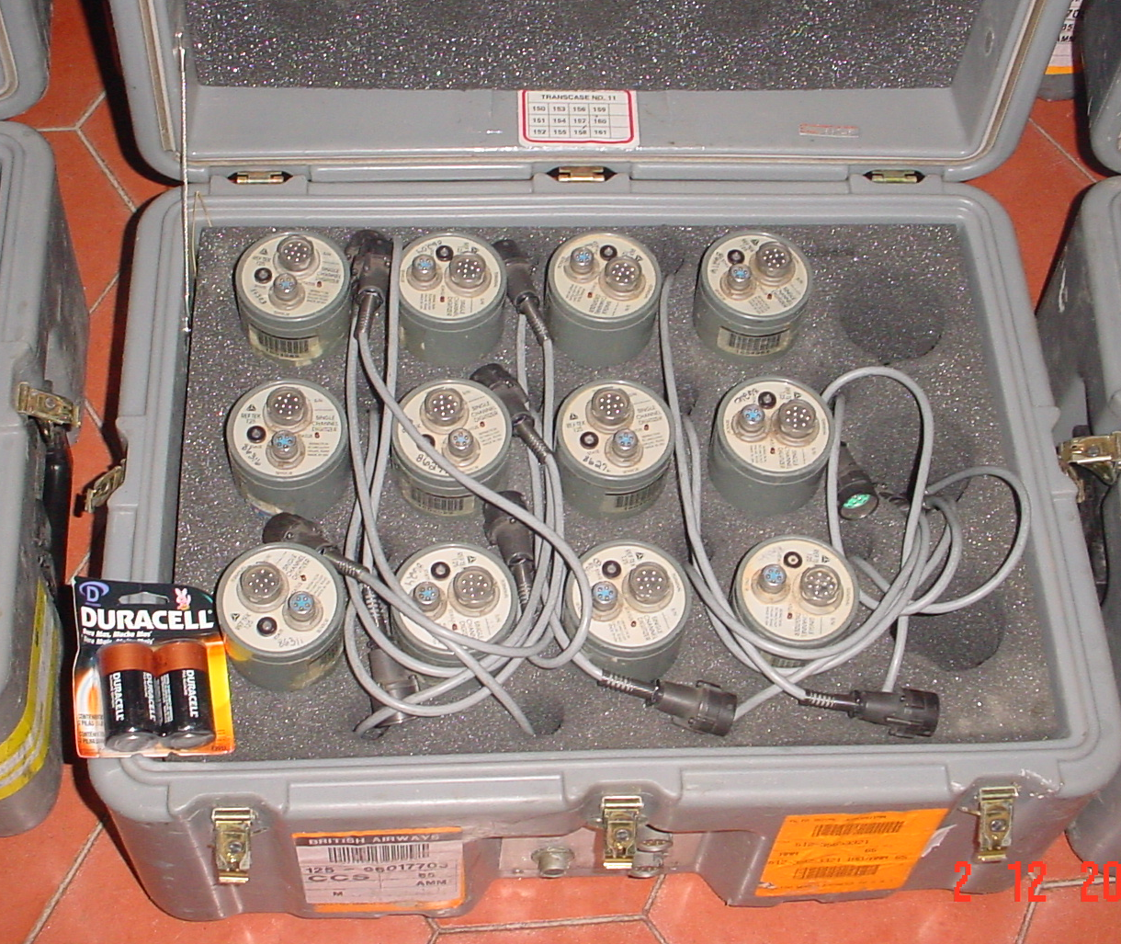
Figure 6. Seismic recording equipment TEXAN (Left, water bottle as scale) and equipments inside box (Right).

A seismic initiator (Penn State Seismic Shot Box; Attachment B) was used to trigger the shots. It consists of a seismic source initiation system and a shot-time synchronization system. The initiator is designed to generate a 10 ms 400 volts impulse for source activation by means of a shot pulse determined by a 100 ns accuracy internal clock synchronized by GPS. The use of two seismic initiators allowed two shot teams to work simultaneously over each profile. The two teams were able to synchronize shot times in windows assigned to each team.

2. METHODOLOGY AND PROCESSING
2.1 Field work.
Field work was done from November 15th to December 22nd, 2004. Field activities began on November 15th, with well drilling. Figure 7 shows the work team organization flowchart during the project.
Coordinator
Michael Schmitz
Permission
Drilling
Measurements
Recording
Víctor Rocabado
Ricardo de Marco

Roberto Álvarez
José Suniaga
Pnina Miller
Galen Kaip
PASSCAL
Seismologist

Greg Chavez
PASSCAL
Electronics
Javier Sánchez
Shots
Víctor Cano
Michael Schmitz
Gabriel Gil
Marianne Yánez
10 Recording Teams
Figure 7. Organization flowchart of the VENCORP 2004 project.

Recording equipment installation was done by 10 recording teams, supported by permission, drilling, recording, and shot teams. Each recording team was composed of 2 volunteers in a sport-utility type vehicle.
The first step in field work was TEXAN battery replacement and configuration, the battery replacement was done by volunteers and configuration by the PASSCAL technical staff (P. Miller, G. Kaip, G. Chávez) (Figure 8). Configuration consisted of the programming of time windows of 100 s length every 5 min.
Each of the recording teams had an assigned installation zone in each profile, where they were responsible of installing and retrieving approximately 80 recorders (TEXAN). To install the recording equipments, they had to be buried some centimeters in the ground to conceal them from people and to ensure a better coupling between the geophone and the soil (Figure 9).
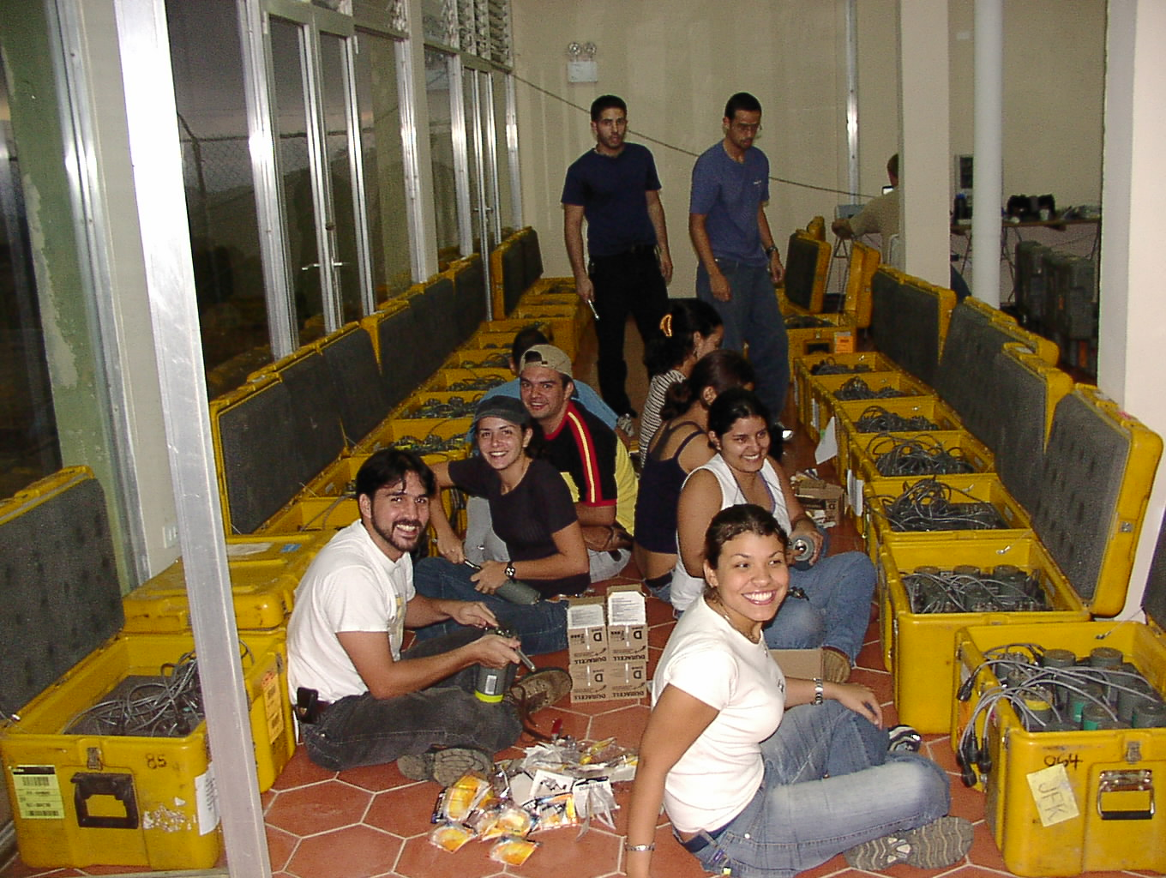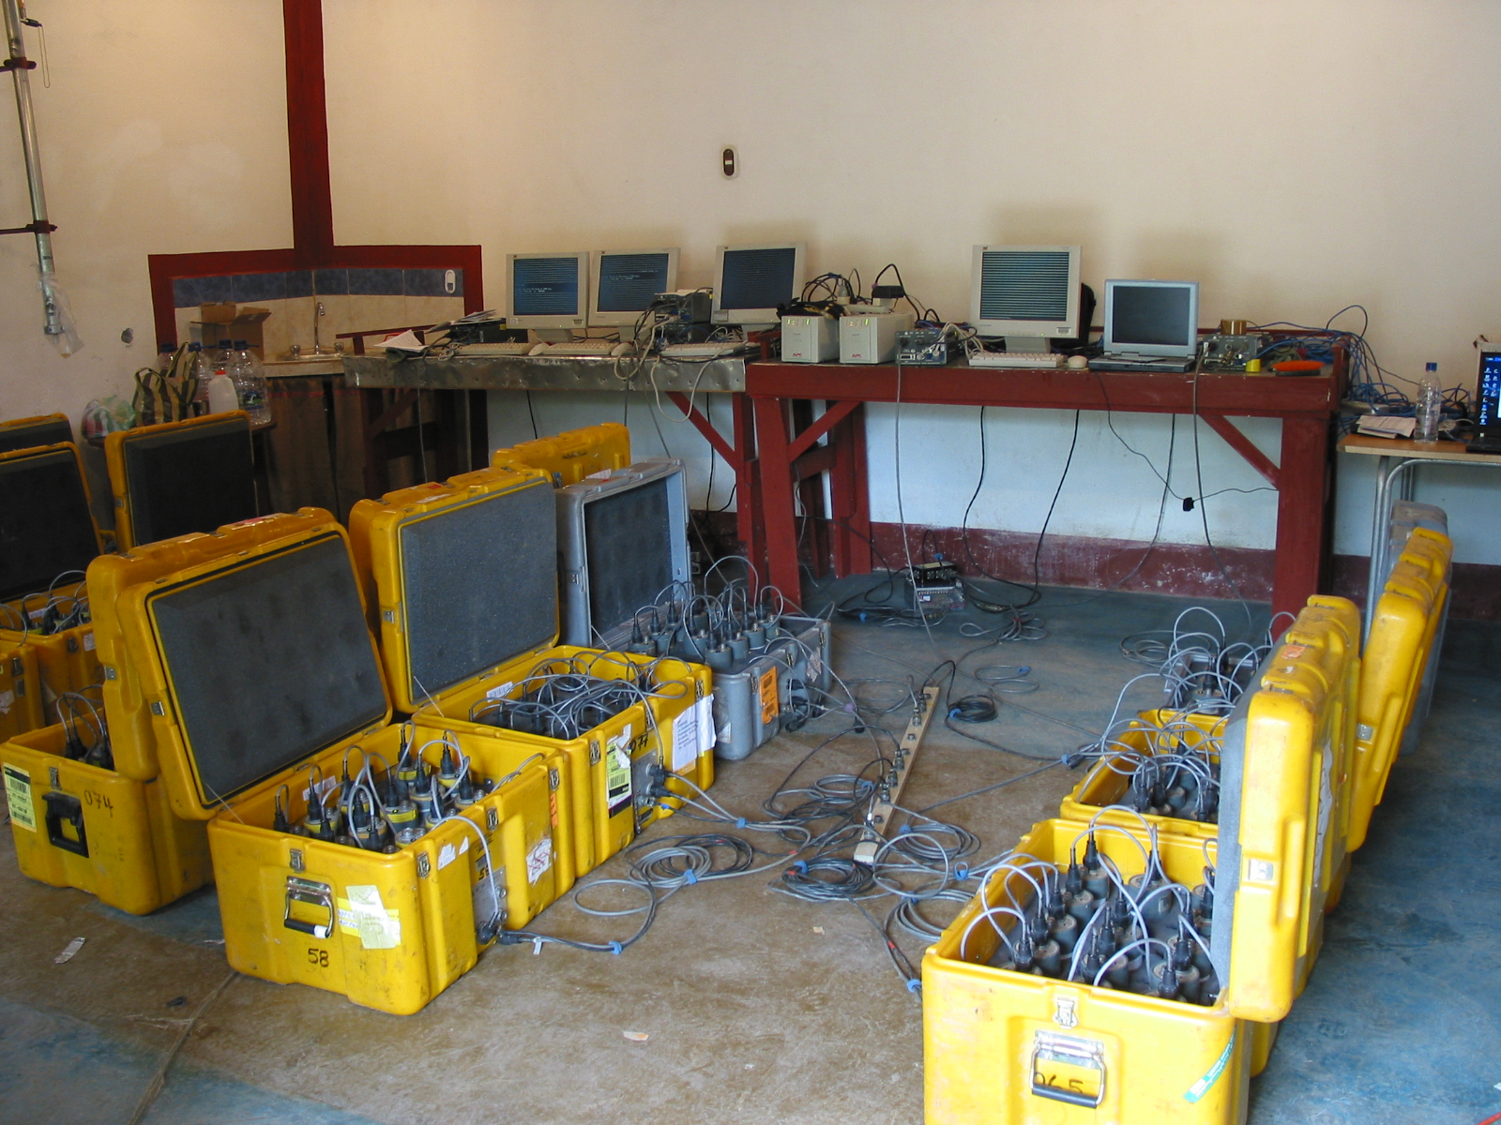
Figure 8. Change of batteries and TEXAN configuration.
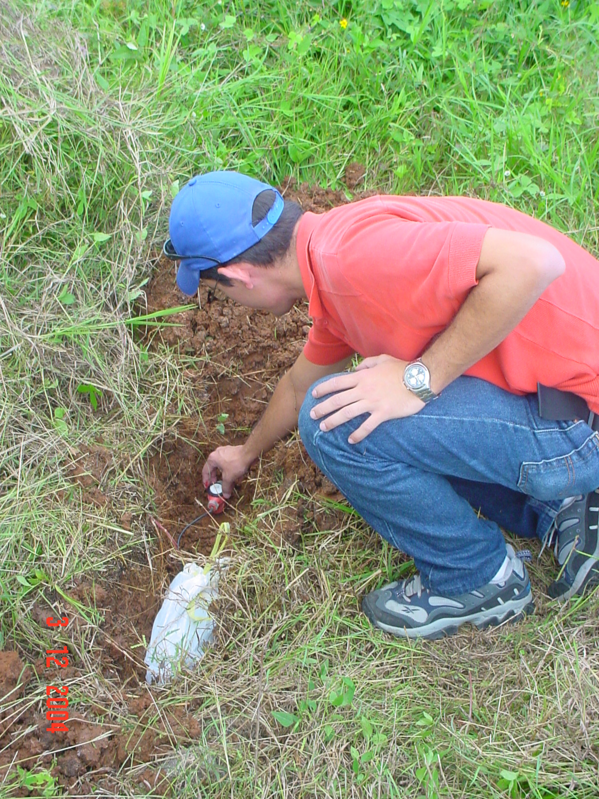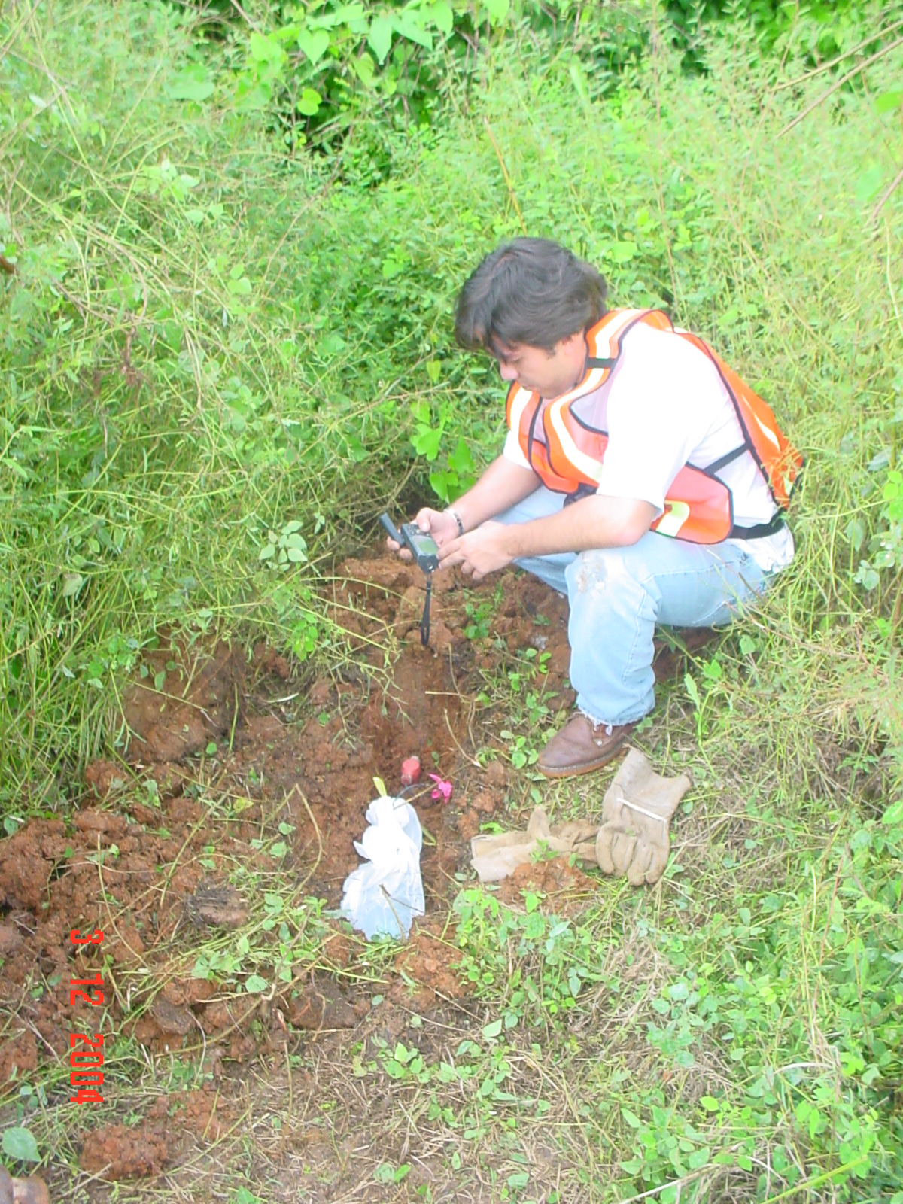
Figure 9. TEXAN seismic equipment installation (Geophone levelling and GPS location).

Recording point locations were done with GPS GARMIN V navigators, measuring the distance from certain reference points given along the seismic profiles. The reference datum used in the navigators was Provisional South American 1956. Recording equipments were installed every 100 m on the western and central profiles, and every 50 m on the eastern profile.
After the firing of the shots (Figures 10 and 11), the drilling and shot teams carried out the recovery of the affected zones (Figure 12) in accordance with environmental laws and the “Ministerio de Ambiente y de los Recursos Naturales” permit for the project.
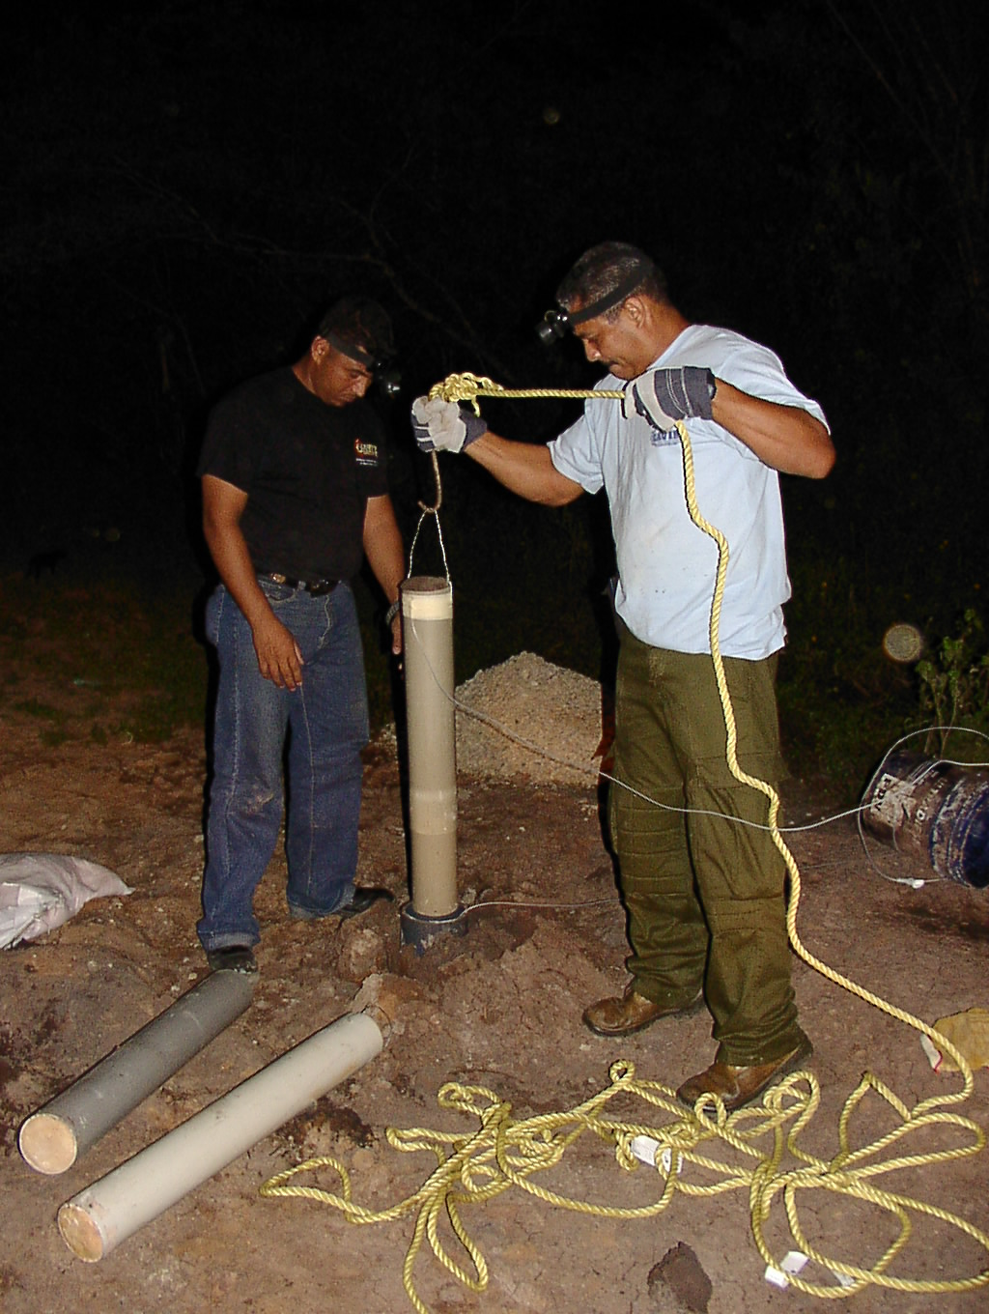
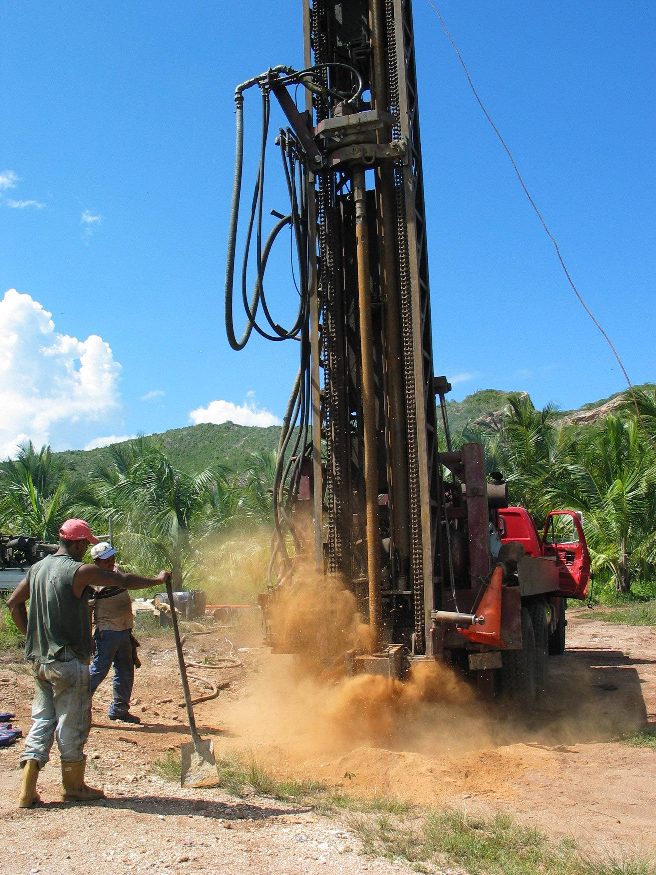
Figure 10. Drilling and well charging with explosives.
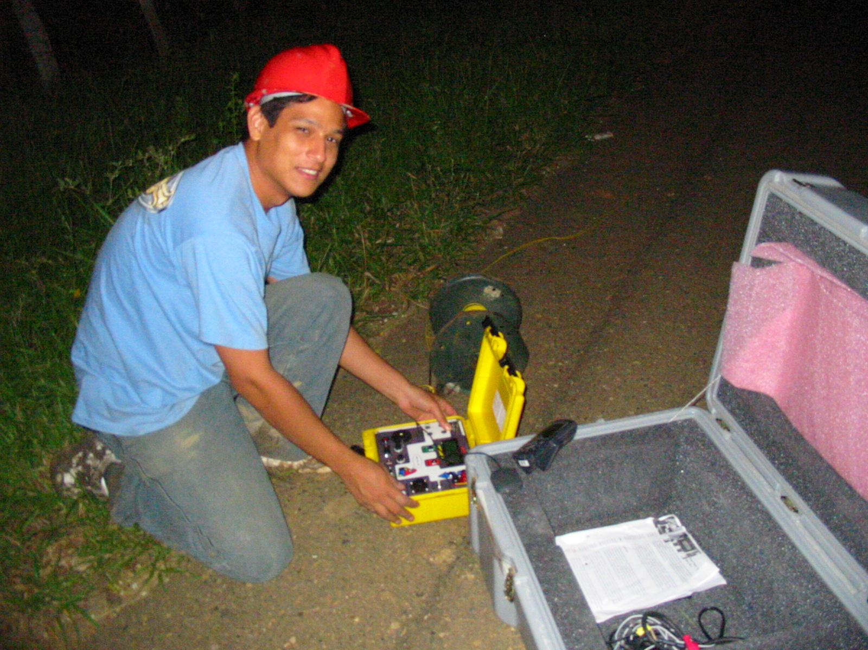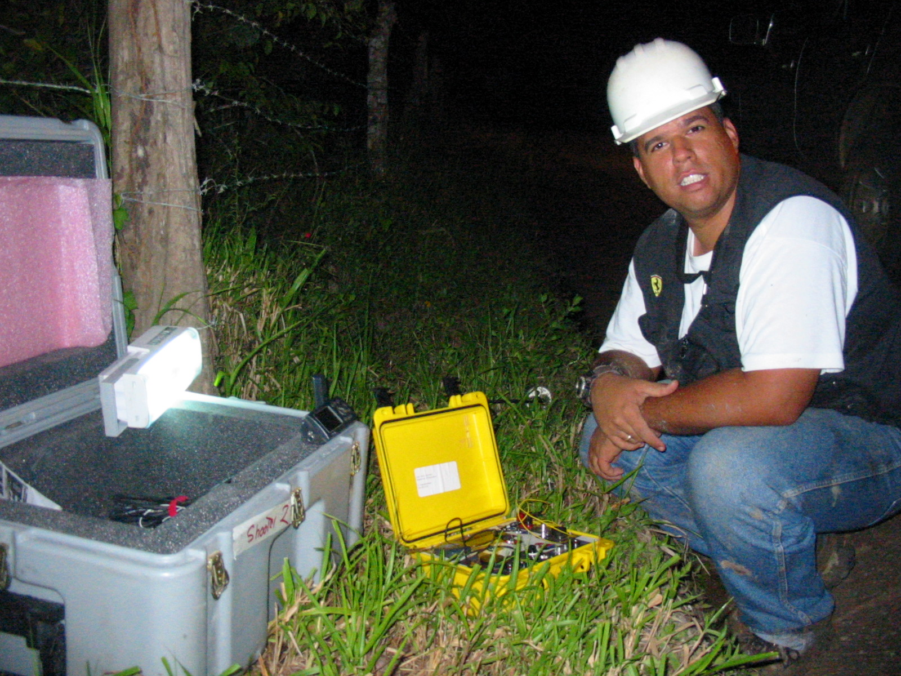
Figure 11. Shot activation.
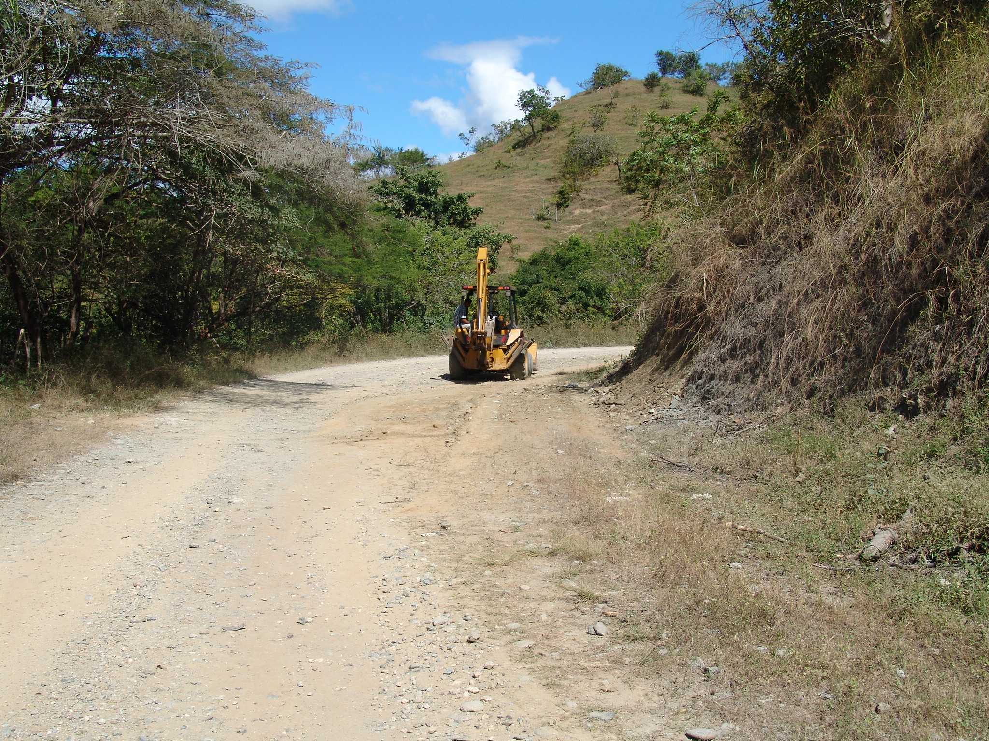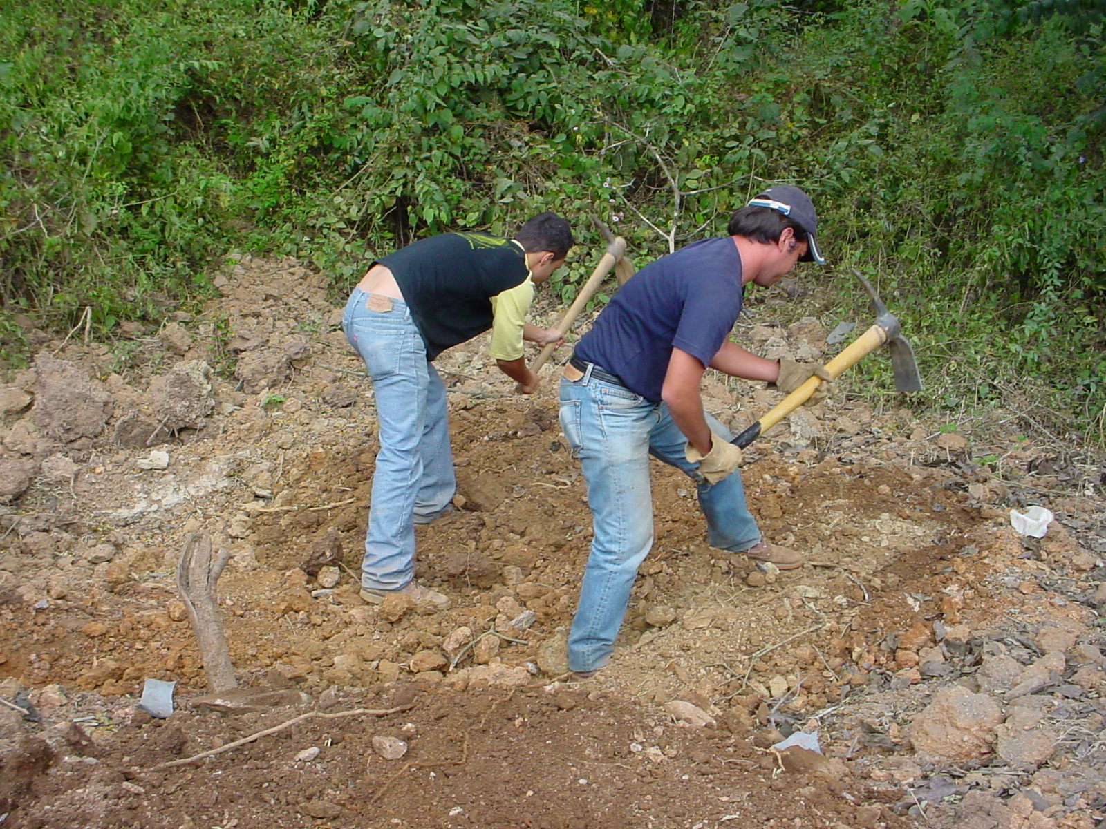
Figure 12. Recovery of zones affected by shots.

2.2. Acquisition parameters
Three deep seismic reflection profiles were acquired. General acquisition parameters are shown in Table 1.

Table 1. Parameters for seismic profiles acquisition, VENCORP 2004 project.
Profile | # of active channels | # of shots | Dist. between shots (km) | Dist. between receivers (m) | Total profile length (km)
Western 70w | 768 | 15 | 3 | 100 | 80
Central 67W | 768 | 21 | 3 | 100 | 80
Eastern 64W | 768 | 31 | 3 | 50 | 87

With the intention of estimating the expected fold values on seismic lines and optimizing the acquisition parameters, line folds were calculated (Arencibia, S., Calderon, J., Ortega, A., Sánchez, J., personal communication), using the simulation and seismic survey design program MESA (Input/Output, 2000). Modeling assumptions were: ideal lineal geometry and profile maximum length of 80 km. Thus, the receiver array was expanded to reach that length in Western (70ºW) and Central (67ºW) profiles. The number of active channels, corresponding to the number of available TEXANS, was set to 800 channels.
Parameters used in fold calculations are the following:
- Western Profile 70°W:
Maximum offset: 80 km
Receiver spacing: 100 m
Shot spacing: 3 km
Total shots: 15
Number of active channels: 800
- Central Profile 67°W:
Maximum offset: 80 km
Receiver spacing: 100 m
Shot spacing: 3 km
Total shots: 21
Number of active channels: 800
- Eastern Profile 64°W:
Maximum offset: 40 km
Total profile length: 80 km
Number of arrays: 3
Tapering between arrays: 20 km
Receiver spacing: 100 m
Shot spacing: 3 km
Total shots: 30
Number of shots per array: 10
Number of active channels: 800

The calculated fold for each profile is shown in Figures 13-15. The principal limitation consisted in the fact that the recording array was fixed and shots were placed uniformly over it. For this reason, the recording lines on profiles 70ºW and 67ºW were extended beyond the shots (Figures 13 and 14). On the 64ºW profile the recording equipments were distributed in such a way as to reduce the maximum fold in the central part of the profile, with the intention of increasing lateral resolution (Distance between recording equipment of 50 m) by installing the recorders in three arrays. In this way, it was possible to extend the medium fold zone towards the ends of the profile (Figure 15).
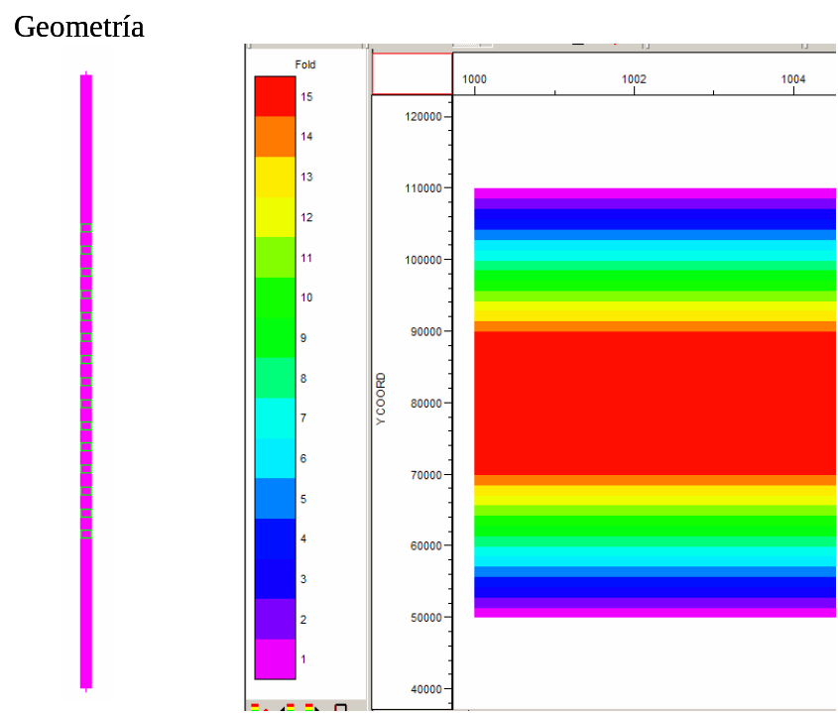
Figure 13. Fold for 800 channels, 15 centered shots, 100 m spacing fixed 70ºW profile array. (Generated with MESA, Advanced Acquisition Design Software).

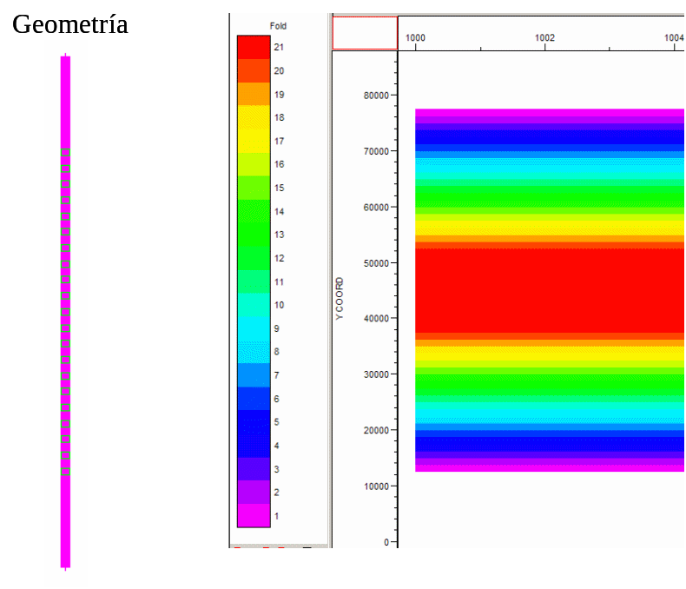
Figure 14. Fold for 800 channels, 21 centered shots, 100 m offset fixed 67ºW profile array. (Generated with MESA, Advanced Acquisition Design Software).
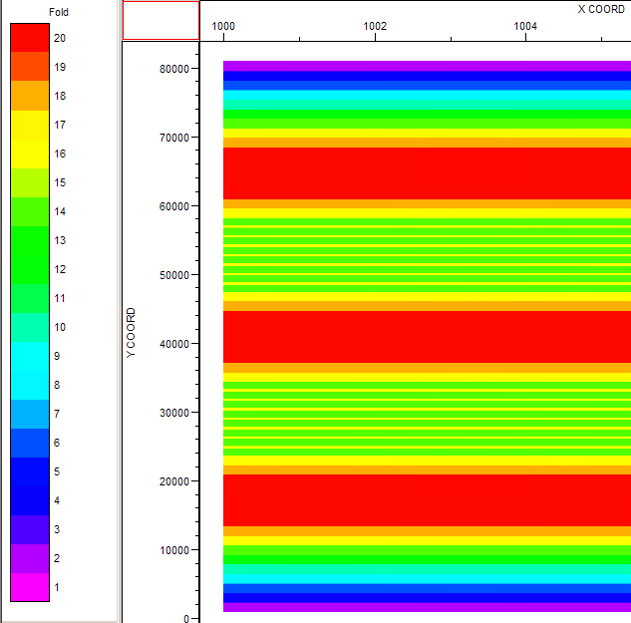
Figure 15. Fold for three 40 km length arrays, 50 m offset, 64ºW profile survey. (Generated with MESA, Advanced Acquisition Design Software).

Explosives were used as energy sources, in quantities between 20 and 120 kg per borehole, at depths between 8 and 15 m. Table 1 shows a summary of acquisition parameters for each profile. Table 2 shows a summary of shot parameters used in seismic recording. Location of shots and receiver stations was done using handheld GPS navigators (GARMIN V) (Table 3). Shot times were synchronized by GPS times and adjusted with measured times in equipments located at 15 and 150 m offsets from shot points (Up hole geophones) (Table 4).

Table 2. General shot parameters, VENCORP 2004 project.
Profile | # of boreholes | Depth (m) | Diameter (inches) | Total explosives (kg)
Western 70W | 15 | 15 | 6 | 80-120
Central 67W | 21 | 10-15 | 4-6 | 80-120
Eastern 64W | 31 | 8-15 | 6 | 20-120

Table 3. Location of seismic profile shots, VENCORP 2004 project.
 | 70W Profile |  |  |  |  | DATUM WGS 84
Bore-hole # | Event | Borehole coordinates |  |  |  |  |  |  |  | Explosive charge Kg | Uphole geophone offset / texan #
Bore-hole # | Event | UTM E |  | UTM N | Lat. |  | Long. | Elev. |  | Explosive charge Kg | Dist. | texan # | Dist. | texan #
1 | 31 | 433751 |  | 1232477 | -69.6048 |  | 11.1518 | 670 |  | 100 | 15 | 5208 | 150 | 5209
2 | 37 | 435716 |  | 1230816 | -69.5868 |  | 11.1368 | 430 |  | 100 | 15 | 5208 | 150 | 5209
3 | 45 | 435780 |  | 1227813 | -69.5861 |  | 11.1096 | 285 |  | 100 | 15 | 5208 | 100 | 5209
4 | 49 | 434044 |  | 1225697 | -69.602 |  | 11.0904 | 368 |  | 120 | 15 | 5208 | 150 | 5209
5 | 55 | 434574 |  | 1222346 | -69.5971 |  | 11.0602 | 474 |  | 100 | 15 | 5208 | 70 | 5209
6 | 59 | 435391 |  | 1219801 | -69.5896 |  | 11.0372 | 412 |  | 80 | 15 | 5208 | 105 | 5209
7 | 65 | 437346 |  | 1216765 | -69.5716 |  | 11.0097 | 433 |  | 100 | 15 | 5208 | 115 | 5209
8 | 6 | 436395 |  | 1213644 | -69.5803 |  | 10.9815 | 561 |  | 100 | 15 | 5208 | 150 | 5209
9 | 10 | 438776 |  | 1211184 | -69.5584 |  | 10.9593 | 359 |  | 100 | 15 | 87530 | 80 | 87591
10 | 14 | 440287 |  | 1208250 | -69.5446 |  | 10.9328 | 326 |  | 100 | 15 | 87530 | 80 | 87591
11 | 18 | 439290 |  | 1205348 | -69.5536 |  | 10.9065 | 336 |  | 120 | 15 | 87530 | 80 | 87591
12 | 22 | 439145 |  | 1202663 | -69.5549 |  | 10.8822 | 519 |  | 100 | 15 | 87530 | 90 | 87591
13 | 26 | 440202 |  | 1200227 | -69.5452 |  | 10.8602 | 850 |  | 100 | 15 | 87530 | 90 | 87591
14 | 30 | 441267 |  | 1197070 | -69.5354 |  | 10.8317 | 853 |  | 80 | 15 | 87530 | 70 | 87591
15 | 38 | 441658 |  | 1194093 | -69.5318 |  | 10.8048 | 897 |  | 100 | 15 | 87530 | 100 | 87591

Table 3 (continued). Location of seismic profile shots, VENCORP 2004 project.
 | 67W Profile |  |  |  |  |  |  |  | DATUM WGS 84
Bore-hole # | Event |  |  | Borehole coordinates |  |  |  |  |  |  |  |  |  |  |  |  |  | Explosive charge Kg |  |  | Uphole geophone offset / texan #
Bore-hole # |  |  |  | UTM E |  |  | UTM N |  | Lat. |  |  |  | Long. |  | Elev. |  |  |  |  |  | Dist. |  | texan # |  |  | Dist. |  |  | texan #
1 | 284 |  |  | 678332 |  |  | 1138483 |  | -67.3715 |  |  |  | 10.2950 |  | 711 |  |  | 90 |  |  | 15 |  | 87513 |  |  | 117 |  |  | 87506
2 | 279 |  |  | 677895 |  |  | 1135836 |  | -67.3756 |  |  |  | 10.2711 |  | 673 |  |  | 90 |  |  | 15 |  | 87513 |  |  | 151 |  |  | 87506
3 | 275 |  |  | 680816 |  |  | 1134814 |  | -67.3490 |  |  |  | 10.2617 |  | 614 |  |  | 100 |  |  | 15 |  | 87513 |  |  | 142 |  |  | 87506
4 | 267 |  |  | 680920 |  |  | 1131627 |  | -67.3482 |  |  |  | 10.2329 |  | 579 |  |  | 100 |  |  | 15 |  | 87513 |  |  | 124 |  |  | 87506
5 | 263 |  |  | 680627 |  |  | 1129781 |  | -67.3510 |  |  |  | 10.2162 |  | 559 |  |  | 100 |  |  | 15 |  | 87513 |  |  | 157 |  |  | 87506
6 | 257 |  |  | 682530 |  |  | 1127503 |  | -67.3337 |  |  |  | 10.1955 |  | 646 |  |  | 100 |  |  | 15 |  | 87513 |  |  | 134 |  |  | 87506
7 | 245 |  |  | 685477 |  |  | 1125237 |  | -67.3069 |  |  |  | 10.1749 |  | 1020 |  |  | 80 |  |  | 15 |  | 87513 |  |  | 142 |  |  | 87506
8 | 241 |  |  | 686795 |  |  | 1124767 |  | -67.2949 |  |  |  | 10.1706 |  | 870 |  |  | 110 |  |  | 15 |  | 87513 |  |  | 147 |  |  | 87506
9 | 233 |  |  | 690045 |  |  | 1121065 |  | -67.2655 |  |  |  | 10.1370 |  | 645 |  |  | 100 |  |  | 15 |  | 87513 |  |  | 142 |  |  | 87506
10 | 225 |  |  | 692627 |  |  | 1117903 |  | -67.2421 |  |  |  | 10.1083 |  | 585 |  |  | 85 |  |  | 15 |  | 87591 |  |  | 150 |  |  | 87530
11 | 219 |  |  | 693527 |  |  | 1115102 |  | -67.2340 |  |  |  | 10.0829 |  | 543 |  |  | 95 |  |  | 15 |  | 87591 |  |  | 160 |  |  | 87530
12 | 209 |  |  | 695231 |  |  | 1111514 |  | -67.2186 |  |  |  | 10.0504 |  | 494 |  |  | 100 |  |  | 15 |  | 87591 |  |  | 110 |  |  | 87530
13 | 194 |  |  | 695910 |  |  | 1108403 |  | -67.2126 |  |  |  | 10.0222 |  | 438 |  |  | 100 |  |  | 15 |  | 87591 |  |  | 100 |  |  | 87530
14 | 202 |  |  | 696054 |  |  | 1105501 |  | -67.2114 |  |  |  | 9.9960 |  | 440 |  |  | 100 |  |  | 15 |  | 87591 |  |  | 100 |  |  | 87530
15 | 208 |  |  | 696720 |  |  | 1102832 |  | -67.2055 |  |  |  | 9.9718 |  | 399 |  |  | 100 |  |  | 15 |  | 87591 |  |  | ??? |  |  | 87530
16 | 216 |  |  | 698053 |  |  | 1099886 |  | -67.1935 |  |  |  | 9.9451 |  | 354 |  |  | 120 |  |  | 15 |  | 87591 |  |  | 80 |  |  | 87530
17 | 226 |  |  | 697410 |  |  | 1097829 |  | -67.1994 |  |  |  | 9.9266 |  | 355 |  |  | 100 |  |  | 15 |  | 87591 |  |  | 100 |  |  | 87530
18 | 234 |  |  | 689348 |  |  | 1095088 |  | -67.2731 |  |  |  | 9.9022 |  | 390 |  |  | 100 |  |  | 15 |  | 87591 |  |  | 90 |  |  | 87530
19 | 238 |  |  | 690974 |  |  | 1094100 |  | -67.2583 |  |  |  | 9.8932 |  | 412 |  |  | 70 |  |  | 15 |  | 87591 |  |  | 90 |  |  | 87530
20 | 246 |  |  | 693824 |  |  | 1092230 |  | -67.2324 |  |  |  | 9.8761 |  | 350 |  |  | 130 |  |  | 15 |  | 87591 |  |  | 130 |  |  | 87530
21 | 252 |  |  | 695469 |  |  | 1090265 |  | -67.2175 |  |  |  | 9.8583 |  | 344 |  |  | 100 |  |  | 15 |  | 87591 |  |  | 100 |  |  | 87530
 |  | 64W Profile |  |  |  |  |  |  |  |  |  |  |  | DATUM WGS 84
Bore-hole # |  | Event | Borehole coordinates |  |  |  |  |  |  |  |  |  |  |  |  |  |  |  | Explosive charge Kg |  |  | Uphole geophone offset / texan #
 |  | Event | UTM E |  |  | UTM N |  |  |  | Lat. |  | Long. |  |  |  | Elev. |  |  |  |  |  | Dist. |  | texan # |  |  | Dist. | texan #
1 |  | 302 | 430482 |  |  | 1175648 |  |  |  | 10.6346 |  | -63.6356 |  |  |  | 8 |  |  | 120 |  |  | 15 |  | 537 |  |  | 150 | 538
2 |  | 310 | 428284 |  |  | 1172937 |  |  |  | 10.61 |  | -63.6556 |  |  |  | 71.7 |  |  | 120 |  |  | 15 |  | 537 |  |  | 150 | 538
3 |  | 316 | 427702 |  |  | 1169853 |  |  |  | 10.5821 |  | -63.6609 |  |  |  | 68 |  |  | 20 |  |  | 15 |  | 537 |  |  | 150 | 538
4 |  | 320 | 428348 |  |  | 1166622 |  |  |  | 10.5529 |  | -63.6549 |  |  |  | 109 |  |  | 20 |  |  | 15 |  | 537 |  |  | 150 | 538
5 |  | 326 | 429838 |  |  | 1164358 |  |  |  | 10.5325 |  | -63.6412 |  |  |  | 74 |  |  | 120 |  |  | 15 |  | 537 |  |  | 150 | 538
6 |  | 332 | 429600 |  |  | 1161765 |  |  |  | 10.509 |  | -63.6434 |  |  |  | 35 |  |  | 20 |  |  | 15 |  | 537 |  |  | 150 | 538
7 |  | 340 | 430707 |  |  | 1158863 |  |  |  | 10.4828 |  | -63.6332 |  |  |  | 14 |  |  | 100 |  |  | 15 |  | 87530 |  |  | 100 | 87591
8 |  | 325 | 429920 |  |  | 1156729 |  |  |  | 10.4635 |  | -63.6404 |  |  |  | 26 |  |  | 120 |  |  | 15 |  | 87530 |  |  | 100 | 87591
9 |  | 317 | 432798 |  |  | 1153129 |  |  |  | 10.431 |  | -63.614 |  |  |  | 240 |  |  | 100 |  |  | 15 |  | 87530 |  |  | 100 | 87591
10 |  | 311 | 432756 |  |  | 1149558 |  |  |  | 10.3987 |  | -63.6143 |  |  |  | 340 |  |  | 100 |  |  | 15 |  | 87530 |  |  | 100 | 87591
11 |  | 160 | 430665 |  |  | 1146280 |  |  |  | 10.369 |  | -63.6334 |  |  |  | 140 |  |  | 100 |  |  | 15 |  | 537 |  |  | 150 | 538
12 |  | 168 | 436470 |  |  | 1144023 |  |  |  | 10.3487 |  | -63.5803 |  |  |  | 111 |  |  | 100 |  |  | 15 |  | 537 |  |  | 150 | 538
13 |  | 172 | 435077 |  |  | 1141295 |  |  |  | 10.324 |  | -63.593 |  |  |  | 330 |  |  | 100 |  |  | 15 |  | 537 |  |  | 150 | 538
14 |  | 178 | 436572 |  |  | 1137801 |  |  |  | 10.2924 |  | -63.5793 |  |  |  | 510 |  |  | 60 |  |  | 15 |  | 537 |  |  | 150 | 538
15 |  | 182 | 437161 |  |  | 1135049 |  |  |  | 10.2675 |  | -63.5738 |  |  |  | 695 |  |  | 100 |  |  | 15 |  | 537 |  |  | 150 | 538
16 |  | 179 | 439742 |  |  | 1132572 |  |  |  | 10.2452 |  | -63.5502 |  |  |  | 1144 |  |  | 100 |  |  | 15 |  | 87530 |  |  | 100 | 87591
17 |  | 173 | 440137 |  |  | 1129592 |  |  |  | 10.2182 |  | -63.5466 |  |  |  | 1132 |  |  | 100 |  |  | 15 |  | 87530 |  |  | 95 | 87591
18 |  | 167 | 441915 |  |  | 1126497 |  |  |  | 10.1903 |  | -63.5303 |  |  |  | 1182 |  |  | 140 |  |  | 18 |  | 87530 |  |  | 95 | 87591
19 |  | 161 | 444245 |  |  | 1124496 |  |  |  | 10.1722 |  | -63.509 |  |  |  | 864 |  |  | 30 |  |  | 15 |  | 87530 |  |  | 100 | 87591
20 |  | 153 | 433118 |  |  | 1119943 |  |  |  | 10.1309 |  | -63.6105 |  |  |  | 967 |  |  | 100 |  |  | 15 |  | 87530 |  |  | 115 | 87591
21 |  | 1 | 429414 |  |  | 1117580 |  |  |  | 10.1094 |  | -63.6443 |  |  |  | 540 |  |  | 100 |  |  | 15 |  | 87530 |  |  | 100 | 87591
22 |  | 7 | 427019 |  |  | 1115118 |  |  |  | 10.0871 |  | -63.6661 |  |  |  | 437 |  |  | 100 |  |  | 15 |  | 87530 |  |  | 100 | 87591
23 |  | 17 | 440528 |  |  | 1112129 |  |  |  | 10.0603 |  | -63.5427 |  |  |  | 584 |  |  | 60 |  |  | 15 |  | 87530 |  |  | 100 | 87591
24 |  | 23 | 440358 |  |  | 1108686 |  |  |  | 10.0292 |  | -63.5442 |  |  |  | 398 |  |  | 100 |  |  | 15 |  | 87530 |  |  | 100 | 87591
25 |  | 29 | 440961 |  |  | 1105419 |  |  |  | 9.99962 |  | -63.5387 |  |  |  | 281 |  |  | 100 |  |  | 15 |  | 87530 |  |  | 100 | 87591
26 |  | 36 | 442537 |  |  | 1102700 |  |  |  | 9.97505 |  | -63.5243 |  |  |  | 263 |  |  | 100 |  |  | 15 |  | 537 |  |  | 150 | 538
27 |  | 28 | 443806 |  |  | 1099724 |  |  |  | 9.94816 |  | -63.5127 |  |  |  | 215 |  |  | 100 |  |  | 15 |  | 537 |  |  | 150 | 538
28 |  | 20 | 442868 |  |  | 1096733 |  |  |  | 9.92109 |  | -63.5212 |  |  |  | 346 |  |  | 100 |  |  | 15 |  | 537 |  |  | 150 | 538
29 |  | 14 | 445065 |  |  | 1093764 |  |  |  | 9.89427 |  | -63.5011 |  |  |  | 298 |  |  | 80 |  |  | 15 |  | 537 |  |  | 150 | 538
30 |  | 6 | 445950 |  |  | 1090676 |  |  |  | 9.86635 |  | -63.493 |  |  |  | 238 |  |  | 120 |  |  | 15 |  | 537 |  |  | 150 | 538
31 |  | 299 | 436495 |  |  | 1137800 |  |  |  | 10.2924 |  | -63.58 |  |  |  | 510 |  |  | 140 |  |  | 15 |  | 87530 |  |  | 100 | 87591
Table 4. Shot times, VENCORP 2004 project.
 | 70W Profile
Event | Date - Time |  |  |  | Bore-hole # | Explosive Charge (kg) |  | Up hole geophone offset
Event | Start |  |  | End | Bore-hole # |  |  | Dist. |  |  | texan # |  |  | Dist. |  |  | texan #
6 | 2004:340:02:24:50 |  |  | 2004:340:02:26:30 | 8 | 100 |  | 15 |  |  | 5208 |  |  | 150 |  |  | 5209
10 | 2004:340:02:44:50 |  |  | 2004:340:02:46:30 | 9 | 100 |  | 15 |  |  | 5208 |  |  | 150 |  |  | 5209
14 | 2004:340:03:04:50 |  |  | 2004:340:03:06:30 | 10 | 100 |  | 15 |  |  | 5208 |  |  | 100 |  |  | 5209
18 | 2004:340:03:24:50 |  |  | 2004:340:03:26:30 | 11 | 120 |  | 15 |  |  | 5208 |  |  | 150 |  |  | 5209
22 | 2004:340:03:44:50 |  |  | 2004:340:03:46:30 | 12 | 100 |  | 15 |  |  | 5208 |  |  | 70 |  |  | 5209
26 | 2004:340:04:04:50 |  |  | 2004:340:04:06:30 | 13 | 80 |  | 15 |  |  | 5208 |  |  | 105 |  |  | 5209
30 | 2004:340:04:24:50 |  |  | 2004:340:04:26:30 | 14 | 100 |  | 15 |  |  | 5208 |  |  | 115 |  |  | 5209
38 | 2004:340:05:04:50 |  |  | 2004:340:05:06:30 | 15 | 100 |  | 15 |  |  | 5208 |  |  | 150 |  |  | 5209
31 | 2004:340:04:29:50 |  |  | 2004:340:04:31:30 | 1 | 100 |  | 15 |  |  | 87530 |  |  | 80 |  |  | 87591
37 | 2004:340:04:59:50 |  |  | 2004:340:05:01:30 | 2 | 100 |  | 15 |  |  | 87530 |  |  | 80 |  |  | 87591
45 | 2004:340:05:39:50 |  |  | 2004:340:05:41:30 | 3 | 120 |  | 15 |  |  | 87530 |  |  | 80 |  |  | 87591
49 | 2004:340:05:59:50 |  |  | 2004:340:06:01:30 | 4 | 100 |  | 15 |  |  | 87530 |  |  | 90 |  |  | 87591
55 | 2004:340:06:29:50 |  |  | 2004:340:06:31:30 | 5 | 100 |  | 15 |  |  | 87530 |  |  | 90 |  |  | 87591
59 | 2004:340:06:49:50 |  |  | 2004:340:06:51:30 | 6 | 80 |  | 15 |  |  | 87530 |  |  | 70 |  |  | 87591
65 | 2004:340:07:19:50 |  |  | 2004:340:07:21:30 | 7 | 100 |  | 15 |  |  | 87530 |  |  | 100 |  |  | 87591
 |  | 67W Profile
Event |  | Date - Time |  |  | Bore-hole # |  | Explosive Charge (kg) | Up hole geophone offset
 |  | Start |  | End |  |  | Explosive Charge (kg) | Dist. |  | texan # |  |  | Dist. |  |  | texan #
194 |  | 2004:344:02:04:50 |  | 2004:344:02:06:30 | 13 |  | 90 | 15 |  | 87513 |  |  | 117 |  |  | 87506
202 |  | 2004:344:02:44:50 |  | 2004:344:02:46:30 | 14 |  | 90 | 15 |  | 87513 |  |  | 151 |  |  | 87506
208 |  | 2004:344:03:14:50 |  | 2004:344:03:16:30 | 15 |  | 100 | 15 |  | 87513 |  |  | 142 |  |  | 87506
216 |  | 2004:344:03:54:50 |  | 2004:344:03:56:30 | 16 |  | 100 | 15 |  | 87513 |  |  | 124 |  |  | 87506
226 |  | 2004:344:04:44:50 |  | 2004:344:04:46:30 | 17 |  | 100 | 15 |  | 87513 |  |  | 157 |  |  | 87506
234 |  | 2004:344:05:24:50 |  | 2004:344:05:26:30 | 18 |  | 100 | 15 |  | 87513 |  |  | 134 |  |  | 87506
238 |  | 2004:344:05:44:50 |  | 2004:344:05:46:30 | 19 |  | 80 | 15 |  | 87513 |  |  | 142 |  |  | 87506
246 |  | 2004:344:06:24:50 |  | 2004:344:06:26:30 | 20 |  | 110 | 15 |  | 87513 |  |  | 147 |  |  | 87506
252 |  | 2004:344:06:54:50 |  | 2004:344:06:56:30 | 21 |  | 100 | 15 |  | 87513 |  |  | 142 |  |  | 87506
209 |  | 2004:344:03:19:50 |  | 2004:344:03:21:30 | 12 |  | 85 | 15 |  | 87591 |  |  | 150 |  |  | 87530
219 |  | 2004:344:04:09:50 |  | 2004:344:04:11:30 | 11 |  | 95 | 15 |  | 87591 |  |  | 160 |  |  | 87530
225 |  | 2004:344:04:39:50 |  | 2004:344:04:41:30 | 10 |  | 100 | 15 |  | 87591 |  |  | 110 |  |  | 87530
233 |  | 2004:344:05:19:50 |  | 2004:344:05:21:30 | 9 |  | 100 | 15 |  | 87591 |  |  | 100 |  |  | 87530
241 |  | 2004:344:05:59:50 |  | 2004:344:06:01:30 | 8 |  | 100 | 15 |  | 87591 |  |  | 100 |  |  | 87530
245 |  | 2004:344:06:19:50 |  | 2004:344:06:21:30 | 7 |  | 100 | 15 |  | 87591 |  |  | ??? |  |  | 87530
257 |  | 2004:344:07:19:50 |  | 2004:344:07:21:30 | 6 |  | 120 | 15 |  | 87591 |  |  | 80 |  |  | 87530
263 |  | 2004:344:07:49:50 |  | 2004:344:07:51:30 | 5 |  | 100 | 15 |  | 87591 |  |  | 100 |  |  | 87530
267 |  | 2004:344:08:09:50 |  | 2004:344:08:11:30 | 4 |  | 100 | 15 |  | 87591 |  |  | 90 |  |  | 87530
275 |  | 2004:344:08:49:50 |  | 2004:344:08:51:30 | 3 |  | 70 | 15 |  | 87591 |  |  | 90 |  |  | 87530
279 |  | 2004:344:09:09:50 |  | 2004:344:09:11:30 | 2 |  | 130 | 15 |  | 87591 |  |  | 130 |  |  | 87530
284 |  | 2004:344:09:34:50 |  | 2004:344:09:36:30 | 1 |  | 100 | 15 |  | 87591 |  |  | 100 |  |  | 87530
Table 4 (Continued). Shot times, VENCORP 2004 project.
Event | Day |  | Bore-hole # | Explosive Charge (kg) | Up hole geophone offset
Event | Start | End | Bore-hole # | Explosive Charge (kg) | Dist. | texan # | Dist. | texan #
302 | 2004:354:03:04:50 | 2004:354:03:06:30 | 1 | 120 | 15 | 537 | 150 | 538
310 | 2004:354:03:44:50 | 2004:354:03:46:30 | 2 | 120 | 15 | 537 | 150 | 538
316 | 2004:354:04:14:50 | 2004:354:04:16:30 | 3 | 20 | 15 | 537 | 150 | 538
320 | 2004:354:04:34:50 | 2004:354:04:36:30 | 4 | 20 | 15 | 537 | 150 | 538
326 | 2004:354:05:04:50 | 2004:354:05:06:30 | 5 | 120 | 15 | 537 | 150 | 538
332 | 2004:354:05:34:50 | 2004:354:05:36:30 | 6 | 20 | 15 | 537 | 150 | 538
340 | 2004:354:06:14:50 | 2004:354:06:16:30 | 7 | 100 | 15 | 87530 | 100 | 87591
325 | 2004:354:04:59:50 | 2004:354:05:01:30 | 8 | 120 | 15 | 87530 | 100 | 87591
317 | 2004:354:04:19:50 | 2004:354:04:21:30 | 9 | 100 | 15 | 87530 | 100 | 87591
311 | 2004:354:03:49:50 | 2004:354:03:51:30 | 10 | 100 | 15 | 87530 | 100 | 87591
160 | 2004:352:03:14:50 | 2004:352:03:16:30 | 11 | 100 | 15 | 537 | 150 | 538
168 | 2004:352:03:54:50 | 2004:352:03:56:30 | 12 | 100 | 15 | 537 | 150 | 538
172 | 2004:352:04:14:50 | 2004:352:04:16:30 | 13 | 100 | 15 | 537 | 150 | 538
178 | 2004:352:04:44:50 | 2004:352:04:46:30 | 14 | 60 | 15 | 537 | 150 | 538
299 | 2004:354:02:49:50 | 2004:354:02:51:30 | 14b (31) | 140 | 15 | 87530 | 100 | 87591
182 | 2004:352:05:04:50 | 2004:352:05:06:30 | 15 | 100 | 15 | 537 | 150 | 538
179 | 2004:352:04:49:50 | 2004:352:04:51:30 | 16 | 100 | 15 | 87530 | 100 | 87591
173 | 2004:352:04:19:50 | 2004:352:04:21:30 | 17 | 100 | 18 | 87530 | 95 | 87591
167 | 2004:352:03:49:50 | 2004:352:03:51:30 | 18 | 140 | 15 | 87530 | 95 | 87591
161 | 2004:352:03:19:50 | 2004:352:03:21:30 | 19 | 30 | 15 | 87530 | 100 | 87591
153 | 2004:352:02:39:50 | 2004:352:02:41:30 | 20 | 100 | 15 | 87530 | 115 | 87591
1 | 2004:350:01:59:50 | 2004:350:02:01:30 | 21 | 100 | 15 | 87530 | 100 | 87591
7 | 2004:350:02:29:50 | 2004:350:02:31:30 | 22 | 100 | 15 | 87530 | 100 | 87591
17 | 2004:350:03:19:50 | 2004:350:03:21:30 | 23 | 60 | 15 | 87530 | 100 | 87591
23 | 2004:350:03:49:50 | 2004:350:03:51:30 | 24 | 100 | 15 | 87530 | 100 | 87591
29 | 2004:350:04:19:50 | 2004:350:04:21:30 | 25 | 100 | 15 | 87530 | 100 | 87591
36 | 2004:350:04:54:50 | 2004:350:04:56:30 | 26 | 100 | 15 | 537 | 150 | 538
28 | 2004:350:04:14:50 | 2004:350:04:16:30 | 27 | 100 | 15 | 537 | 150 | 538
20 | 2004:350:03:34:50 | 2004:350:03:36:30 | 28 | 100 | 15 | 537 | 150 | 538
14 | 2004:350:03:04:50 | 2004:350:03:06:30 | 29 | 80 | 15 | 537 | 150 | 538
6 | 2004:350:02:24:50 | 2004:350:02:26:30 | 30 | 120 | 15 | 537 | 150 | 538

2.3 Schedule of Activities
Field work was done between November 15th and December 22nd, 2004. The first step of field work was well drilling, beginning on November 15th, 2004, and recording activities began on December 1, 2004. Table 5 shows the activities chronogram for the project.

Table 5. Schedule of activities during the VENCORP 2004 project.
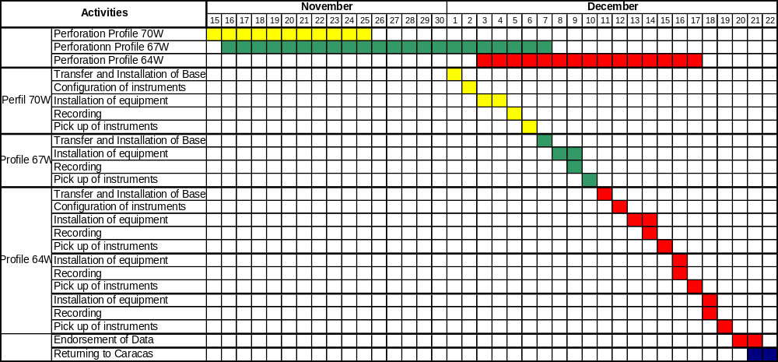
Shot times were pre-established according to TEXAN recording windows (Tables 6 and 7). Shots were shot at night (between 10 PM and 6 AM local time) to reduce environmental noise levels. Recording windows activation in shot points was controlled by installing a recorder at the shot point location.

Table 6. Shot windows during the VENCORP 2004 project, 70ºW and 67ºW profiles.
---------- RefTek 125 "Texan" Event Table ----------
File: 70W
File format: UNIX
Created by: txnetm, Version 2001.320 (PIC)
System time: 2004:337:23:03:45

Title: event file for 70W and 67W

Checked by: ______________________________
(PI signature)
Actions Meaning Parameters
------- --------- --------------------------------
1 A/D Power Power state: 0 = Off, Else = On
2 A/D Sync Sample rate:
1 = 1000 5 = 125 9 = 25 D = 5
2 = 500 6 = 100 A = 20 E = 4
3 = 250 7 = 50 B = 10 F = 2
4 = 200 8 = 40 C = 8 G = 1
3 A/D Data Event state: 0 = Off, 1 = On
NOTE: Any line starting with a non-digit is a comment!

>>>>>>>> Session 1 <<<<<<<<
Sample rate: 250 sps
Event length: 100 sec
Event interval: 300 sec
Number of events: 96
Warmup starts at: 2004:340:01:54:50
First event at: 2004:340:01:59:50
Last event at: 2004:340:09:54:50
Shutdown at: 2004:340:09:56:31

>>>>>>>> Session 2 <<<<<<<<
Sample rate: 250 sps
Event length: 60 sec
Event interval: 300 sec
Number of events: 96
Warmup starts at: 2004:341:01:54:50
First event at: 2004:341:01:59:50
Last event at: 2004:341:09:54:50
Shutdown at: 2004:341:09:55:51

>>>>>>>> Session 3 <<<<<<<<
Sample rate: 250 sps
Event length: 100 sec
Event interval: 300 sec
Number of events: 96
Warmup starts at: 2004:344:01:54:50
First event at: 2004:344:01:59:50
Last event at: 2004:344:09:54:50
Shutdown at: 2004:344:09:56:31

>>>>>>>> Session 4 <<<<<<<<
Sample rate: 250 sps
Event length: 60 sec
Event interval: 300 sec
Number of events: 96
Warmup starts at: 2004:345:01:54:50
First event at: 2004:345:01:59:50
Last event at: 2004:345:09:54:50
Shutdown at: 2004:345:09:55:51

>>>>>>>> Session 5 <<<<<<<<
Sample rate: 250 sps
Event length: 60 sec
Event interval: 300 sec
Number of events: 96
Warmup starts at: 2004:346:01:54:50
First event at: 2004:346:01:59:50
Last event at: 2004:346:09:54:50
Shutdown at: 2004:346:09:55:51

Table 7. Shot windows during VENCORP project, 64ºW profile.
---------- RefTek 125 "Texan" Event Table ----------

File: 125_ETBL.TET
File format: MS-DOS
Created by: txnetm, Version 2001.320 (PIC)
System time: 2004:345:16:50:35

Title: Line 64W Caripe

Checked by: ______________________________
(PI signature)

Actions Meaning Parameters
------- --------- --------------------------------
1 A/D Power Power state: 0 = Off, Else = On
2 A/D Sync Sample rate:
1 = 1000 5 = 125 9 = 25 D = 5
2 = 500 6 = 100 A = 20 E = 4
3 = 250 7 = 50 B = 10 F = 2
4 = 200 8 = 40 C = 8 G = 1
3 A/D Data Event state: 0 = Off, 1 = On

NOTE: Any line starting with a non-digit is a comment!

>>>>>>>> Session 1 <<<<<<<<
Sample rate: 250 sps
Event length: 100 sec
Event interval: 300 sec
Number of events: 72
Warmup starts at: 2004:350:01:54:50
First event at: 2004:350:01:59:50
Last event at: 2004:350:07:54:50
Shutdown at: 2004:350:07:56:31

>>>>>>>> Session 2 <<<<<<<<
Sample rate: 250 sps
Event length: 60 sec
Event interval: 300 sec
Number of events: 72
Warmup starts at: 2004:351:01:54:50
First event at: 2004:351:01:59:50
Last event at: 2004:351:07:54:50
Shutdown at: 2004:351:07:55:51

>>>>>>>> Session 3 <<<<<<<<
Sample rate: 250 sps
Event length: 100 sec
Event interval: 300 sec
Number of events: 72
Warmup starts at: 2004:352:01:54:50
First event at: 2004:352:01:59:50
Last event at: 2004:352:07:54:50
Shutdown at: 2004:352:07:56:31

>>>>>>>> Session 4 <<<<<<<<
Sample rate: 250 sps
Event length: 60 sec
Event interval: 300 sec
Number of events: 72
Warmup starts at: 2004:353:01:54:50
First event at: 2004:353:01:59:50
Last event at: 2004:353:07:54:50
Shutdown at: 2004:353:07:55:51

>>>>>>>> Session 5 <<<<<<<<
Sample rate: 250 sps
Event length: 100 sec
Event interval: 300 sec
Number of events: 72
Warmup starts at: 2004:354:01:54:50
First event at: 2004:354:01:59:50
Last event at: 2004:354:07:54:50
Shutdown at: 2004:354:07:56:31

>>>>>>>> Session 6 <<<<<<<<
Sample rate: 250 sps
Event length: 60 sec
Event interval: 300 sec
Number of events: 72
Warmup starts at: 2004:355:01:54:50
First event at: 2004:355:01:59:50
Last event at: 2004:355:07:54:50
Shutdown at: 2004:355:07:55:51

2.4 Recording formats and data processing
Due to the particular characteristics of the instruments used, it was necessary to convert the recorded data from the native recording format (PASSCAL-SEGY) to SEG-Y format. The SEG-Y data was then imported to the format used by the SU processing package (Cohen and Stockwell, 1994).
The data was processed with UNIX routines provided by IRIS/PASSCAL Instrument Centre Inc., which, out of the individually recorded data in each TEXAN, isolate the events corresponding to each shot and convert them to SEG-Y format, from the original format: TRD.
The processing sequence applied to the data was as follows:
trdpeek: file checking for obvious problems, file corruption, data loss, etc.
trdcut: extraction of data windows corresponding to each shot.
clockcorr: correction of internal clocks synchronization problems.
125procc.sh: format conversion from TEXAN to SEG-Y format.
trdsegycnt.py: checks the existence of all SEG-Y files that should be created.
txn2segy: sorting of individual traces to shot gathers.
This processing sequence was entirely done by the technical staff of IRIS/PASSCAL Instrument Centre Inc (Pnina Miller), and raw data and shot gathers were sent to FUNVISIS in digital format (hard drive) for further processing.
3. RESULTS
After downloading the data acquired during the whole project, the seismic sections for each profile were obtained. After making a data backup, the traces were partially processed at FUNVISIS for format conversion, from original recording format (TRD) to standard processing format (SEG-Y).
Total raw data volume was of about 30 Gb, backup of this data was done in hard drives and DVD’s. To perform a first quality control on the traces, they were visualized with pql. Figures 16 and 17 show some traces corresponding to shots 24 and 30 of 64ºW profile respectively. Traces observed in figures 16 and 17 are raw traces without any processing applied, only the format change previously described. The impulses observed in each trace correspond to the P-wave first arrivals.

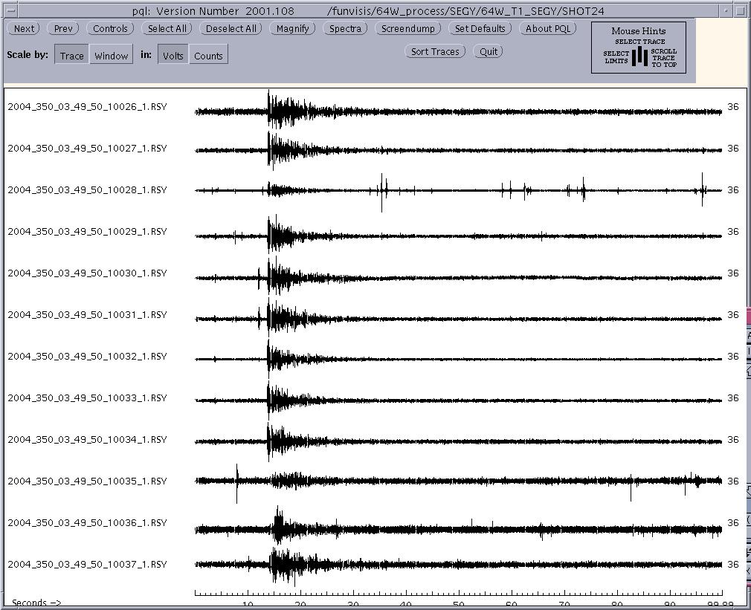
Figure 16. Traces belonging to Eastern profile, shot # 24. This traces has no processing applied, only format change from TRD format to SEG-Y format. (Generated with PQL Program, SU Utilities).
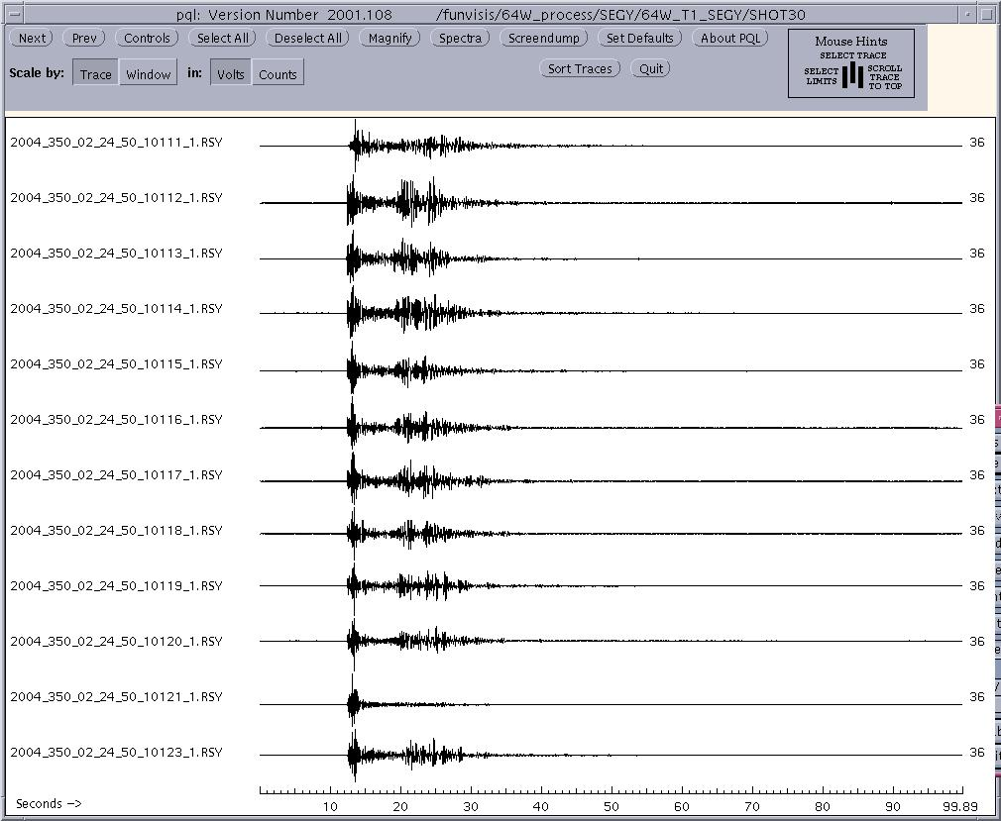
Figure 17. Traces belonging to Eastern profile, shot # 30. This traces has no processing applied, only format change from TRD format to SEG-Y format (Generated with PQL Program, SU Utilities).

After applying format conversion and sorting of data, the useful data (shot gathers and up hole geophones) amounts to a volume of about 4.5 Gb.
At this point, shot gathers were ready to be processed. Figure 18 shows the shot gathers of shot # 29 of 64ºW profile. Displayed are raw data, without any gaining or filtering applied. Some processing tests have been already applied to shot gathers: these tests include band-pass filtering and gain control. Figure 19 shows the same shot gather as Figure 18, but with band-pass butterworth filtering with cut frequencies of 0.5-1-40-60 Hz and gain control (Gain factor of t^tpow, tpow=1.0).

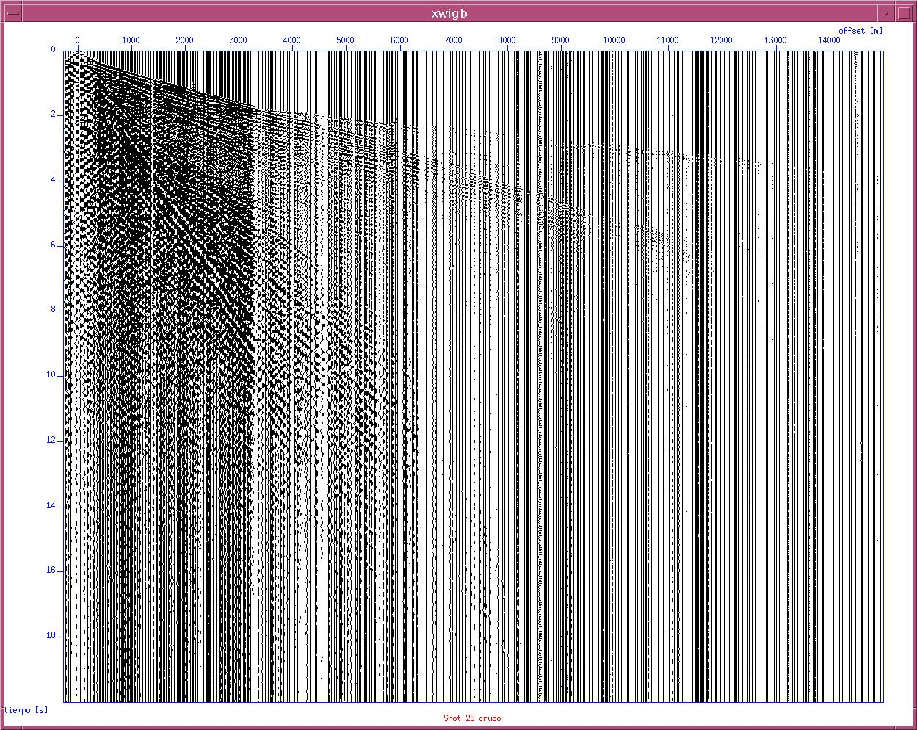
Figure 18. Raw data of shot # 29. Eastern profile.
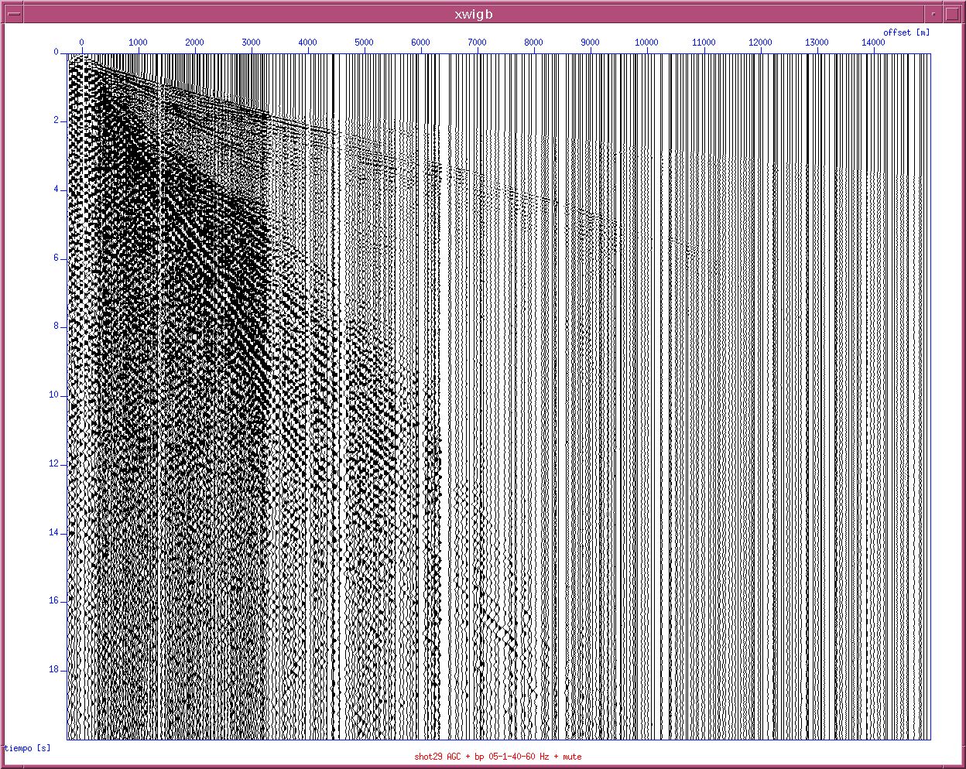
Figure 19. Eastern profile shot # 29 after band-pass filtering (0.5-1-40-60 Hz) and gain control (data mulitplied by t).
At the beginning of the field work, 768 recorders were active, but, because of equipment internal problems and high humidity levels in the field where the recorders were installed, the number of operative recorders was reduced to 762 by the end of the project. A complete data set will be given to IRIS/PASSCAL Data Management Centre, as it is indicated in the statutes of IRIS/PASSCAL Instrument Centre Inc. For experiments using equipment belonging to that organization.
The seismic data processing will be carried out during 2005, and by the end of the year it is expected to have a preliminary product for the interpretation of phases and determine the existing geological structures.

4. CONCLUSIONS
During the field work phase all shots were done according to the planned goals. Due to field conditions, some modifications had to be made to the acquisition parameters and execution of drilling and shooting, but this did not affect the project negatively. First data reviews show an excellent quality. Together with the April/May 2004, deep refraction recordings along the same profiles, it is expected to get a detailed image of crustal structures in the studied zones.

5. ACKNOWLEDGEMENTS
The realization of seismic measurements required, due to the characteristics of the area of study, the efforts of all the participants in the field measurements, who we thank for their work. We also thank the FUNVISIS staff involved in the preaparation of the experiment. We are specially thankful to IRIS/PASSCAL Instrument Centre Inc. for lending us 768 TEXAN seismic recorders and for their technical support (P. Miller, G. Chavez and G. Kaip) troughout the acquisition and pre-processing of the data. We thank Sridhar Anandakrishnana from Penn State University for loaning us the shot boxes.
We thank the property owners of the places where the shots took place and the local mayor’s offices for their support. Drilling was done by Cimientos Bya C.A., we are thankful for their effort, specially to PerfoStar’s team coordinated by G. Housepian. Shooting was done by CAVIM under the coordination of L. Pregitzer, to whom we are thankful. To the “Dirección Nacional de Protección Civil y Administración de Desastres” and the other state institutions that helped us to inform people about the experiment, our special thanks.

6. REFERENCES
Cohen, J., Stockwell, J., 1994. The SU User`s Manual. Center for Wave Phenomena, Colorado School of Mines. 126 pp.
Levander, A., Schmitz, M., Rendón, H. and the SE Caribbean Continental Dynamics Working Group, 2002. The SE Caribbean Continental Dynamics Project. XI Congreso Venezolano de Geofísica, Caracas, CD, 4 pp.
Levander, A., Mann, P., Avé Lallemant; H.G., Schmitz, M. and the BOLIVAR Study Group, 2004. BOLIVAR: The SE Caribbean Continental Dynamics Project. AGU Fall Meeting, San Francisco, abstract.
Schmitz, M., Rocabado, V., Cano, V., Ollarves, R., Sánchez, J., Bezada, M., Vieira, E., Ávila, J., Yañez, M., 2004a. Informe de Campo, Estudios Sísmicos en Tierra en el marco de los proyectos: “Estudio sobre la Interacción Corteza-Manto en la Zona Colisión Caribe-Suramérica (Proyecto SE - Caribe)”y GEODINOS - "Geodinamica reciente del límite norte de la placa Sudamericana" (Estudio de la litósfera mediante métodos geofísicos y geológicos), 22 pp.
Schmitz, M., Rocabado, V., Sánchez, J., Cano, V., Ollarves, R., Bezada, M., Ávila, J., Vieira, E., Yánez, M., Levander, A., Zelt, C. y “BOLIVAR active seismic working group”, 2004b. Observaciones en Tierra de Señales Sísmicas de Fuentes Marinas y Terrestres en el Norte de Venezuela. I Simposio Exploración y Estudios Integrados, Maturín, Venezuela, resúmen.
Input/Output, 2000. Owner’s Manual, MESA Advanced Acquisition Design Software. 150 pp.

ATTACHMENT A

TECHNICAL SPECIFICATIONS OF RECORDING INSTRUMENTS (TEXAN)

The modified Miniature Seismic Recorder (Texan), model 125A, is an important advancement in the seismology industry. The Texan's self-contained, compact design allows greater flexibility and the ability to easily integrate into system operations.
Specification Description
Model Number 125A-01
Size:  3.0” (76 mm) diameter x 7.7”(196 mm) lenght
Weight:  < 2.5 lb (1.1 kg) including 2 ”D” cell alkaline batteries
Watertight Integrity:  Water immersion without leaking in 2 meters water (48 hours). Operating temperature:  -40º C to +60º C
Power (Internal)
Batteries:  “D” cell alkaline, two required
Voltage:  1.6 VDC-3.0 VDC
Current:  50 micro-amp - sleep
 25 mA - standby
 125 mA operating
Power (External)
Voltage:  5 - 15 VDC
Current:  50 mA @ 5 V; 200 mA @ 5 V HiSpeed USB access
A/D Converter
Input Impedance:  2 Mohms, 0.2 uFd, differential
Common Mode Rejection:  Greater than 70 dB
Gain Selection:  Variable Gain x4 - x256 (by factor of 2)
Input Full Scale:  5 Vpp - 78.125 mV (by factor of 2)
Type: modulation, 256 KHz base rate, 24-bit output resolution
Sample Rates: 1000, 500, 250, 200, 125, 100, 50, 25 sps
Data Storage
Word Size:  24-bit two’s-complement (3 bytes per sample)
Storage Type:  HiSpeed USB Flash drive
Capacity:  128, 256, 512 Mbyte

Trigger for Crustal Studies
Description:  Recording windows are programmed by the host PC as a start
 and stop time
Time Trigger:  1000 trigger times may be programmed
Record Length:  A minimum of 1 second to a maximum time that will fill the data storage
Time Base
Frequency: 2.048 MHz, electronic control
Stability:  +/- 0.1 ppm from 0 o C to 50 o C; +/- 0.3 ppm from -20º C to 0º C
Connectors
Seismometer:  U229/U
Power I/O:  U77/U
Recording Format
Format:  PASSCAL Recording Format
HOST INTERFACE  USB2.0 for command/control, data upload, firmware download
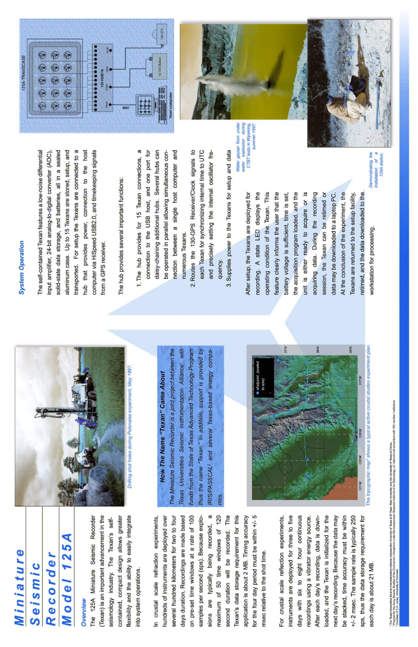
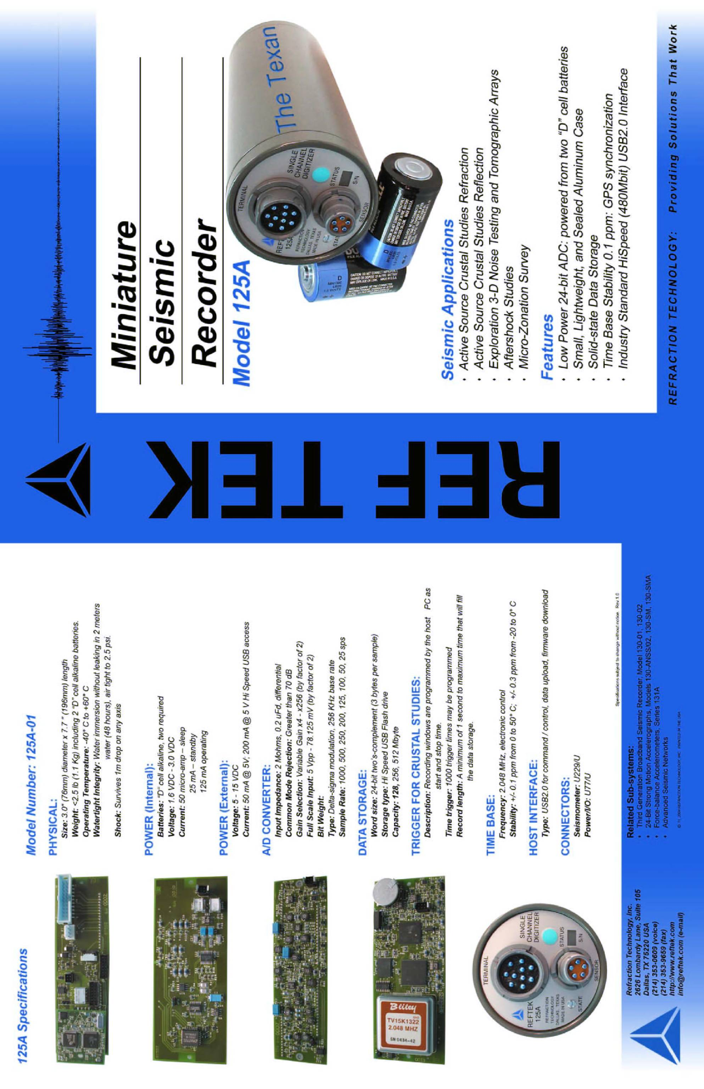

ATTACHMENT B

TECHNICAL SPECIFICATIONS OF SEISMIC INITIATORS (SHOT BOXES)

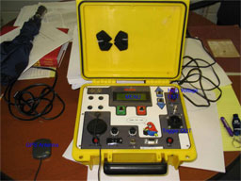
Penn State Seismic Shot Box
The Penn State GPS-based shot box is a self-contained system for initiating seismic explosives as well as triggering a seismic recorder. The device is designed to generate a 5V TTL pulse at a shot-instant determined by the internal GPS clock. Thus, two of these devices separated by kilometers can synchronize the shot-instant and the recording system's zero-time. The shot-instant accuracy is better than 100 ns, which is adequate for seismic applications.
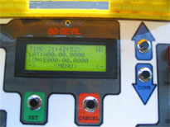
The shot box has an internal battery that will operate the system for 1-2 hours continuously, though in practice the unit should be switched off until it is needed. In general the GPS will lock within 15 to 30 seconds, so there is little delay associated with turning on the system before a shot. An external 12V battery can be plugged into the "12C DC" socket with the provided cable to allow the unit to run for a longer time. Do not operate the seismic recorder with the same battery as is used for the seismic recorder. The internal battery can be charged from a 110 V AC (United States power standard) source using the supplied power cord.

Theory of Operation
An internal GPS board and the external GPS antenna are used to determine the location of the unit and the accurate current time. This current time is the same for all GPS units (with an accuraccy of 100ns) and can be used to synchronize multiple recorders or recorders and shooters. The GPS antenna should be placed high up and to the side so that the user does not cover it. The display will indicate either "ND" for No Data, if there is no GPS lock, "2D" for poor GPS lock and "3D" for good GPS lock. The display will also show coordinates and time, which the user should log in a notebook.
The menu is used to set the INTERVAL TIME which determines the acceptable shot-instants. The interval time can be set to one of a number of values between 5 seconds and 12hrs. The most useful are probably 1 or 2 minutes. The acceptable shot instants would be at the next round time interval. What that means is that, for example, if the interval time = 1 minute, then the next acceptable shot-instant would be when time equals a rounded multiple of 1 minute (i.e, 14:01, 14:02, 14:03...). If the time interval is 5 minutes, then the shot instants are 14:00, 14:05, 14:10, etc.
The actual shot instant is determined by the user by selecting the COUNT DOWN menu item. When the user selects count down, the screen will display the number of seconds until the next acceptable shot instant. When that time arrives, a 5v TTL pulse will be output on the TRIGGER OUT connector (the large round 16-pin connector with 2 pins used).
button will move to the previous menu.

Triggering
Trigger OUT: Along the right side is a black circular 16-pin connector (with only 2 pins used). This is the 5V TTL Out used to trigger the seismic recorder. If the user chooses "COUNT DOWN" from the menu, a trigger will be generated across these 2 pins on the next shot-instant and all subsequent shot instants until the user presses "CANCEL". The included cable connects between this connector and 3-pin metal Cannon connector that is used for trigger input on the Geometrics Stratavisor and Geode recorders.
The user can set a 3-digit "Site Name" using the menu. If the "Log ON" switch is set, the shot instant and the site name is logged internally, along with the GPS-determined position and the quality of the GPS lock. These data can be downloaded to a PC using the serial connection.

High Voltage Output
Only licensed, trained, and authorized explosives handlers should use this option of the shot box.
HV Out at top right: The RED and BLACK binding posts at top right are for the HIGH VOLTAGE OUTPUT. Licensed and authorized explosives technicians can connect the 2 leads of a blasting cap to these binding posts. If the unit is charged and armed when the shot-instant arrrives, then a 400V pulse (approximately 10ms long) will be generated across these two terminals.
The HV out terminals (red and black) are electrically shorted to each other to prevent misfires until the ARM button is pressed. Nevertheless, the user should exercise all appropriate caution necessary while working with explosives.
For this HV OUT pulse to work, the user must first press the "HV CHARGE" button on the bottom left, and wait for the menu to display "HV Charged". Then the user should press the "ARM" button while continuing to hold the HV CHARGE button. Both buttons should be held until the shot-instant has passed. Releasing either button prior to the shot instant will disable the shot. Releasing the HV Charge button prior to the shot will also discharge the High Voltage capacitors safely.
The blasting cap continuity can be tested with this device. Choosing the "Cap Test" option on the menu will measure the resistance of the blasting cap using a low-current measurement technique.

Extras
The BNC connector marked "GEOPHONE" can be used to connect an uphole geophone. The unit will measure the time from the shot instant to the time that the uphole geophone is displaced. This has not been widely tested.

