TIWI Detail MEQ Installation

Daily Report: 21 – 22 February 2001
________________________________________________________________

To : Jim Stimac Albert Buban
Gregg Nordquist Frankie Sugiaman

Ken Williamson

CC : Glenn Melosh

Fr. : Doddy Astra
Al Protacio
Bob Greschke

Re : Daily Report # 4

Day7 (Wednesday, 21 February 2001) – First earthquake detected
Conducted telephone conversation with Gregg regarding collocate MEQ station, GPS clock for MEQ, average GPS position from the antenna, and proposed location of station #2 since the original station location is not safe due to security reason.

Bob fixed the cable grounding for Sun computer system, and he also could fix the problem with the Restek # 7601 by jumper the input terminal.

Installed Kababihan (station #1). The station located in the west part of the field. It takes about 30-35 minutes drive from PGI camp and it should be done with four- wheel drive vehicle due to steep dirt road. In the afternoon, Zeus looked for the proposed site #2, which will locate about 500 m or 1000 m west of station # 1 to get a coverage at NW part of Mat-3.

We showed several earthquakes in the Unix station but there is no further processing allow in the Unix system. Some of the events were considered as local events due to the arrival time of P and S wave is smaller. Those events were occurred on 18 February midnight and we recorded the events with 4 stations that we reviewed. The images are shown below in JPG files using digital camera because we could not dump the signal.

The data transfer processes from FCS disk into Unix system were done using several stages of Unix command. Extra and careful procedures (list of unix command) should be prepared to conduct the task especially for inexperience trainee with Unix system. We are planning to make a simple procedure to do this task. Fortunately, Al understands the Unix command and he can resolve the problem while Bob is leaving the field.

Conversion process from raw data into SEGY format is straightforward using one simple command. It is recommended that PGI save the data in SEGY format because it is a standard format for future use. Is it necessary to do this? Finally, we are planning to contact Ernie to get some procedure of data labeling.

Day8 (Thursday, 22 February, 2001)
Five stations were downloaded Cararayan, Nagas, Buyong, Luminko and Kap15. The last three stations above were installed on Monday (19 February,2001), and it showed more or less 60% capacity of Reftek disk (1 Mb capacity). We skipped Lungib stations because we run out of time. At Cararayan, we replaced the problem with Reftek# 7442 with Reftek # 7601. The Reftek #7442 possibly had a problem with power cable connector while we shorted B connector to allow the disk spinning during the download process.

We succesfully installed the 12th station this afternoon. It located at Manitonito (station #1) +/- 400 m NW of Q-5 well pad (original proposed location). It takes about 35-40 minutes walk from the bridge over the Bariis river in the main road along the Lagonoy Gulf.

Others – schedule
Al is going back Manila on the week-end (23-25 February). He is planning to go back to the field on 26 February 2001 while Doddy and Bob will handle the MEQ system. Al is going to be stayed in the field on the week end of (2-4 March) following the infield injection started on 28 February 2001.

Bob and Doddy plan to go back to Manila on 2 –3 March, and Bob is making a reservation on Sunday (4 March) to fly back to the USA. While Doddy is going back to Jakarta on Saturday, 3 March 2001.

Station Installation and Coordinates

Station name | North | East | Elevation | Remark
Cararayan | 572975 | 1489520 | 20 m | End of road
Kap-15 | 568707 | 1489625 | 211 m | Well pad K-15
Nagas | 572072 | 1485830 | 127 m | Well pad N-69
Naga | 570573 | 1490170 | 42 m | +/- 10’ walk
Matalibong | 569074 | 1491065 | 112 m | +/- 5’ walk
Joroan | 567567 | 1492057 | 100 m | Steep trail; +/- 5’ walk
Biyong | 569386 | 1487605 | 178 m | Well pad Nag-25
Luminko | 567089 | 1488069 | 465 m | Well pad K-24
Lungib | 565966 | 1488214 | 565 m | Proposed pad O-13
Manibtib | 567561 | 1489697 | 299 m | 300 m west of M-3
Kababihan | 565563 | 1489712 | 594 m | Half way to Q-5
Manitonito | 566802 | 1490957 | 210 m | 40’ walk from the main road & Bariis bridge

Station Identification & Instrumentation

Station name | Number | Seismometer | Digitizer | Installation | Remark
Cararayan | 10 | G300 | 7442 | 16 Feb. | Change w/ 7601 on 22 February
Kap-15 | 12 | G363 | 7601 | 16 Feb. | Change w/ 7619 on 19 February
Nagas | 4 | G187 | 7331 | 16 Feb.
Naga | 9 | G155 | 7618 | 17 Feb.
Matalibong | 8 | G174 | 7597 | 17 Feb.
Joroan | 7 | G046 | 7591 | 17 Feb.
Biyong | 11 | G190 | 7284 | 19 Feb.
Luminko | 5 | G101 | 7303 | 19 Feb.
Lungib | 3 | G156 | 7297 | 19 Feb.
Manibtib | 6 | G171 | 7328 | 20 Feb.
Kababihan | 1 | G096 | 7285 | 21 Feb.
Manitonito | 2 | G372 | 7288 | 22 Feb.

Earthquake signal from Unix Sun Computer

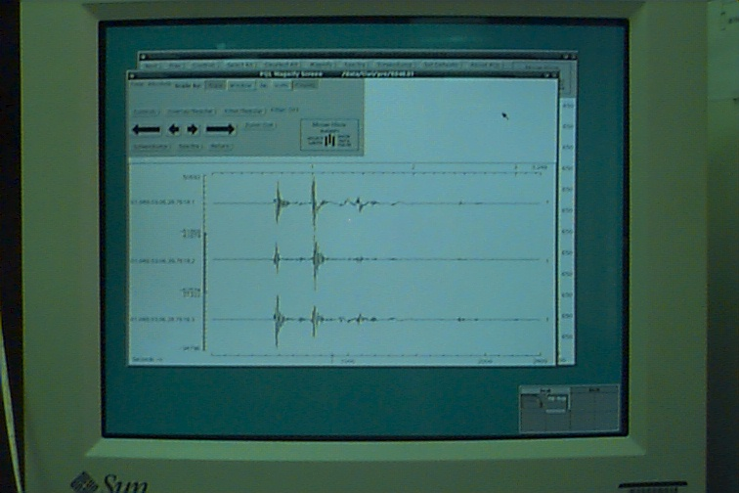

One of the local events identified from 3 stations occurred on 49,14:47 (day 49 or 18 February and 14:47 GMT). The image showed above is only come from one station with three channels.

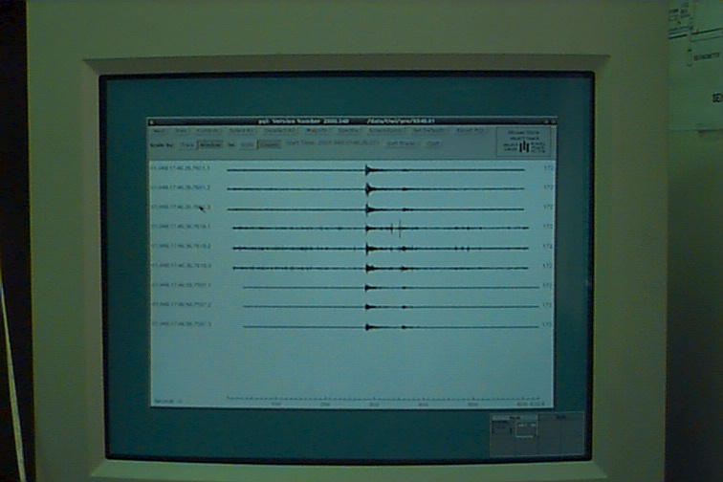
The regional events on 49, 13:36 recorded in four stations, but we could only shows in three stations. The fourth station could not display because it is appear in the next screen.

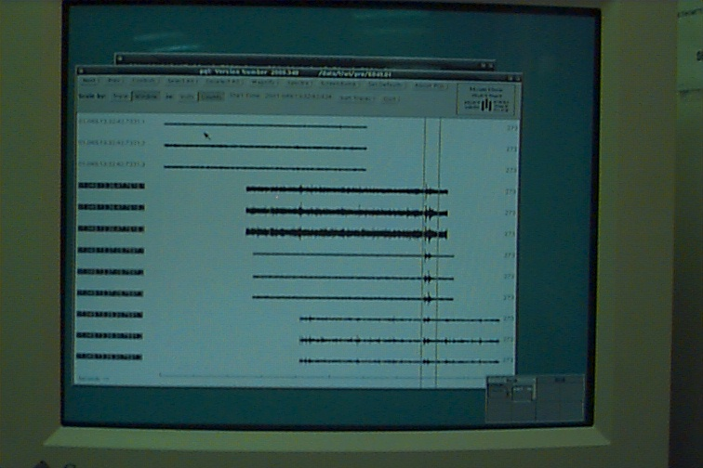

This is a display of the events in Unix computer, the parallel shows the events that we zoom below. It takes time to identify the events because all data were dump into one directory with Reftek series and time as identifier. Each line above is 2400 seconds. The data inside the parallel line were shown below.

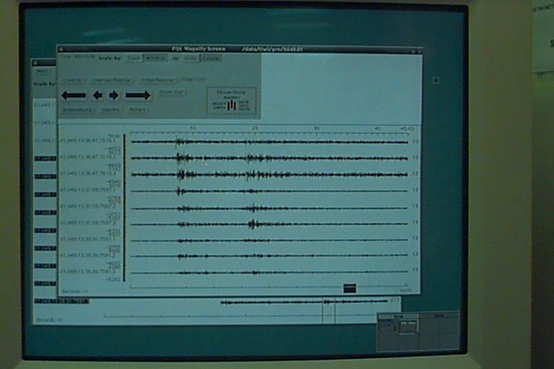

One of further plan is try to review the regional events to check the appearance of the events in 12 field stations. We got information (from the website) regarding the regional events located in South China Sea (more or less 400 miles north of our array) on 19 February but we did not install all of the stations yet.

