Mirror Lake Project

The seismic data acquisition equipment was initially borrowed from PASSCAL, IRIS to study the Keweenaw fault located at the Keweenaw county, MI. However, no data was collected for that project.
In August 2017, R. Askari from the Department of Geological and Mining Engineering and Sciences, Michigan Technological University used the borrowed equipment for another project at the FSE well field, Mirror Lake, Grafton County, NH (Figure 1). The major objective of the acquisition was to study seismic Radial anisotropy. The acquisition included three lines of acquisition close to wells FES8. FSE10, FSE13 (Figure 1). A Betsy gun (vertical component) and sledgehammer (transverse component) were two sources used for the line close to FSEL10 were whereas for the lines close to FSE8 and FSE13, the Betsy gun was used for both vertical and transverse component.
For all acquisitions, 24 3C 4.5 Hz geophones with two recording Geode systems were used. Although the geophones were 3C, the data were recorded on the vertical and transverse components to record the Rayleigh and Love waves. The geophone interval was 3.5 m, and the total array length was 80.5 m. The total recording times were 2 s for FSE8 and FSE13, and 0.5 s for FSE10 respectively. The sampling time was 0.125 s. The minimum source-receiver offset was 4 m for all acquisitions.
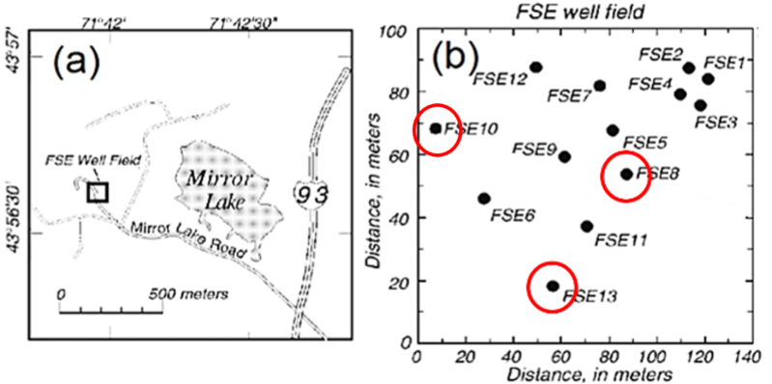
Figure1: (a) FSE Well Field with respect to Mirror Lake, and (b) locations of the wells. Modified after Day-Lewis et al. (2006). Three lines of acquisition were deployed close to wells FSE8, FSE10 and FSE13 (highlighted by red circles).
Data:
FSE10_V.segy: The data recorded on the vertical component of the line FSE10. Source: Betsy gun
FSE10_T.segy: The data recorded on the transverse component of the line FSE10. Source. Sledge Hammer
FSE8.segy: The data recorded on the vertical (traces 1-24) and transverse (traces 25-48) components of the line FSE8. Source: Betsy gun
FSE13.segy: The data recorded on the vertical (traces 1-24) and transverse (traces 25-48) components of the line FSE13. Source: Betsy gun
If you have any question about the data, please contact Roohollah Askari (raskari@mtu.edu).

