Investigation of seismic radial anisotropy of a carbonate bedrock at Hannahville Indian Community, Menominee County, MI

PI: Radwin Askari
Objective
Fractures are crucial to characterize fluid flow and solute transport in the geological environments, and estimate the hydraulic properties of fractured-rock formations. Seismic radial anisotropy can be used as a strong attribute for forecasting fractures. In this study, we studies fractures of a carbonate bedrock via seismic radial anisotropy.
Site of Study
The site of study is located at the Hannahville Indian Community, Menominee County, Michigan (hereafter HIC) in which four seismic lines were acquired (Figure 1 and Table 1). We utilized 24 3C 4.5 Hz geophones with two recording Geode systems. Although the geophones were 3C, we only recorded data on the vertical and transverse components to record the Rayleigh and Love waves respectively. We also used a Betsy M3 Seisgun that is a barrel positioned in a small hole (about 0.3 m depth), backfilled with wet soil to generate the seismic waves. The Betsy gun is a strong and repeatable seismic source that fires 8 ga industrial blanks. The source was positioned 5 m away from the seismic lines of acquisition. All the data were recorded for 2 s with a 0.125 ms sample rate.
Data
We have archived eight Segy file. The line numbers (Lines 1-4) and corresponding geophone components (either vertical or transverse) have been specified in the file names (e.g., “Line1_transverse.sgy”).
Publications
The results of the above studies have been published in the following papers in which we acknowledged the Incorporated Research Institutions for Seismology (IRIS) Portable Array Seismic Studies of the Continental Lithosphere (PASSCAL).
- Jeng, J. Y., R. Askari, S. Chatterjee, 2020, Correlation of Near Surface Fractures with Seismic Radial Anisotropy: An Approach for Near Surface Fracture Identification: Journal of Applied Geophysics ,173, 103925.
- Jeng, J. Y., R. Askari, S. Chatterjee, 2019, Correlation of fractures with seismic radial anisotropy in two metamorphic-igneous and sedimentary bedrocks: SEG Technical Program Expanded Abstracts 2019, 2984-2989.

Table 1. Details of data acquisition for each line
Name | Location | Nearest well | Geophone interval (m) | Total length (m)
Line 1 | Hannahville, MI | Community 1 and 2 | 3.5 | 80.5
Line 2 | Hannahville, MI | Community 1 and 2 | 4 | 92
Line 3 | Hannahville, MI | Casino 5 (unlogged) | 3.5 | 80.5
Line 4 | Hannahville, MI | Casino 5 (unlogged) | 4 | 92
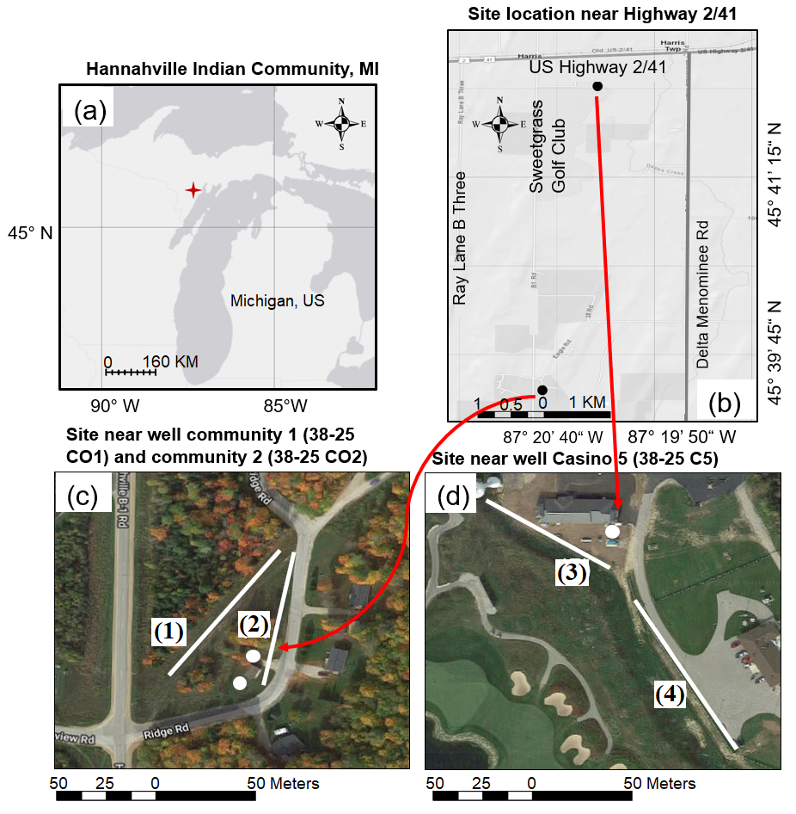
Figure 1. The site of study at HIC. (a) Site location, (b) two acquisition sites, the locations are about 3.5 miles apart from each other. (c) Line 1 and Line 2 near well community 1 and community 2 (white dots) located at 45°39'27"N, 87°20'44"W. (d) Line 3 and Line 4 near unlogged well Casino 5 (white dot) located at 45°41'58"N, 87°20'18"W.

