Description of 2018-2019 Dry Alluvium Geology (DAG) 1,2, and 3 Gradiometry Data for Release

Thursday, May 18, 2023

Robert Abbott (ORG-8911) reabbot@sandia.gov
Daniel Wells (ORG-8911) dewells@sandia.gov

Table Of Contents

Data Release Information 3
Data Information 3
Installation 3
Data Collection 4
Contents of data set 4
Data Access 5
Data Transfer and License 5
Tables 5
Appendix 1 5

Data Release Information
Robert Abbott and Daniel Wells ( ORG 8911 ) would like to release seismic gradiometry data collected at the Nevada National Security Site over the course of three buried chemical explosion tests (DAG 1-3) during 2018 and 2019 to a public data repository. The data is part of the seismic data recorded for the Source Physics Experiment (SPE) Phase II. We will contribute the data to the IRIS/earthscope seismic data repository. The dataset consists of a set of 42, 30-second-long seismic traces for each of two gradiometers for each of 3 explosive tests, compiled into two separate files per test. These data encompass a continuation the release of SPE Phase II data, the majority of which is already available at IRIS/earthscope at the following URLs: https://ds.iris.edu/mda/21-020/, https://ds.iris.edu/mda/21-021/, https://ds.iris.edu/mda/21-022/, and https://ds.iris.edu/mda/21-023/.

Data Information

Installation
The buried chemical explosions were not repeated due to inelastic, non-linear deformation. Each explosion was at a different depth and size. (Table 1). The two gradiometers which recorded the seismic waves for each explosion were deployed 1.5 km ENE (Gradiometer Array East, GAE) and NNW (Gradiometer Array North, GAN) from the surface ground zero of the explosions ( Figure 1 ). Each gradiometer consisted of 14 Geospace Technologies GS-11D 4.5 Hz, three-component geophones recording to RefTek RT130 data loggers at a sample rate of 500 Hz, where 13 of the 14 geophones were arranged circularly around the 14th geophone in the center.

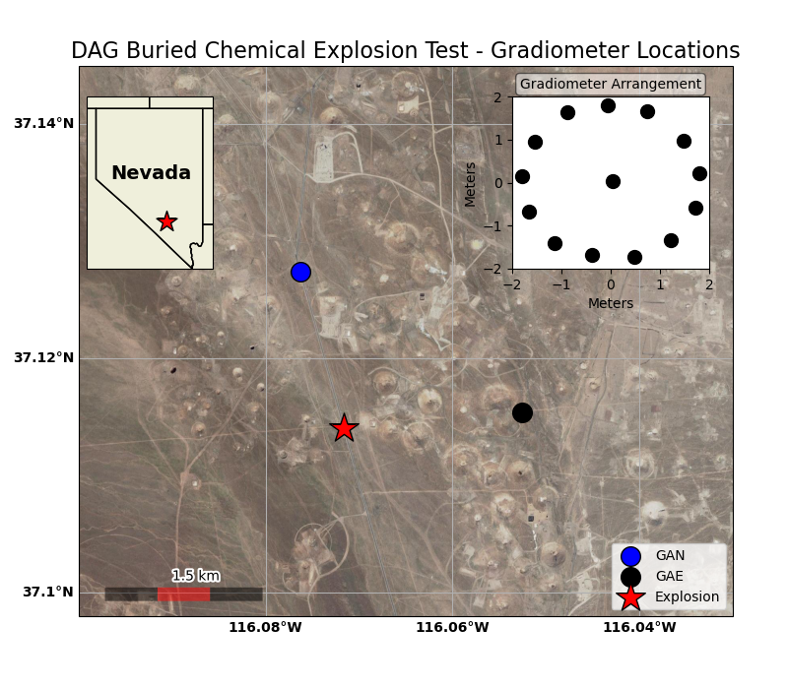
Figure 1: DAG 1-3 Gradiometer installation arrangement. The inset in the upper right of the figure shows the arrangement of geophones in each gradiometer.

Data Collection
Data were collected at 500 samples/second (sps) for 30 seconds starting at the explosion. The unit of measure was in millivolts. The data in this release has been corrected for the instrument response, with the final units being in nm/s. The data are prepared in the MATLAB .mat file format and contain appropriate metadata, including exact geophone location.

Contents of data set
The data set to be released consists of:
- 252 (14 geophones x 3 components x 2 gradiometers x 3 tests) 30-second seismic recordings (Table 2)
- Two Microsoft Excel files (.xlsx) with the coordinates, in latitude/longitude format and northing/easting format, of the geophones of both gradiometers and the source.
- One README.txt file that describes the data (Appendix 1)
- The total data volume is 58.3 MB.

Data Access
The collection of seismic data from the DAG tests is available from:
smb://snl/Collaborative/GeophysicsDept/GeophysicsDept/Projects/SPE/WELLS_2020/DATA

The data can be viewed via MATLAB or any module capable of reading MATLAB .mat data files. In MATLAB, the command load('/PATH_TO_DATA/DAG1/gae_data.mat') will load the GAE data for DAG1.

Data Transfer and License
The date will be uploaded to IRIS/earthscope seismic data repository and will have a creative commons CC-BY license attached. This license allows re-users to distribute, remix, adapt, and build upon the material in any medium or format, so long as attribution is given to Sandia National Laboratories.

Tables

Test | Date | Depth (m) | Explosion size (tons TNT equiv.) | SDOB (m/kt^{1/3})
DAG-1 | 20 July, 2018 | 385 | 0.91 | 3156
DAG-2 | 19 Dec., 2018 | 300 | 51 | 642
DAG-3 | 27 Apr. 2019 | 150 | 0.91 | 1229
Table 1: The DAG experimental schedule. The date, depth, yield and scaled depth of burial (SDOB) for each of the DAG explosions with associated gradiometric data.

Appendix 1

Readme.txt
Thursday, May 18, 2023

The data are arranged into 3 subfolders, DAG1, DAG2, and DAG3. Each subfolder contains a file for the GAE and GAN data in MATLAB .mat data format.

The data have been deconvolved with the instrument response such that the units are velocity in nm/s.

Each data file contains the 14 associated seismic traces for each component of vertical, north, and east (traces), the sampling interval (dt), the data units (nm/s), and the date and time of the recording (nzdttm, kzdate, kztime), the names of each geophone/station (statname), and the station position in easting (east) and northing (north).

This research was funded by the U.S. Department of Energy. Sandia National Laboratories is a multimission laboratory managed and operated by National Technology and Engineering Solutions of Sandia, LLC, a wholly owned subsidiary of Honeywell International, Inc., for the U.S. Department of Energy’s National Nuclear Security Administration under contract DE-NA-0003525. The views expressed in the article do not necessarily represent the views of the U.S. Department of Energy or the United States Government.

Copyright 2023 National Technology & Engineering Solutions of Sandia, LLC (NTESS). Under the terms of Contract DE-NA0003525 with NTESS, the U.S. Government retains certain rights in this software.

For more information contact
Robert Abbott, reabbot@sandia.gov

