RIFSIS Project

RIFSIS project is aimed at obtaining the crustal structure beneath the Rif Cordillera (North Morocco) in terms of seismic crustal velocity models along two mostly orthogonal wide-angle seismic reflection (WA) transects crossing the Rif in the NS and EW directions. This geometry is aimed to acquire seismic data over the zone where a significant low Bouguer anomaly has been previously identified by Hildenbrand et al. (1988). The Bouguer gravity anomaly database maintained by the International
Gravimetric Bureau (BGI; http://bgi.omp.obs-mip.fr/data-products/Grids-andmodels/ wgm2012) shows that a very prominent -150 mGal gravity low is located to the south of the Internal Zones of the Rif, over the External Zones and the western region of the Gharb foreland basin (Figure 1). The gravity anomaly increases towards the oceanic areas, reaching maximum values of up to 250 mGal over the Atlantic and from 50 to 150 mGal in the Alboran Basin and its transition towards the oceanic Algerian basin. The new seismic models derived in this chapter from our data will be also converted to density and the predicted Bouguer anomaly compared with the observed one from BGI database

In October 2011, we acquired one 330 km-long and another 430 km-long wide-angle seismic reflection profiles oriented, approximately, EW and NS (Figure 2). The profile directions were designed to approximate the overall Rif strike and dip directions and conform to major and minor axes of the elliptical Bouguer anomaly pattern (Figure 1). The EW transect extends across the Rif orogen from the Gharb Basin to the Algerian border. The NS line extended 70 km into the Iberian Peninsula and over 300 km within Morocco to the Mid-Atlas, overlapping with the SIMA seismic wide-angle transect in the Atlas Mountains (Ayarza et al., 2014). Jointly, SIMA and the NS RIFSIS profile extend 700 km-long from the northern Sahara desert into southernmost Iberia. The Iberian portion of the NS RIFSIS profile is not reversed as there were no source points in Iberia.

Each of the 5 sources consisted of 1Tn of chemical explosives in 2 boreholes and
were recorded by 845 digital seismographs with one-component 4.5 Hz geophones
(Reftek RF125 IRIS-PASSCAL Texans). The average receiver spacing was 750 m.
Shots R1 through R3 where located along the NS line, and R3-R5 were along the EW line. Shot R3 is at the intersection of the two profiles. All shots were recorded by all the stations producing fan shots for 3-D control on deep structure (Carbonell et al., 2014). Up to 402 seismographs were deployed along the EW profile and 443 along the NS profile including 35 in Spain. The signal-to-noise ratio in our data is within the usual range for this kind of experiments, providing a reasonably good overall data quality although shot R1 near Gibraltar has low signal-to-noise ratio at offsets larger than 80 km.

The wide-angle seismic data of the two RIFSIS profiles were processed including
amplitude recovery, frequency filtering using a classical band-pass Butterworth filter (3-10 Hz) and phase enhancement by a lateral phase coherency filter (Schimmel and Gallart, 2007). This latter procedure allows a better identification of weak seismic arrivals at large offsets, as it was presented previously in Chapter 3 (Figure 3.8). The coherency filter was especially valuable in the case of shot R1 allowing us to identify arrivals from 80 to 140 km offsets. A total of 2297 picks were obtained, 1154 from the NS profile and 1143 from the EW.

P-wave velocity-depth models were derived by forward modeling travel-times of
diving and reflected waves using RAYINVR software (Zelt and Smith, 1992).
Additional geological and geophysical constraints were considered in the modeling
procedure where available. For the NS profile we start from the velocity-depth model presented by Ayarza et al. (2014) from the interpretation of the SIMA profile, crossing the Atlas and partially overlapping our profile. At the northern edge, the seismic models by Medialdea et al. (1986) were also taken into consideration. Different geological results compiled in Chalouan et al. (2008) have been used to get an initial estimation of the geometry and velocities in the uppermost sedimentary layers. Identified seismic phases (shown and labeled in the figures) follow the conventional nomenclature: Ps and Pg denote refractions through the sedimentary cover and the basement, respectively; PiP, PcP and PmP stand for P to P reflections produced at the top of the middle crust, top of the lower crust and Moho discontinuity, respectively; and P1, P1P identify refraction and reflection events on a locally limited sedimentary layer. Because the shot spacing is rather large, varying from about 80 to 140 km, phases from the sedimentary layers and the upper crust generally are not reversed, whereas the deeper phases Pg, PcP, and PmP generally are. Despite careful inspection and analysis of the filtered and unfiltered record sections, I have not found clear evidences of arrivals displaying a convincing lateral correlation and which could be attributed to lower crustal or Moho refracted phases. Hence, I have preferred to use only the well identified reflected phases as the observations for modeling. In the following sections I describe: (1) the quality of the data; (2) the parts of the models that are well constrained; and (3) the travel-time picks and fit. Estimated uncertainties of the travel-times picks are, on average 0.05 s for Ps, 0.1 s for Pg and between 0.1 and 0.2 s for reflected phases PiP, PcP and PmP. The derived P-wave velocity models reproduce the picked travel-time branches with a very good agreement. The observed travel-time misfits (usually less than 0.15 s) are reasonable in view of contributing factors such as the acquisition geometry, local oscillations on topography, outcropping lithologies, etc.

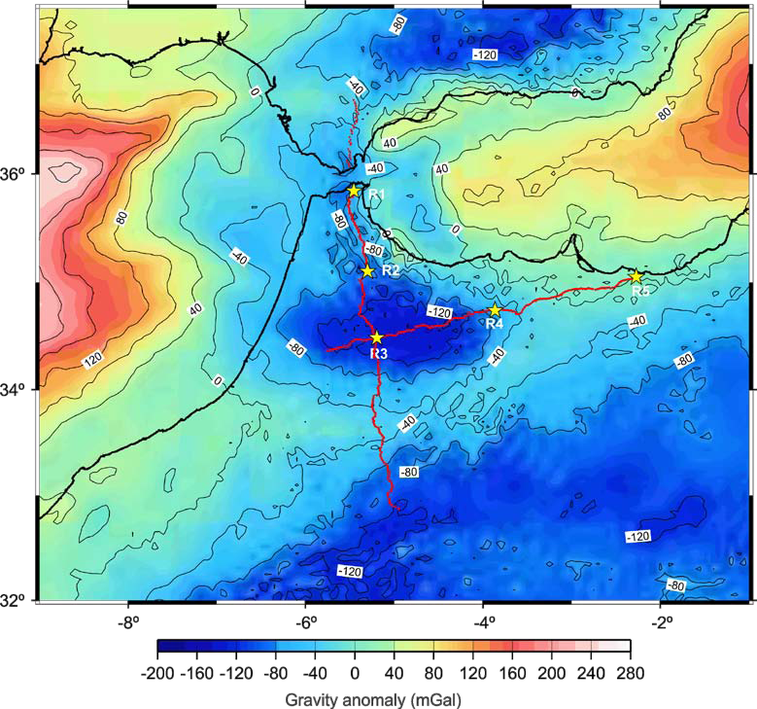
Figure 1: Gravity anomaly contour map of the southern Iberian Peninsula and
northern Morocco. Bouguer anomalies have been extracted from the BGI (Bureau
Gravimétrique International, http://bgi.obs-mip.fr). The contour interval is 40 mGal.
The red lines indicate the location of the seismic profiles. Note that the wide-angle
transects closely follow the axes of the minimum of the Bouguer anomaly (-150 mGal)
beneath the Rif domain.

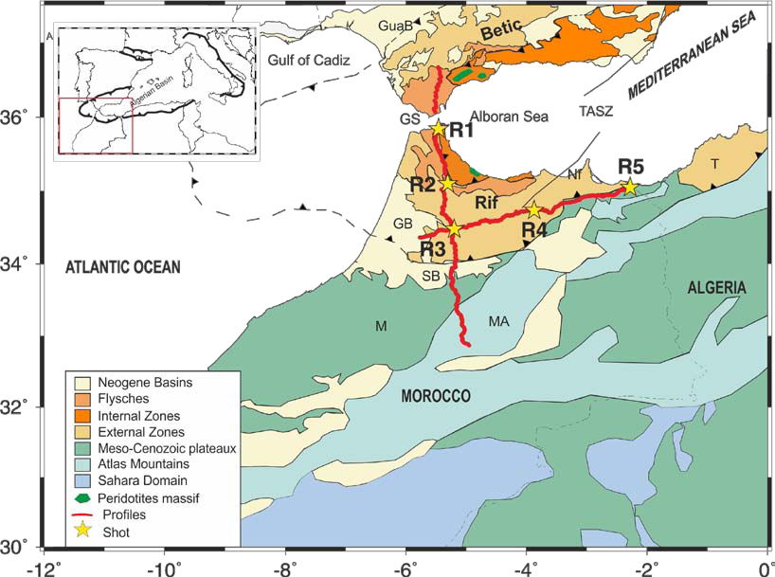
Figure 2: Map of Southern Iberia and Northern Morocco with the location of seismic
wide-angle profiles acquired through the RIFSIS project (in red, the digital stations; stars, the source points) and simplified geology of the study area. The major tectonic domains and
boundaries are indicated. GB: Gharb Basin; GuaB: Guadalquivir Basin; GS: Gibraltar Strait; M: Meseta; MA: Middle Atlas; Nf: Nekkor fault; SB: Saïss Basin; T: Tell Mountain TASZ: Trans-Alboran Shear Zone. The dashed line represents the geometry of the Gibraltar Arc. The inset shows location within the Euro-Mediterranean domain and includes an outline of the Westernmost Mediterranean Alpine Belt.

