Data Report for ZV 2021
Insights into the subsurface architecture of the Monahans Dune Field, west Texas

2 November 2022

Further details can be found in Spears, B., 2022. “Seismic Site Characterization via Joint Modeling of Horizontal-to-Vertical Spectral Ratios and Surface Wave Dispersion: Developing and Validating a Geophysical Tool for Deciphering Quaternary Stratigraphic Architecture of the Monahans Dune Field, West Texas”, M.S. Thesis, Baylor University, Waco, TX
Author: Brady Spears and Jay Pulliam
Mentors: Jay Pulliam and Steven L. Forman
Field Party: Jay Pulliam, John Dunbar, Brady Spears, Yashwant Soni, Debajeet Barman, Ben Sadler, Aicha Coulibaly (all of Baylor University)

Details of the data acquisition effort can be found in the section entitled “Field and Data Methods”.

ABSTRACT
Quaternary deposition for the Monahans dune system is reflected in its stratigraphic architecture through various periods of dune accretion, stabilization, and erosion as well as buried clay, carbonate-rich soils, and playa lake deposits. The complex and discontinuous stratigraphy of Monahans is difficult to capture without extensive borehole investigation. Shallow seismic techniques using Horizontal-to-Vertical Spectral Ratios (HVSR) and surface wave dispersion offer a cost-effective alternative to deciphering Quaternary architecture, but inverse models are subject to ambiguity and nonuniqueness. We jointly model HVSR and surface wave phase velocity dispersion measurements via global optimization to produce best-fit 1D shear wave velocity models for the interpretation of geologic structure and use statistical tools, including posterior probability distributions and parameter correlations, to demonstrate that joint modeling has the potential to impose stronger constraints on model parameters than modeling either seismic dataset alone.

LIST OF FIGURES
Figure 1.1. a) Location of the Monahans AT2 Dune Field in relation to other large Quaternary dune systems of the Great High Plains. b) Aerial photograph of the Monahans AT2 Dune Field
Figure 1.2. a) Three-dimensional Geosoft model of the dune field, constructed from stratigraphic analysis of borehole measurements. b) Location of borehole measurements. c) Basal red-clay paleosurface as interpolated from borehole measurements
Figure 2.1.1. Location of Line A in relation to the dune field
Figure 2.1.2. Locations of Lines B, C, D, E, F, H, I, and J .
Figure 2.1.3. Location of Line G in relation to the dune field
Figure 2.2.1. HVSR curve computed for Line A station A080
Figure 2.2.2. HVSR curve computed for Line G station G030
Figure 2.3.1. Frequency-phase velocity amplitude spectrum of seismic data for station A102, with manually picked dispersion curve
Figure 2.3.2. Frequency-phase velocity amplitude spectrum of seismic data for station G108, with manually picked dispersion curve
Figure 2.3.3. Frequency-phase velocity amplitude spectrum of seismic data for station B10, with manually picked dispersion curve

LIST OF TABLES
Table 2.1. Seismic deployment details
Table A.1. Coordinates for seismic nodes on Line A
Table A.2. Coordinates for seismic nodes on Line B
Table A.3. Coordinates for seismic nodes on Line C
Table A.4. Coordinates for seismic nodes on Line D
Table A.5. Coordinates for seismic nodes on Line E
Table A.6. Coordinates for seismic nodes on Line F
Table A.7. Coordinates for seismic nodes on Line G
Table A.8. Coordinates for seismic nodes on Line H
Table A.9. Coordinates for seismic nodes on Line I
Table A.10. Coordinates for seismic nodes on Line J

Introduction

Study Area and Paleoclimate Context
The Monahans AT2 Dune Field is one of many large, complex, Quaternary aeolian depositional systems comprising the Southern High Plains located in Winkler County, West Texas (Fig. 1.1). Dune systems of the Southern High Plains exemplify multiple periods of dune accretion, erosion, and stabilization (Rich & Stokes, 2011) and are largely composed of sediments time-equivalent with the Pleistocene Blackwater Draw Formation or reworked from Pleistocene aeolian sediment (Forman et al., in press; Muhs & Holliday, 2001). Borings, cores, and stratigraphic architectural modeling indicate that the Pleistocene aeolian sand occurs immediately above a dense, clast-rich red clay, associated with wetter conditions in the Pliocene/Miocene (Forman et al., in press; Mayhack, 2021). Accretion of large dune systems reflect complex environmental factors related to wind speed, sediment source and availability of sand, and climate variability. A recent chronostratigraphic analysis for the Monahans dune field identify six aeolian depositional periods (ADP) at 545 to 475, 460 to 420, 350 to 320, 300 to 260, 70 to 45, and post 16 ka separated by distinct carbonate-rich paleosols. Playa lake deposits identified west of the Monahans dunes and correlative to carbonate-rich paleosols within the dune field indicate that wetter conditions prevailed during the interglacial MIS 7, 235 to 195 ka. Another wetter period, 25 to 16 ka, with the formation of Lake King in the adjacent Rio Grande Valley is correlative with pedogenically-modified 2 m-thick aeolian sand (Forman et al., in press).
Investigations into Monahan’s sedimentary architecture have identified periods of dune accretion, erosion, and stabilization, evidenced through numerous clay and carbonate-rich buried soils and playa lake deposits (Forman et al., in press; Machenberg, 1984). Further exploration confirmed that the Monahans dune system infills against a Pliocene-Miocene paleo-valley margin with a basal surface characterized by dense, gravely, red clay, which features pedogenic alterations and has been interpreted as a fluvial deposit. This basal surface also shows evidence of sinkholes from the dissolution of Permian strata that are not evident at the surface (Mayhack, 2021).
The basal surface marks an unconformity between surficial deposits and the pre-Pleistocene “basement.” While interpolations between borehole measurements and sample cores have allowed for the construction of a subsurface model (Fig. 1.2), the remarkably complex and discontinuous stratigraphy of the Monahans aeolian system, with its numerous intercalated paleosols and pluvial lake sediments is difficult to capture without extensive and expensive borehole investigation. Shallow seismic techniques offer a non-invasive and cost-effective alternative to delineating the Quaternary sedimentary architecture of the Monahans AT2 Dune Field.
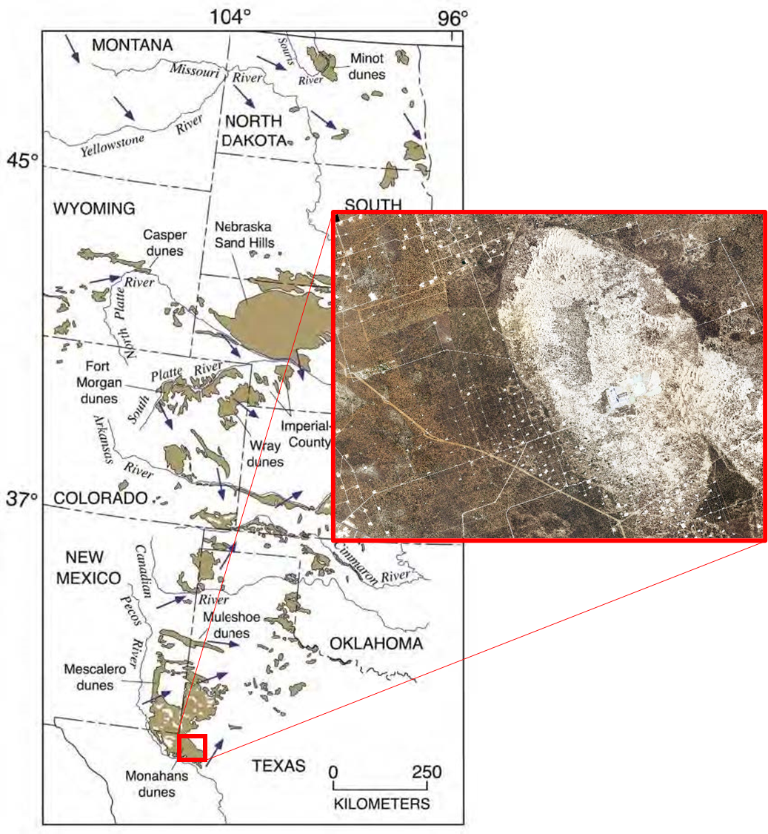
b
a
Figure 1.1. a) Location of the Monahans AT2 Dune Field in relation to dune fields across the Great Plains Region. b) Aerial photograph of the active dune field and the western flank of the sand sheet, which is heavily populated by oil and gas infrastructure.
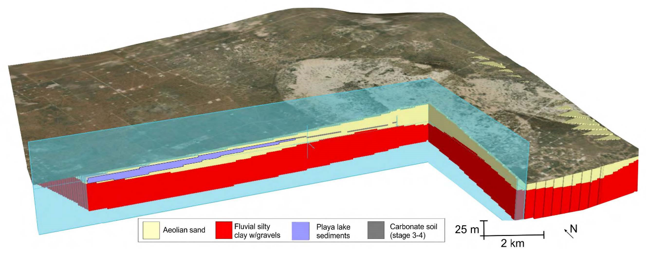
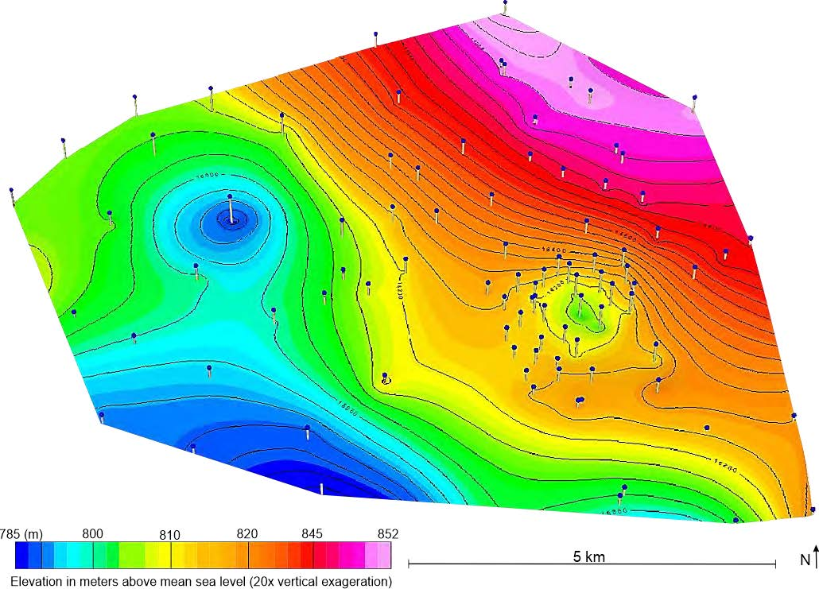
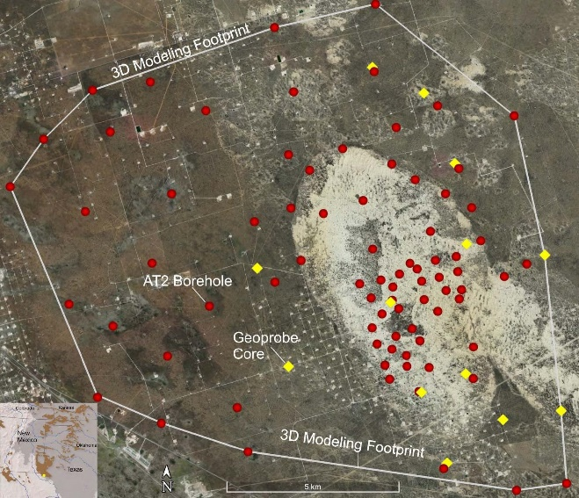

c
b
a
Figure 1.2 a) Three-dimensional Geosoft model of the Monahans AT2 dune structure, as derived from sonic borings of the region. b) Aerial view of the study area with locations of borehole measurements (red) and Geoprobe cores (yellow). c) Upper contact of the clay-rich paleosurface that has since been infilled by aeolian sands, as interpolated from borehole measurements, which are shown as blue dots. The color scale delineates the elevation above sea level for the paleosurface and ranges from 785m (dark blue) to 852m (pink) (Mayhack, 2021).

Seismic Site Characterization
Seismic site characterization comprises a set of widely-practiced techniques in geophysics that attempt to describe the amplification and frequency content of ground shaking at local scale (Borcherdt, 1970). Site characterization has traditionally been employed to estimate a locale’s response to seismic stimulation and to determine if ground amplification in sedimentary basins would compromise man-made infrastructure. Site characterization and its various processing methods have also allowed for the construction of subsurface shear wave velocity profiles. Two techniques commonly used in shallow seismic site characterization include Multichannel Analysis of Surface Waves (MASW) and the modeling of Horizontal-to-Vertical Spectral Ratios (HVSR). Assuming a 1D subsurface model consisting of stacked soil layers, the techniques lend information about shear wave velocity, Poisson’s ratio, layer thickness, and density.
So popular are these surface wave methods in geotechnical engineering that proprietary software and instrumentation have been specially designed for the easy collection of surface wave data and its subsequent modeling for shear wave velocity structure. One such instrument is MoHo’s Tromino accompanied by MoHo’s Grilla modeling software, which allows for a user-friendly experience when performing surface-wave-based seismic surveys.

Joint Modeling of Complementary Datasets

Horizontal-to-Vertical Spectral Ratios (HVSR)
Coined by Nakamura (1989), the HVSR technique identifies seismic resonance frequencies of the shallow subsurface through ambient-noise, single-station, three-component measurements. The HVSR curve, calculated by dividing the spectral amplitudes of the horizontal components by the spectral amplitude of the vertical component, allows for the identification of resonant frequencies, or eigenfrequencies, of the subsurface. The HVSR technique provides a low-cost and effective alternative to the estimation of the empirical transfer function (Lermo & Chávez-García, 1993), and has more recently gained popularity in determining thicknesses and shear wave velocities of soft sediments (Ibs-von Seht & Wohlenberg, 1999; Liang et al., 2018).
Although there is an overwhelming volume of literature on HVSR in microzonation studies, there is no consensus on the physical meaning of the HVSR curve. Some theoretical studies attribute features of the HVSR curve to body-wave effects; and others attribute the features to Rayleigh wave ellipticity. Others propose that relative contributions of Rayleigh and body waves may be largely site-dependent (Fäh et al., 2001). Despite the validity of both viewpoints in constructing HVSR curves from subsurface models, surface-wave-exclusive methods are generally adopted when conducting analytical studies due to their comparatively singular reliance on Rayleigh waves (Lunedei & Malischewsky, 2015).
In addition to the ambiguity of stimulus, the HVSR technique suffers from the effect of additional surface wave modes and the influence of quality factors, all of which can contribute to variability (Giancarlo, 2010). As the forward calculation of eigenfrequencies for a stacked soil layer is nonlinear, the inverse problem is also nonunique.

Surface Wave Dispersion
Surface waves are inherently dispersive, meaning that waves of different frequencies travel at different speeds. The functional form of the frequency-dispersion relation (called a “dispersion curve”) depends on geologic structure, primarily the distribution of shear velocity with depth. One estimates a dispersion curve by isolating and measuring the speed of frequency components for Rayleigh waves that travel between receivers. The shape and values of the dispersion curve are determined by the shear wave velocity profile beneath the measurement location. Rayleigh waves can be created through “active-source” methods such as a hammer blow, weight drop, explosion, or Vibroseis, or discovered through “passive-source” techniques, using cross-correlations and stacking many short time periods of ambient noise.
Numerous methods have been developed for measuring and estimating dispersion curves. These include Spectral Analysis of Surface Waves (SASW) (Heisey et al., 1982), Refraction Microtremor (ReMi) (Louie, 2001), and Multichannel Analysis of Surface Waves (MASW) (Park et al., 1999). Each method is specifically designed to be sensitive to particular bands of frequencies, with active-source SASW and MASW commonly identifying structure at higher frequencies and passive-source ReMi and MASW identifying structure at lower frequencies (Jin et al., 2006). Passive-source MASW is a relatively new technique in which seismic interferometry techniques can be used to retrieve dispersion curves from purely ambient noise (Cheng et al., 2015).
Much like HVSR, the process of modeling surface wave dispersion is usually nonunique (Luke & Calderón-Macías, 2007) and commonly suffers from data misinterpretation due to effects from multiple modes, far- and near-field effects, and guided waves (Giancarlo, 2010).

Joint Modeling through Global Optimization
Modeling HVSR and surface wave dispersion curves is inherently nonunique, but each dataset also has unique sensitivity. HVSR is highly sensitive to shear wave velocity contrasts while surface wave dispersion is sensitive to absolute values of shear wave velocity as a function of depth (Giancarlo, 2010). These distinct sensitivities suggest that the joint modeling of the two data types may impose stronger constraints on model parameters than either HVSR or surface wave dispersion separately.
Due to the high degree of nonuniqueness in model parameters and the complexities of the forward model equations, solutions to observed seismic data exist in a complex parameter space. Understanding and visualizing this space is important but sampling it in large capacities is difficult due to the high dimensionality of independent variables in the governing equations. Global optimization strategies provide an efficient method of sampling and thus characterizing the parameter space.
Simulated annealing is a popular global optimization method that has been used widely in geophysical applications. It operates through an analogy to the gradual cooling of a crystal in statistical mechanics, where high-temperature, energetic molecules are afforded time to cool slowly, eventually coming to rest in their lowest energy state. Likewise, a stochastic starting model is provided a cooling schedule, which is proportionally related to the probability of a model with large misfit being accepted over a model with smaller misfit. With careful consideration to the hyperparameters governing the cooling schedule, this allows the simulated annealing algorithm to broadly sample the parameter space in beginning modeling iterations and gradually focus on lower misfit model solutions in the latter stages (Ingber, 1993).
Very fast simulated annealing (VFSA) is a variant of simulated annealing that introduces a variation on the probability of model acceptance, using a Cauchy distribution as opposed to a Boltzmann or uniform distribution that was made popular by the original Metropolis algorithm. Because the Cauchy distribution asymptotically approaches zero more slowly than does the uniform distribution, the probability of a particular solution exiting a local minimum is greater. It therefore allows the cooling schedule to be accelerated (Ingber, 1989). VFSA has been shown to identify effectively the global minimum of an objective function in a number of geophysical studies (Sen & Stoffa, 2013).

Field and Data Methods

Field Campaign
Active and passive seismic data were collected over a period of two weeks from May 12th, 2021 to May 21st, 2021 in the Monahans AT2 Dune Field. 150 three-component SmartSolo IGU-16HR seismic “nodes” (all-in-one sensors/recorders) were deployed in linear fashion along oil service roads on both the active dune structure and the Western flank of the sand sheet. Three separate deployments of 150 nodes were completed during the campaign. MoHo Tromino instruments were also deployed at a few redundant sites in Line A for purposes of instrument comparison.
Line A recorded ambient noise continuously from May 12th to May 15th (Figure 2.1.1). Line A aimed to delineate not only the pre-Pleistocene, clay-rich paleosurface but also the subsurface structure of a large lacustrine deposit interbedded in the eolian sands. Line A saw the deployment of 150 seismic nodes at 2m spacing, for a total aperture of 300m. A traditional MASW-style active survey was conducted on May 13th, using an R.T. Clark 40-kg propelled energy generator (“PEG”). Shot points were made at every fourth station along Line A. Two MoHo Tromino instruments were deployed at every tenth station on May 14th, and recorded ambient vibrations for 12 minutes.
A second deployment distributed the 150 nodes along eight separate lines, which are detailed in Table 2.1. Nodes along each of these lines, which were placed along service roads in the sand sheet area, were spaced at 200 m (Figure 2.1.2). Ambient recordings were collected from May 16th to May 19th, with an active-source MASW survey using the propelled energy generator taking place on the 18th. These lines aimed at capturing more extensive features of the dune field, specifically the fluvial-sand contact.

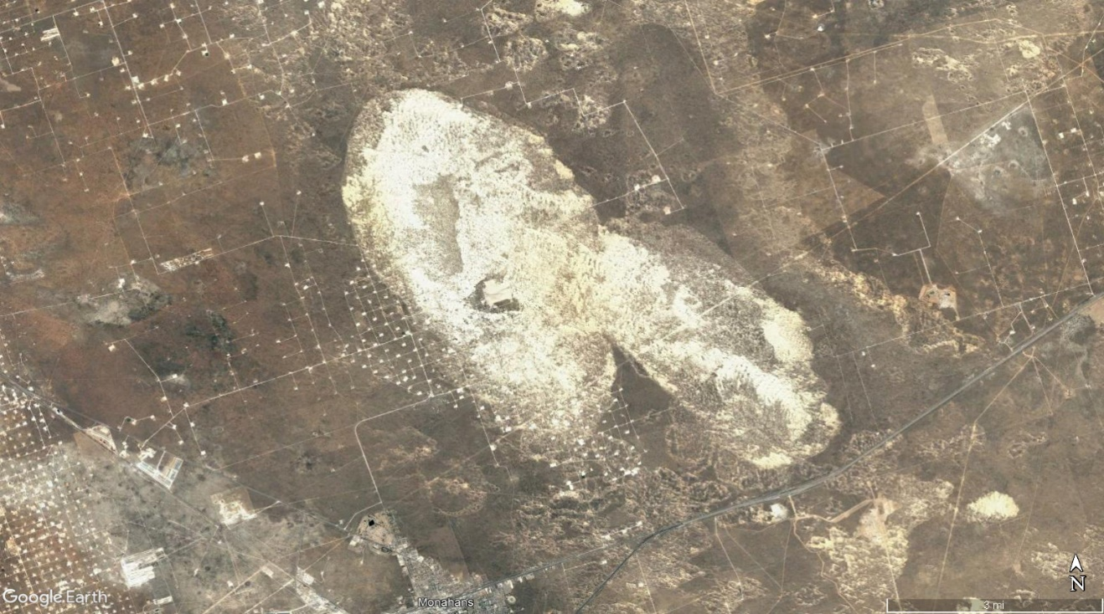
Figure 2.1.1. Location of Line A in relation to the Monahans AT2 Dune Field. Line A consisted of 150 seismic nodes at 2 meter spacing, extending from East to West.

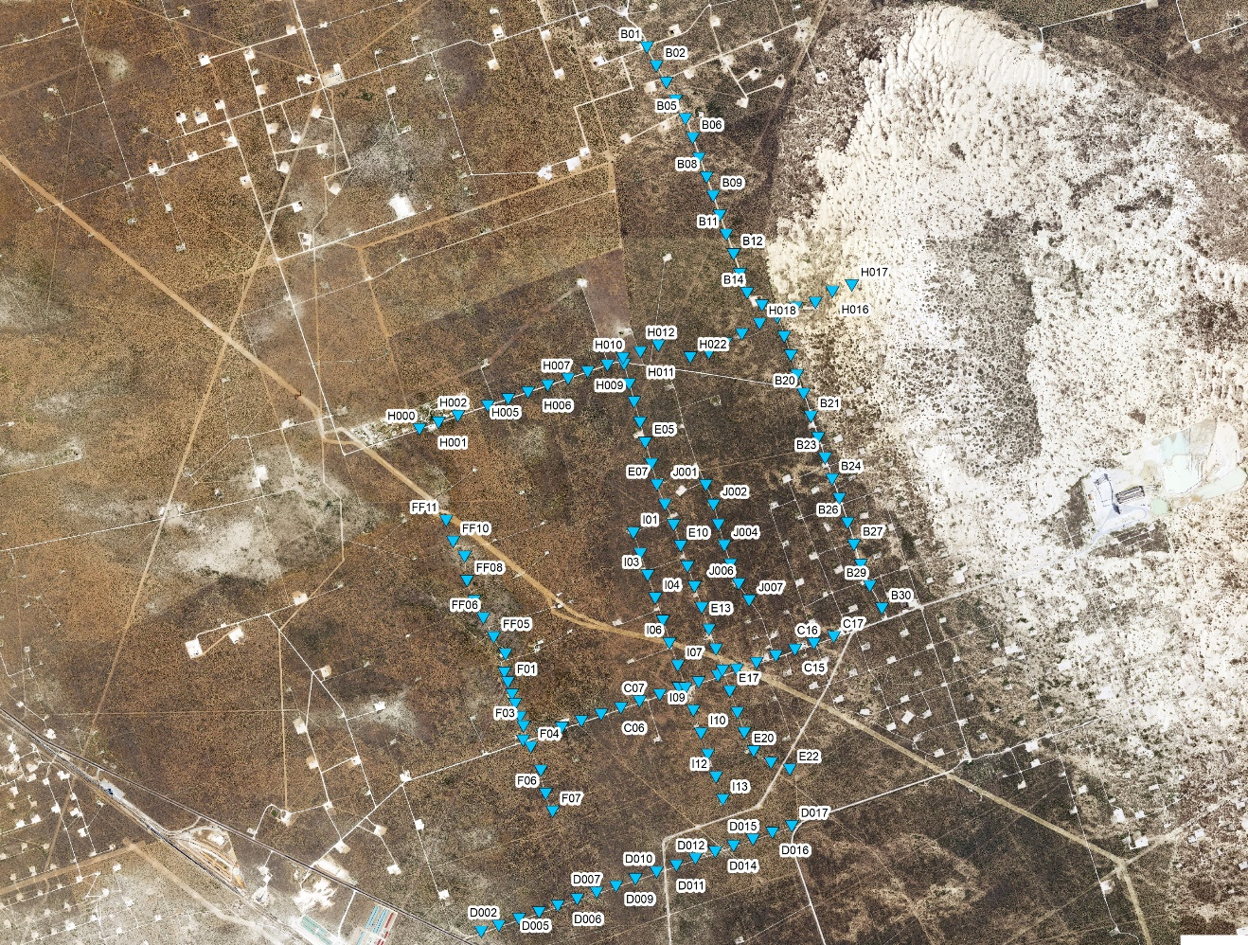
Figure 2.1.2. Location of Lines B, C, D, E, F, H, I, and J in relation to the Monahans AT2 Dune Field. Seismic line information is summarized in Table 2.1.

Line G, deployed on the active dune structure, recorded ambient noise from May 19th to May 22nd (Figure 2.1.3) and was aimed at characterizing the subsurface structure beneath thicker eolian sediment (compared to Line A). 150 seismic nodes were arrayed at a linear spacing of 5 m for a total aperture of 750 m. An active-source MASW survey was conducted on May 20th using the same propelled energy source used in data acquisition for Line A. Multiple shots were made at every second station along Line G.

Figure 2.1.3. Location of Line G in relation to the Monahans AT2 Dune Field. Line G consisted of 150 seismic nodes at 2 meter spacing, extending from West to East.

Table 2.1. Seismic deployment details
Name | Recording Start Date | Recording End Date | Number of Receivers | Spacing (m) | Aperture (km)
Line A | 5/12/21 | 5/15/21 | 150 | 2 | 0.30
Line B | 5/16/21 | 5/19/21 | 30 | 200 | 6.00
Line C | 5/16/21 | 5/19/21 | 17 | 200 | 3.40
Line D | 5/16/21 | 5/19/21 | 17 | 200 | 3.40
Line E | 5/16/21 | 5/19/21 | 22 | 200 | 4.40
Line F | 5/16/21 | 5/19/21 | 19 | 200 | 3.80
Line G | 5/19/21 | 5/22/21 | 150 | 5 | 0.75
Line H | 5/17/21 | 5/19/21 | 23 | 200 | 4.60
Line I | 5/17/21 | 5/17/21 | 13 | 200 | 2.60
Line J | 5/17/21 | 5/17/21 | 7 | 200 | 1.40

Data Processing

Horizontal-to-Vertical Spectral Ratios (HVSR)
Data from each node deployment was processed using the hvsrpy Python package (Vantassel, 2021). Passive, three-component seismic data were segmented into 60-second-long windows. HVSR curves for individual time windows over a total period of 24 hours were then automatically evaluated for peak reliability and clarity based on the SESAME (2004) criteria. Accepted time windows for each station were then averaged to produce a summary HVSR curve for the station (Fig. 2.1). HVSR curves that exemplified spurious or irregular behavior compared to their neighboring stations were not included in the final modeling. These included several stations on Line G, which were deployed on caliche crossroads and several stations on Line A, which did not record data.
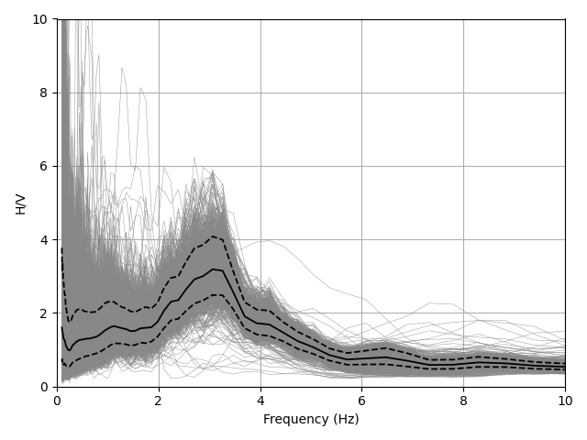

Figure 2.2.1. Average HVSR curve computed for Line A station A080 (thick black line), with all 60-second, time-windowed HVSR curves (thin gray lines), and the ±1 standard deviation of the averaged HVSR curve (dotted black lines). A single, prominent peak is observed at about 3 Hz and is likely indicative of a characteristic impedance contrast at depth.
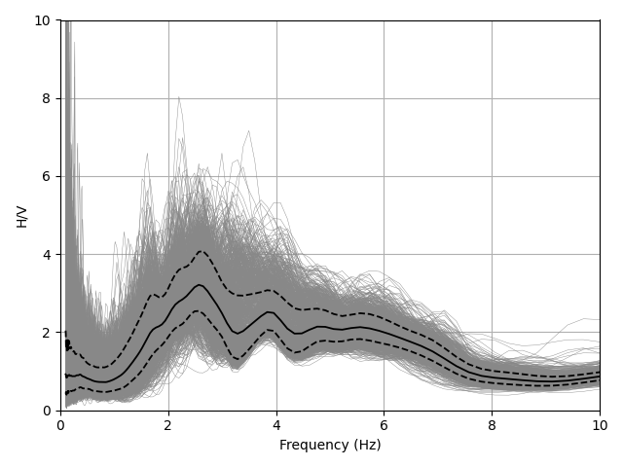
Figure 2.2.2. Average HVSR curve computed for Line G station G032 (thick black line), with all 60-second, time-windowed HVSR curves (thin gray lines), and the ±1 standard deviation of the averaged HVSR curve (dotted black lines). The curve’s structure is significantly more complex than was found for stations on Line A, featuring several peaks between 2 and 5 Hz, which indicate several impedance contrasts at varying depths.

Surface Wave Dispersion
Surface wave dispersion curves were produced through traditional MASW methods, relying on active sources for Lines A and G and passive sources for the remaining lines. For all deployments a surface wave dispersion curve was produced from a virtual shot gather that was obtained using the common mid-point cross correlation (CMPCC) method (Hayashi & Suzuki, 2004).
Fixed-length seismic traces were extracted for time periods in which the active source was being triggered on Lines A and G. For each shot, cross-correlations between all pairs of stations on the line were calculated and summed for all shots taken at either end of the line. Cross-correlation pairs were then grouped based on their common midpoint along the array to produce virtual source gathers. Common midpoints that were co-located beneath a deployed station were then included in that station’s virtual source gather. For nodes that recorded only ambient noise, the preprocessing steps follow those of Levshin and Ritzwoller (2001), where four-minute-long seismic traces are extracted, preprocessed, and summed over the course of a day. For each station pair in a given line, cross-correlations were calculated and subsequently summed and organized to yield CMPCCs co-located with the other stations in the array.
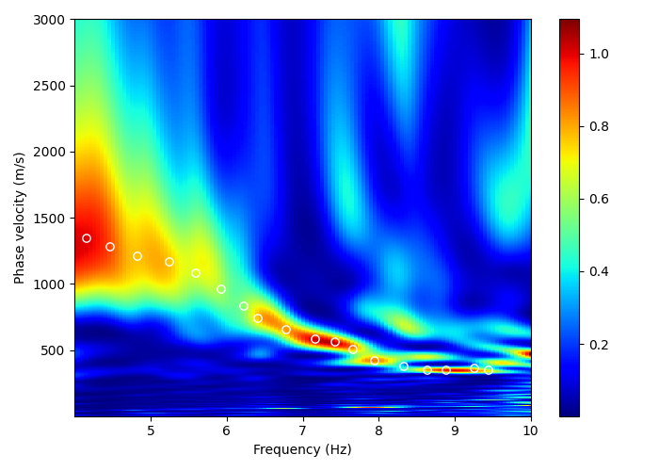
The frequency-phase velocity (f-c) transform was then used to visualize the energy distribution of surface waves as a function of frequency. Dispersion curves were picked manually from the visualization of this transform for each CMPCC gather (Fig. 2.2).
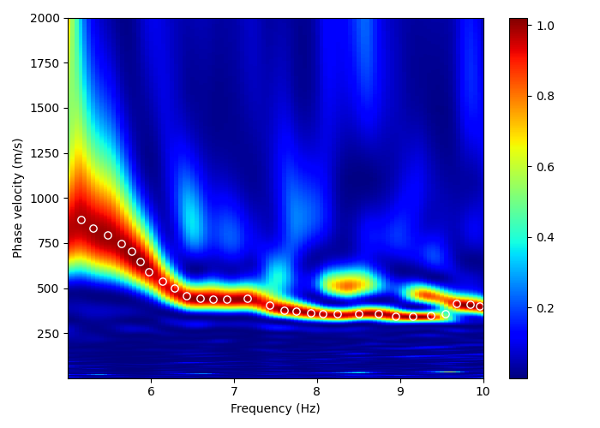
Figure 2.3.1 Frequency-velocity (f-c) transform of active-source seismic data for station A102, with the picks along the maximum amplitude of the transformed space corresponding to the final dispersion curve shown as white circles.
Figure 2.3.2. f-c transform of active-source seismic data for station G108, with dispersion curve picks shown as white circles. Phase velocities are generally higher for stations on Line G compared to Line A and are, like the HVSR curves, more complex, featuring multiple modes.

Figure 2.3.3. f-c transform of passive-source seismic data for station B10, with dispersion curve picks shown as white circles. Frequency content is much lower and velocities are much higher compared to Lines A and G. This is due to the reliance on the ambient wavefield, which is composed of dominantly lower frequencies and the significantly larger station spacing, which samples surface waves that penetrate at deeper depths.

Modeling through Very Fast Simulated Annealing (VFSA)
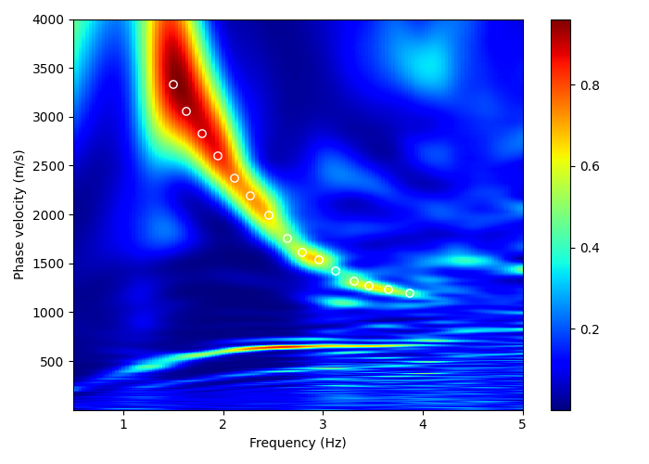
A one-dimensional (1D) wave propagation model based on the modified Tompson (1950) - Haskell (1953) propagation matrix method, known also as the stiffness matrix method developed by Kausel and Roësset (1981), was performed to estimate soil properties and theoretical amplification factors of shallow soil layers. Search ranges for shear wave velocity, Poisson’s ratio, and layer thickness were established separately for each deployment, informed by lithologies present in nearby boreholes in the study area. Density was held constant for all modeling runs. Ranges for each parameter were broad enough to compensate for the lack of known seismic characteristics. After determining the best parameters through a series of trial-and-error experiments, all VFSA runs started at a dimensionless temperature of 1e6 and were allowed to cool to a temperature of 1e-21, providing sufficient time for the identification and convergence on, ideally, a global minimum.
Figure 2.3.3. f-c transform of passive-source seismic data for station B10, with dispersion curve picks shown as white circles. Frequency content is much lower and velocities are much higher compared to Lines A and G. This is due to the reliance on the ambient wavefield, which is composed of dominantly lower frequencies and the significantly larger station spacing, which samples surface waves that penetrate at deeper depths.

Best-fit models for every station in each deployment were generated using HVSR curves only, surface wave dispersion curves only, and both in a joint model. Objective function weights in the joint modeling were determined through experimentation, with an HVSR misfit coefficient of 0.75 and a surface wave dispersion misfit coefficient of 0.25 found to consistently produce the best fit to observed data. Best-fit models represented the convergence of the misfit function after 3000 iterations (Fig. 2.3).

References cited
Borcherdt, R. D. (1970). Effects of local geology on ground motion near San Francisco Bay*. Bulletin of the Seismological Society of America, 60(1), 29-61. https://doi.org/10.1785/BSSA0600010029
Cheng, F., Xia, J., Xu, Y., Xu, Z., & Pan, Y. (2015). A new passive seismic method based on seismic interferometry and multichannel analysis of surface waves. Journal of Applied Geophysics, 117, 126-135. https://www.sciencedirect.com/science/article/pii/S0926985115001329
Fäh, D., Kind, F., & Giardini, D. (2001). A theoretical investigation of average H/V ratios. Geophysical Journal International, 145(2), 535-549. https://doi.org/10.1046/j.0956-540x.2001.01406.x
Forman, S. L., Tew-Todd, V., Mayhack, C. J., Marin, L., Weist, L., & Money, G. (in press). Late Quaternary aeolian environments, luminescence chronology and climate change for the Monahans dune field, Winkler County, West Texas, USA. Aeolian Research.
Giancarlo, D. M. (2010). Insights on surface wave dispersion and HVSR: Joint analysis via Pareto optimality. Journal of Applied Geophysics, 72(2), 129-140. https://www.sciencedirect.com/science/article/pii/S0926985110001102
Haskell, N. A. (1953). The dispersion of surface waves on multilayered media*. Bulletin of the Seismological Society of America, 43(1), 17-34. https://doi.org/10.1785/BSSA0430010017
Hayashi, K., & Suzuki, H. (2004). CMP cross-correlation analysis of multi-channel surface-wave data. Exploration Geophysics, 35(1), 7-13.
Heisey, J., Stokoe, K., & Meyer, A. (1982). Moduli of pavement systems from spectral analysis of surface waves. Transportation research record, 852(22-31), 147.
Ibs-von Seht, M., & Wohlenberg, J. (1999). Microtremor measurements used to map thickness of soft sediments. Bulletin of the Seismological Society of America, 89(1), 250-259. https://doi.org/10.1785/BSSA0890010250
Ingber, L. (1989). Very fast simulated re-annealing. Mathematical and Computer Modelling, 12(8), 967-973. https://www.sciencedirect.com/science/article/pii/0895717789902021
Ingber, L. (1993). Simulated annealing: Practice versus theory. Mathematical and Computer Modelling, 18(11), 29-57. https://www.sciencedirect.com/science/article/pii/089571779390204C
Jin, X., Luke, B., & Louie, J. (2006). Comparison of Rayleigh wave dispersion relations from three surface wave measurements in a complex-layered system. In GeoCongress 2006: Geotechnical Engineering in the Information Technology Age (pp. 1-6).
Kausel, E., & Roësset, J. M. (1981). Stiffness matrices for layered soils. Bulletin of the Seismological Society of America, 71(6), 1743-1761. https://doi.org/10.1785/BSSA0710061743
Lermo, J., & Chávez-García, F. J. (1993). Site effect evaluation using spectral ratios with only one station. Bulletin of the Seismological Society of America, 83(5), 1574-1594. https://doi.org/10.1785/BSSA0830051574
Levshin, A. L., & Ritzwoller, M. H. (2001). Automated Detection, Extraction, and Measurement of Regional Surface Waves. In A. L. Levshin & M. H. Ritzwoller (Eds.), Monitoring the Comprehensive Nuclear-Test-Ban Treaty: Surface Waves (pp. 1531-1545). Basel: Birkhäuser Basel.
Liang, D., Gan, F., Zhang, W., & Jia, L. (2018). The application of HVSR method in detecting sediment thickness in karst collapse area of Pearl River Delta, China. Environmental Earth Sciences, 77(6), 259. https://doi.org/10.1007/s12665-018-7439-x
Louie, J. N. (2001). Faster, Better: Shear-Wave Velocity to 100 Meters Depth from Refraction Microtremor Arrays. Bulletin of the Seismological Society of America, 91(2), 347-364. https://doi.org/10.1785/0120000098
Luke, B., & Calderón-Macías, C. (2007). Inversion of Seismic Surface Wave Data to Resolve Complex Profiles. Journal of Geotechnical and Geoenvironmental Engineering, 133(2), 155-165. https://ascelibrary.org/doi/abs/10.1061/%28ASCE%291090-0241%282007%29133%3A2%28155%29
Lunedei, E., & Malischewsky, P. (2015). A Review and Some New Issues on the Theory of the H/V Technique for Ambient Vibrations. In A. Ansal (Ed.), Perspectives on European Earthquake Engineering and Seismology: Volume 2 (pp. 371-394). Cham: Springer International Publishing.
Machenberg, M. D. (1984). Geology of Monahans Sandhills State Park, Texas. Virtual Landscapes of Texas.
Mayhack, C. J. (2021). Late Quaternary Sedimentary Architecture and Depositional History of the Monahans Dune Field, Winkler County, TX. (MS), Baylor University, Waco, TX.
Muhs, D. R., & Holliday, V. T. (2001). Origin of late Quaternary dune fields on the Southern High Plains of Texas and New Mexico. GSA Bulletin, 113(1), 75-87. https://doi.org/10.1130/0016-7606(2001)113<0075:OOLQDF>2.0.CO;2
Nakamura, Y. (1989). A Method for Dynamic Characteristics Estimation of Subsurface using Microtremor on the Ground Surface. Quarterly Report of Rtri, 30.
Park, C. B., Miller, R. D., & Xia, J. (1999). Multichannel analysis of surface waves. GEOPHYSICS, 64(3), 800-808. https://library.seg.org/doi/abs/10.1190/1.1444590
Rich, J., & Stokes, S. (2011). A 200,000-year record of late Quaternary Aeolian sedimentation on the Southern High Plains and nearby Pecos River Valley, USA. Aeolian Research, 2, 221-240.
Sen, M. K., & Stoffa, P. L. (2013). Global Optimization Methods in Geophysical Inversion. Cambridge: Cambridge University Press.
SESAME. (2004). Guidelines for the Implementation of the H/V Spectral Ratio Technique on Ambient Vibrations Measurements, Processing, and Interpretation. In (Vol. 62). Research General Directorate: European Commission - Research General Directorate.
Spears, B., 2022. “Seismic Site Characterization via Joint Modeling of Horizontal-to-Vertical Spectral Ratios and Surface Wave Dispersion: Developing and Validating a Geophysical Tool for Deciphering Quaternary Stratigraphic Architecture of the Monahans Dune Field, West Texas”, M.S. Thesis, Baylor University, Waco, TX
Tompson, W. (1950). Transmission of elastic waves through a stratified soil medium. Journal of Applied Physics, 21, 89-93.
Vantassel, J. (2021). jpvantassel/hvsrpy (Version v1.0.0): Zenodo.
APPENDICES. Seismic Node Coordinates by Line

Table A.1. Coordinates for seismic nodes on Line A, obtained using a Leica Geosystems Differential GPS
Station Name | Latitude (deg) | Longitude (deg) | Elevation (m)
A001  A002  A003  A004  A005  A006  A007  A008  A009  A010  A011  A012  A013  A014  A015  A016  A017  A018  A019  A020  A021  A022  A023  A024  A025  A026  A027  A028  A029  A030  A031  A032  A033  A034  A035  A036  A037  A038  A039  A040  A041  A042  A043  A044  A045  A046  A047  A048  A049  A050  A051  A052  A053  A054  A055  A056  A057  A058  A059  A060  A061  A062  A063  A064  A065  A066  A067  A068  A069  A070  A071  A072  A073  A074  A075  A076  A077  A078  A079  A080  A081  A082  A083  A084  A085  A086  A087  A088  A089  A090  A091  A092  A093  A094  A095  A096  A097  A098  A099  A100  A101  A102  A103  A104  A105  A106  A107  A108  A109  A110  A111  A112  A113  A114  A115  A116  A117  A118  A119  A120  A121  A122  A123  A124  A125  A126  A127  A128  A129  A130  A131  A132  A133  A134  A135  A136  A137  A138  A139  A140  A141  A142  A143  A144  A145  A146  A147  A148  A149  A150 | 31.6695044  31.6695085  31.6695128  31.6695142  31.6695180  31.6695243  31.6695284  31.6695345  31.6695418  31.6695452  31.6695510  31.6695558  31.6695621  31.6695653  31.6695728  31.6695776  31.6695824  31.6695909  31.6695936  31.6696000  31.6696047  31.6696079  31.6696149  31.6696186  31.6696261  31.6696301  31.6696338  31.6696405  31.6696448  31.6696459  31.6696547  31.6696614  31.6696663  31.6696705  31.6696776  31.6696800  31.6696863  31.6696919  31.6696966  31.6697034  31.6697093  31.6697147  31.6697196  31.6697268  31.6697307  31.6697374  31.6697428  31.6697484  31.6697528  31.6697609  31.6697678  31.6697745  31.6697809  31.6697851  31.6697925  31.6697983  31.6698021  31.6698090  31.6698142  31.6698170  31.6698287  31.6698366  31.6698435  31.6698460  31.6698503  31.6698521  31.6698593  31.6698677  31.6698684  31.6698739  31.6698814  31.6698890  31.6699004  31.6699029  31.6699061  31.6699102  31.6699153  31.6699215  31.6699248  31.6699320  31.6699355  31.6699434  31.6699469  31.6699576  31.6699628  31.6699682  31.6699724  31.6699748  31.6699814  31.6699901  31.6699977  31.6700014  31.6700038  31.6700129  31.6700175  31.6700241  31.6700269  31.6700332  31.6700417  31.6700457  31.6700505  31.6700509  31.6700595  31.6700679  31.6700737  31.6700763  31.6700851  31.6700892  31.6700963  31.6701018  31.6701080  31.6701135  31.6701199  31.6701289  31.6701335  31.6701393  31.6701469  31.6701529  31.6701566  31.6701600  31.6701679  31.6701720  31.6701794  31.6701868  31.6701909  31.6701980  31.6702006  31.6702033  31.6702107  31.6702154  31.6702203  31.6702249  31.6702293  31.6702355  31.6702428  31.6702483  31.6702518  31.6702563  31.6702636  31.6702741  31.6702793  31.6702831  31.6702883  31.6702940  31.6703016  31.6703067  31.6703103  31.6703186  31.6703206  31.6703292 | -102.948244  -102.948225  -102.948203  -102.948183  -102.948163  -102.948140  -102.948120  -102.948101  -102.948076  -102.948060  -102.948037  -102.948023  -102.948003  -102.947982  -102.947961  -102.947940  -102.947916  -102.947897  -102.947879  -102.947855  -102.947837  -102.947821  -102.947795  -102.947776  -102.947755  -102.947737  -102.947714  -102.947698  -102.947679  -102.947654  -102.947636  -102.947612  -102.947593  -102.947575  -102.947555  -102.947536  -102.947513  -102.947492  -102.947471  -102.947450  -102.947429  -102.947410  -102.947390  -102.947371  -102.947349  -102.947332  -102.947306  -102.947290  -102.947267  -102.947253  -102.947236  -102.947215  -102.947194  -102.947171  -102.947152  -102.947131  -102.947115  -102.947092  -102.947072  -102.947051  -102.947031  -102.947015  -102.946995  -102.946979  -102.946963  -102.946933  -102.946915  -102.946898  -102.946879  -102.946857  -102.946832  -102.946816  -102.946793  -102.946780  -102.946756  -102.946737  -102.946720  -102.946695  -102.946673  -102.946653  -102.946636  -102.946613  -102.946594  -102.946569  -102.946552  -102.946538  -102.946513  -102.946493  -102.946477  -102.946453  -102.946440  -102.946422  -102.946398  -102.946378  -102.946357  -102.946337  -102.946315  -102.946296  -102.946274  -102.946255  -102.946235  -102.946212  -102.946195  -102.946176  -102.946157  -102.946136  -102.946119  -102.946097  -102.946077  -102.946052  -102.946037  -102.946012  -102.945994  -102.945976  -102.945955  -102.945934  -102.945915  -102.945897  -102.945874  -102.945858  -102.945839  -102.945813  -102.945798  -102.945774  -102.945758  -102.945738  -102.945715  -102.945695  -102.945673  -102.945654  -102.945637  -102.945613  -102.945594  -102.945576  -102.945558  -102.945533  -102.945514  -102.945496  -102.945475  -102.945454  -102.945436  -102.945413  -102.945395  -102.945375  -102.945356  -102.945337  -102.945316  -102.945296  -102.945277  -102.945257 | 796.906  796.865  796.970  796.980  796.960  796.905  796.963  797.060  796.745  796.970  796.682  796.756  796.788  796.881  796.917  796.836  796.883  796.837  796.885  796.771  797.005  797.011  796.978  796.741  796.934  796.798  796.741  796.790  796.764  796.735  796.739  796.720  796.603  796.659  796.648  796.504  796.490  796.546  796.527  796.627  796.637  796.741  796.823  796.761  796.857  796.802  796.907  796.939  796.877  796.869  796.856  796.887  796.799  796.622  796.656  796.606  796.728  796.585  796.508  796.482  796.637  796.582  796.493  796.532  796.625  796.332  796.392  796.336  796.254  796.347  796.416  796.300  796.492  796.474  796.299  796.298  796.306  796.564  796.423  796.443  796.609  796.564  796.591  796.443  796.534  796.433  796.426  796.421  796.552  796.540  796.647  796.564  796.655  796.639  796.677  796.689  796.702  796.823  796.919  796.661  796.799  796.762  796.741  796.788  796.846  796.846  796.869  797.098  796.983  796.975  796.980  796.984  797.101  797.026  797.145  797.141  797.024  797.003  797.118  797.105  797.108  797.048  796.946  796.835  796.877  796.998  797.002  796.966  797.027  797.028  797.083  797.085  797.121  797.146  797.125  797.112  797.216  797.162  797.248  797.298  797.271  797.380  797.383  797.322  797.344  797.307  797.299  797.323  797.302  797.433

Table A.2. Coordinates for seismic nodes on Line B, obtained using a Leica Geosystems Differential GPS

Station Name | Latitude (deg) | Longitude (deg) | Elevation (m)
B01 | 31.70224 | -102.926086 | 810.777
B02 | 31.70060 | -102.925134 | 809.345
B03 | 31.69909 | -102.924140 | 809.410
B04 | 31.69751 | -102.923203 | 809.449
B05 | 31.69585 | -102.922261 | 808.790
B06 | 31.69417 | -102.921543 | 807.284
B07 | 31.69240 | -102.920944 | 805.931
B08 | 31.69070 | -102.920200 | 806.559
B09 | 31.68903 | -102.919550 | 808.130
B10 | 31.68732 | -102.918903 | 807.406
B11 | 31.68558 | -102.918273 | 806.507
B12 | 31.68387 | -102.917572 | 806.802
B13 | 31.68212 | -102.916936 | 806.358
B14 | 31.68044 | -102.916234 | 805.017
B15 | 31.67932 | -102.914733 | 805.232
B16 | 31.67821 | -102.913195 | 805.444
B17 | 31.67653 | -102.912504 | 805.110
B18 | 31.67485 | -102.911876 | 803.574
B19 | 31.67312 | -102.911259 | 802.504
B20 | 31.67145 | -102.910627 | 803.200
B21 | 31.66941 | -102.909910 | 801.972
B22 | 31.66754 | -102.909213 | 801.043
B23 | 31.66573 | -102.908534 | 800.529
B24 | 31.66385 | -102.907843 | 802.629
B25 | 31.66213 | -102.907135 | 800.028
B26 | 31.65999 | -102.906328 | 800.460
B27 | 31.65806 | -102.905727 | 798.832
B28 | 31.65626 | -102.905079 | 799.540
B29 | 31.65438 | -102.904170 | 798.883
B30 | 31.65240 | -102.902961 | 797.261

Table A.3. Coordinates for seismic nodes on Line C, obtained using a Leica Geosystems Differential GPS

Station Name | Latitude (deg) | Longitude (deg) | Elevation (m)
C01 | 31.641338 | -102.940173 | 785.765
C02 | 31.641872 | -102.938161 | 786.298
C03 | 31.642414 | -102.936198 | 786.261
C04 | 31.642966 | -102.934145 | 787.395
C05 | 31.643501 | -102.932104 | 788.049
C06 | 31.644070 | -102.930051 | 789.262
C07 | 31.644609 | -102.928093 | 789.989
C08 | 31.645167 | -102.926038 | 791.001
C09 | 31.645723 | -102.924048 | 792.072
C10 | 31.646182 | -102.921992 | 792.042
C11 | 31.646699 | -102.919997 | 792.879
C12 | 31.647265 | -102.918039 | 792.378
C13 | 31.647807 | -102.916022 | 792.885
C14 | 31.648383 | -102.914007 | 793.779
C15 | 31.648885 | -102.912015 | 794.475
C16 | 31.649414 | -102.910051 | 795.72
C17 | 31.649963 | -102.907984 | 797.138

Table A.4. Coordinates for seismic nodes on Line D, obtained using a Leica Geosystems Differential GPS

Station Name | Latitude (deg) | Longitude (deg) | Elevation (m)
D001 | 31.624566 | -102.944876 | 779.011
D002 | 31.625070 | -102.943035 | 779.941
D003 | 31.625646 | -102.940962 | 780.073
D004 | 31.626182 | -102.938884 | 780.190
D005 | 31.626738 | -102.936918 | 780.744
D006 | 31.627279 | -102.934907 | 780.932
D007 | 31.627816 | -102.932902 | 781.747
D008 | 31.628355 | -102.930911 | 781.699
D009 | 31.628946 | -102.928877 | 781.956
D010 | 31.629536 | -102.926697 | 782.708
D011 | 31.630082 | -102.924660 | 782.763
D012 | 31.630637 | -102.922661 | 783.116
D013 | 31.631189 | -102.920638 | 782.826
D014 | 31.631721 | -102.918716 | 784.594
D015 | 31.632250 | -102.916720 | 785.751
D016 | 31.632806 | -102.914700 | 786.015
D017 | 31.633355 | -102.912702 | 787.228

Table A.5. Coordinates for seismic nodes on Line E, obtained using a Leica Geosystems Differential GPS

Station Name | Latitude (deg) | Longitude (deg) | Elevation (m)
E01 | 31.67436 | -102.929073 | 801.855
E02 | 31.67261 | -102.928571 | 800.729
E03 | 31.67099 | -102.928090 | 800.065
E04 | 31.66917 | -102.927545 | 799.424
E05 | 31.66742 | -102.927014 | 798.703
E06 | 31.66552 | -102.926442 | 797.972
E07 | 31.66365 | -102.925893 | 799.499
E08 | 31.66191 | -102.925129 | 800.276
E09 | 31.66010 | -102.924273 | 798.691
E10 | 31.65825 | -102.923606 | 796.612
E11 | 31.65642 | -102.922928 | 796.143
E12 | 31.65462 | -102.922251 | 794.551
E13 | 31.65275 | -102.921547 | 794.160
E14 | 31.65080 | -102.920823 | 793.843
E15 | 31.64907 | -102.920172 | 791.848
E16 | 31.64719 | -102.919528 | 791.156
E17 | 31.64533 | -102.918794 | 789.837
E18 | 31.64343 | -102.918071 | 789.325
E19 | 31.64164 | -102.917397 | 787.197
E20 | 31.64002 | -102.916476 | 786.826
E21 | 31.63897 | -102.914699 | 787.238
E22 | 31.63833 | -102.912793 | 787.678

Table A.6. Coordinates for seismic nodes on Line F, obtained using a Leica Geosystems Differential GPS

Station Name | Latitude (deg) | Longitude (deg) | Elevation (m)
FF11 | 31.66088 | -102.947688 | 796.837
FF10 | 31.65901 | -102.947008 | 796.656
FF09 | 31.65765 | -102.945871 | 796.003
FF08 | 31.65554 | -102.945648 | 794.593
FF07 | 31.65375 | -102.944947 | 793.501
FF06 | 31.65220 | -102.944037 | 792.468
FF05 | 31.65049 | -102.942996 | 791.496
FF04 | 31.64899 | -102.941824 | 790.720
FF03 | 31.64736 | -102.941965 | 789.340
FF02 | 31.64543 | -102.941216 | 787.117
FF01 | 31.64342 | -102.940445 | 786.286
F01 | 31.64651 | -102.941632 | 788.547
F02 | 31.64460 | -102.940913 | 786.922
F03 | 31.64261 | -102.940117 | 785.864
F04 | 31.64075 | -102.939404 | 785.854
F05 | 31.63866 | -102.938430 | 784.985
F06 | 31.63661 | -102.937949 | 784.332
F07 | 31.63504 | -102.937284 | 783.671

Table A.7. Coordinates for seismic nodes on Line G, obtained using a Leica Geosystems Differential GPS

Station Name | Latitude (deg) | Longitude (deg) | Elevation (m)
G001 | 31.66883 | -102.893962 | 810.323
G002 | 31.66883 | -102.894012 | 810.254
G003 | 31.66882 | -102.894064 | 810.217
G004 | 31.66880 | -102.894115 | 810.108
G005 | 31.66879 | -102.894168 | 810.117
G006 | 31.66878 | -102.894220 | 809.957
G007 | 31.66877 | -102.894269 | 809.678
G008 | 31.66876 | -102.894316 | 809.461
G009 | 31.66874 | -102.894368 | 809.212
G010 | 31.66873 | -102.894420 | 808.838
G011 | 31.66871 | -102.894470 | 808.756
G012 | 31.66870 | -102.894521 | 808.466
G013 | 31.66869 | -102.894572 | 808.332
G014 | 31.66867 | -102.894622 | 808.016
G015 | 31.66866 | -102.894671 | 807.773
G016 | 31.66865 | -102.894722 | 807.517
G017 | 31.66863 | -102.894772 | 807.504
G018 | 31.66862 | -102.894822 | 807.280
G019 | 31.66860 | -102.894872 | 807.238
G020 | 31.66859 | -102.894921 | 807.121
G021 | 31.66858 | -102.894972 | 807.022
G022 | 31.66856 | -102.895022 | 806.961
G023 | 31.66855 | -102.895069 | 806.812
G024 | 31.66853 | -102.895124 | 806.898
G025 | 31.66852 | -102.895170 | 806.979
G026 | 31.66851 | -102.895222 | 807.006
G027 | 31.66849 | -102.895271 | 807.047
G028 | 31.66848 | -102.895320 | 807.065
G029 | 31.66847 | -102.895372 | 807.197
G030 | 31.66845 | -102.895421 | 807.370
G031 | 31.66844 | -102.895471 | 807.401
G032 | 31.66842 | -102.895522 | 807.629
G033 | 31.66841 | -102.895572 | 807.734
G034 | 31.66839 | -102.895623 | 807.851
G035 | 31.66838 | -102.895673 | 807.991
G036 | 31.66837 | -102.895722 | 807.957
G037 | 31.66835 | -102.895773 | 808.141
G038 | 31.66834 | -102.895823 | 808.064
G039 | 31.66831 | -102.895868 | 808.355
G040 | 31.66830 | -102.895918 | 808.262
G041 | 31.66830 | -102.895974 | 808.223
G042 | 31.66830 | -102.896030 | 808.137
G043 | 31.66829 | -102.896080 | 808.176
G044 | 31.66828 | -102.896130 | 808.107
G045 | 31.66826 | -102.896180 | 808.138
G046 | 31.66825 | -102.896232 | 808.269
G047 | 31.66823 | -102.896280 | 808.488
G048 | 31.66822 | -102.896327 | 808.642
G049 | 31.66821 | -102.896383 | 808.487
G050 | 31.66820 | -102.896435 | 808.140
G051 | 31.66818 | -102.896480 | 808.128
G052 | 31.66817 | -102.896532 | 807.970
G053 | 31.66816 | -102.896578 | 807.759
G054 | 31.66814 | -102.896632 | 807.394
G055 | 31.66813 | -102.896685 | 807.118
G056 | 31.66811 | -102.896732 | 806.813
G057 | 31.66809 | -102.896778 | 806.586
G058 | 31.66808 | -102.896829 | 806.271
G059 | 31.66806 | -102.896878 | 806.126
G060 | 31.66805 | -102.896926 | 806.085
G061 | 31.66803 | -102.896977 | 805.817
G062 | 31.66802 | -102.897029 | 805.672
G063 | 31.66800 | -102.897077 | 805.664
G064 | 31.66799 | -102.897127 | 805.491
G065 | 31.66797 | -102.897177 | 805.469
G066 | 31.66796 | -102.897228 | 805.095
G067 | 31.66795 | -102.897278 | 805.112
G068 | 31.66793 | -102.897327 | 805.142
G069 | 31.66792 | -102.897378 | 805.049
G070 | 31.66791 | -102.897429 | 805.136
G071 | 31.66789 | -102.897480 | 805.339
G072 | 31.66787 | -102.897527 | 805.634
G073 | 31.66786 | -102.897575 | 805.832
G074 | 31.66784 | -102.897626 | 806.012
G075 | 31.66783 | -102.897677 | 806.138
G076 | 31.66782 | -102.897729 | 806.072
G077 | 31.66781 | -102.897780 | 805.934
G078 | 31.66780 | -102.897829 | 805.979
G079 | 31.66778 | -102.897879 | 805.778
G080 | 31.66777 | -102.897931 | 805.626
G081 | 31.66775 | -102.897980 | 805.562
G082 | 31.66774 | -102.898034 | 805.535
G083 | 31.66772 | -102.898083 | 805.359
G084 | 31.66771 | -102.898136 | 805.181
G085 | 31.66770 | -102.898185 | 805.051
G086 | 31.66768 | -102.898237 | 804.950
G087 | 31.66767 | -102.898285 | 805.040
G088 | 31.66765 | -102.898333 | 805.000
G089 | 31.66764 | -102.898385 | 804.973
G090 | 31.66762 | -102.898436 | 805.037
G091 | 31.66761 | -102.898486 | 805.089
G092 | 31.66760 | -102.898538 | 805.047
G093 | 31.66758 | -102.898586 | 805.114
G094 | 31.66756 | -102.898635 | 805.312
G095 | 31.66755 | -102.898687 | 805.378
G096 | 31.66754 | -102.898736 | 805.291
G097 | 31.66753 | -102.898785 | 805.253
G098 | 31.66752 | -102.898838 | 805.206
G099 | 31.66750 | -102.898889 | 805.038
G100 | 31.66749 | -102.898937 | 804.916
G101 | 31.66748 | -102.898988 | 804.802
G102 | 31.66746 | -102.899039 | 804.683
G103 | 31.66745 | -102.899089 | 804.659
G104 | 31.66744 | -102.899141 | 804.486
G105 | 31.66743 | -102.899189 | 804.312
G106 | 31.66742 | -102.899243 | 804.050
G107 | 31.66740 | -102.899294 | 803.904
G108 | 31.66739 | -102.899342 | 803.821
G109 | 31.66738 | -102.899393 | 803.617
G110 | 31.66737 | -102.899445 | 803.514
G111 | 31.66736 | -102.899496 | 803.556
G112 | 31.66734 | -102.899546 | 803.391
G113 | 31.66733 | -102.899598 | 803.312
G114 | 31.66732 | -102.899645 | 803.286
G115 | 31.66730 | -102.899699 | 803.363
G116 | 31.66729 | -102.899745 | 803.344
G117 | 31.66728 | -102.899798 | 803.450
G118 | 31.66726 | -102.899849 | 803.402
G119 | 31.66725 | -102.899899 | 803.509
G120 | 31.66724 | -102.899951 | 803.582
G121 | 31.66722 | -102.900002 | 803.623
G122 | 31.66720 | -102.900048 | 803.773
G123 | 31.66719 | -102.900094 | 803.637
G124 | 31.66717 | -102.900142 | 803.510
G125 | 31.66717 | -102.900200 | 803.532
G126 | 31.66716 | -102.900250 | 803.555
G127 | 31.66711 | -102.900289 | 803.560
G128 | 31.66710 | -102.900339 | 803.646
G129 | 31.66709 | -102.900389 | 803.446
G130 | 31.66708 | -102.900433 | 803.498
G131 | 31.66707 | -102.900495 | 803.414
G132 | 31.66706 | -102.900546 | 803.353
G133 | 31.66704 | -102.900594 | 803.574
G134 | 31.66703 | -102.900644 | 803.870
G135 | 31.66701 | -102.900697 | 804.261
G136 | 31.66701 | -102.900749 | 804.739
G137 | 31.66699 | -102.900798 | 804.772
G138 | 31.66698 | -102.900849 | 804.650
G139 | 31.66696 | -102.900901 | 804.499
G140 | 31.66695 | -102.900950 | 804.302
G141 | 31.66693 | -102.901000 | 804.393
G142 | 31.66692 | -102.901048 | 804.286
G143 | 31.66691 | -102.901098 | 804.194
G144 | 31.66690 | -102.901149 | 803.899
G145 | 31.66689 | -102.901202 | 803.782
G146 | 31.66687 | -102.901250 | 803.771
G147 | 31.66686 | -102.901300 | 803.721
G148 | 31.66685 | -102.901353 | 803.617
G149 | 31.66684 | -102.901405 | 803.431
G150 | 31.66683 | -102.901456 | 803.443

Table A.8. Coordinates for seismic nodes on Line H, obtained using a Leica Geosystems Differential GPS

Station Name | Latitude (deg) | Longitude (deg) | Elevation (m)
H000 | 31.668962 | -102.950262 | 799.153
H001 | 31.669512 | -102.948264 | 799.666
H002 | 31.670058 | -102.946255 | 799.561
H003 | 31.670905 | -102.943186 | 800.582
H004 | 31.671470 | -102.941061 | 801.859
H005 | 31.672028 | -102.939006 | 801.434
H006 | 31.672602 | -102.936969 | 801.524
H007 | 31.673167 | -102.934840 | 802.836
H008 | 31.673736 | -102.932831 | 802.432
H009 | 31.674292 | -102.930773 | 803.528
H010 | 31.674911 | -102.929155 | 803.696
H011 | 31.675386 | -102.927345 | 804.387
H012 | 31.675925 | -102.925475 | 805.072
H013 | 31.678602 | -102.913211 | 805.627
H014 | 31.679055 | -102.911236 | 806.892
H015 | 31.679451 | -102.909241 | 807.124
H016 | 31.680404 | -102.907467 | 806.679
H017 | 31.680923 | -102.905445 | 809.702
H018 | 31.677699 | -102.915012 | 804.631
H019 | 31.676811 | -102.916852 | 805.441
H020 | 31.676007 | -102.918550 | 805.314
H021 | 31.675167 | -102.920289 | 805.654
H022 | 31.674856 | -102.922233 | 803.342

Table A.9. Coordinates for seismic nodes on Line I, obtained using a Leica Geosystems Differential GPS

Station Name | Latitude (deg) | Longitude (deg) | Elevation (m)
I001 | 31.65945 | -102.928432 | 800.027
I002 | 31.65761 | -102.927747 | 799.658
I003 | 31.65570 | -102.927058 | 797.755
I004 | 31.65369 | -102.926313 | 796.493
I005 | 31.65168 | -102.925569 | 795.710
I006 | 31.64969 | -102.924916 | 794.844
I007 | 31.64768 | -102.924127 | 792.171
I008 | 31.64570 | -102.923385 | 792.384
I009 | 31.64368 | -102.922607 | 791.666
I010 | 31.64168 | -102.921868 | 792.576
I011 | 31.63978 | -102.921188 | 789.565
I012 | 31.63779 | -102.920421 | 788.103
I013 | 31.63579 | -102.919725 | 786.833

Table A.10. Coordinates for seismic nodes on Line J, obtained using a Leica Geosystems Differential GPS

Station Name | Latitude (deg) | Longitude (deg) | Elevation (m)
J001 | 31.66354 | -102.920869 | 801.318
J002 | 31.66179 | -102.920128 | 800.360
J003 | 31.66006 | -102.919668 | 799.659
J004 | 31.65822 | -102.919110 | 800.785
J005 | 31.65653 | -102.918485 | 798.338
J006 | 31.65479 | -102.917683 | 797.125
J007 | 31.65332 | -102.916628 | 796.815

